Snowmass’21 Accelerator Frontier – Magnets
Working group report
Contents
1 Executive summary 2
2 Overview of the HEP accelerator magnet programs 4
2.1 United States 4
2.1.1 HL-LHC Accelerator Upgrade Project 4
2.1.2 US Magnet Development Program 4
2.1.3 Directed R&D 5
2.2 Europe 5
2.3 Japan 6
2.4 China 8
3 HEP Accelerator Magnets Status and Future 9
3.1 High Field Proton Collider Magnets 9
3.2 Muon Collider Magnets 11
3.2.1 Muon collider magnet system 11
3.2.2 Muon production 12
3.2.3 Muon cooling 13
3.2.4 Acceleration 13
3.2.5 Collision 13
3.3 Electron Collider Magnets 14
3.3.1 FCC-ee magnets 14
3.3.2 CEPC magnets 15
4 Detector Magnets Progress and Future Requirements 16
4.1 FCC-ee 17
4.2 FCC-hh 18
4.3 CLIC 19
4.4 ILC – ILD and ILC-SID 20
4.5 Detectors for secondary particle experiments 21
4.5.1 COMET 21
4.5.2 J-PARC g-2/EDM 21
5 Magnet technology R&D for High Energy Physics 22
5.1 Superconducting composites (Sasha) 22
5.1.1 LTS composite wires 23
5.1.2 HTS conductors 25
5.1.3 Other high-field conductors 26
5.2 High-Current Cables 27
5.3 Magnet Development and Test Technologies 28
5.3.1 Approaches and Status of high-field Nb₃Sn accelerator magnet R&D 29
5.3.2 The 12 T operation field range for large scale deployment 29
5.3.3 Accelerator magnets in the 14-16 T operation field range 29
5.3.4 Considerations for accelerator magnets beyond 20 T 31
5.3.5 Diagnostics and testing techniques, technology, advanced modeling. 34
5.3.6 Test infrastructure 35
5.4 Technologies for Detector Magnets 35
5.4.1 Aluminum stabilized superconductor and superconducting coil 36
5.4.2 Winding technique to support cylinder and indirect/conduction cooling 36
5.4.3 E/M ratio and transparency 36
5.4.4 Thermal stabilization and fast quench propagation by using pure-Al strips 36
5.4.5 Transparent vacuum vessel 37
6 Conclusions 37
7 References 38

Executive summary
The performance of high energy colliders is strongly dependent on their magnet system: arc dipoles for energy reach, and interaction region quadrupoles for luminosity. As the HEP community explores its best options to enable future discoveries, magnet technology considerations are essential for informed decisions on the feasibility and cost of achieving the physics goals.
Hadron colliders at the energy frontier are optimized based on circumference and the available dipole field. The cost scales linearly with circumference, while the dipole field limit and cost are strongly dependent on superconductor properties. Three technologies can be considered: Nb-Ti up to 8 T, Nb₃Sn up to 16 T, and High Temperature Superconductors (HTS) beyond 16 T. These materials can be also combined in hybrid designs to optimize magnet cost and performance. Hadron colliders presently under consideration include: the very large circumference “Collider-in-Sea” based on cost-efficient 4 T Nb-Ti magnets [MWP14]; the 100 km ring FCC-hh, based on 16 T Nb₃Sn dipoles, the practical limit for this material [MWP4]; the 50-100 km ring SppC based on 12 T or 20+ T hybrid LTS/HTS dipoles [Xu2022]; and two smaller circumference machines, HE-LHC and CHC, where existing site/infrastructure considerations limit the ring size, requiring dipole fields within the range of 16-26 T to achieve sufficient beam energy.
Muon colliders require very strong solenoids for efficient muon production and cooling. Additional challenges to the magnet system are posed by radiation load at the muon production target. The short muon lifetime motivates novel magnet and optics schemes to enable very rapid acceleration from production target to the storage ring where collisions occur. Examples include: very fast ramping magnets in a synchronous multi-pass configuration, for example using high-temperature superconductors in novel configurations [MWP20], and/or large momentum acceptance magnet optics, such as fixed-field alternating gradient ("FFAG") designs that enable the beam to be accelerated via multiple passes with fixed magnetic field. Finally, since even at relativistic velocities the lifetime of the muon is limited, luminosity considerations motivate the most compact storage ring possible, requiring the highest field dipoles possible to minimize the ring circumference, while coping with severe radiation load from muon decay.
IR magnets are also of critical importance for the Collider physics reach. In addition to hadron and muon colliders, this includes electron-positron colliders, both linear and circular. As already demonstrated by past projects from LEP to HL-LHC, special magnet technology can be deployed in the IR, different from the rest of the machine. The relatively small scale of these systems makes it possible to adopt solutions that push the state of the art, and with potentially higher unit cost, in order to achieve the highest possible Luminosity.
Superconducting detector magnets are a key component of particle physics experiments. Over the past four decades, the design and fabrication of detector magnets has made significant progress thanks to the introduction and demonstration of specific technologies such as: high current, high strength, Al-stabilized superconducting cables; coil winding technique and coil support structures; improved transparency using indirect magnet cooling; etc. Detector magnets for future colliders will be based on these technologies but further improvements will be required to cope with larger size, radiation loads and physics performance requirements. A sustained R&D effort is needed to preserve and further develop the technologies for application in future detector magnets. A collaborative framework between institutes and industries is critical.
The development of accelerator and detector magnet technologies has benefitted from a strong network of worldwide programs and collaborations. Activities include fundamental R&D on conductors, magnet design and fabrication technologies; directed R&D aimed at demonstrating prototypes for specific applications; and series production for individual accelerator projects. Following the 2013 Snowmass and P5, the US HEP General R&D (GARD) magnet programs were integrated in the US Magnet Development Program (MDP) [MWP1]. MDP explores a broad range of concepts and designs based on both low-temperature and high-temperature superconductors, as well as advanced modelling tools, instrumentation and diagnostics techniques. MDP is closely collaborating with advanced magnet programs worldwide and has developed growing synergies with the NSF-funded NHMFL; with other DOE offices, in particular DOE-OFES; and with industry, both for conductor development and through the SBIR program.
In the EU, the Particle Physics Strategy update process resulted in several recommendations for investments in critical technologies for future colliders. The European Laboratory Directors Group (LDG) initiated the development of roadmaps for each area, including magnet technology - the European High Field Magnet program (HFM). That process is now completed, and a report has been issued [MWP4] teams from multiple European laboratories and Universities are currently organizing to deliver on the European magnet roadmap.
In Japan, superconducting accelerator magnet programs have been conducted at KEK for more than 40 years. Following the successful development and operation of the LHC insertion quadrupole MQXA [R1-1], KEK is now developing the large aperture beam separation dipole magnet D1 [R1-2] for HL-LHC. Magnet development for Japan-based experiments includes the superconducting beam line for T2K neutrino experiment facility [R1-3] and solenoid magnets for detector and muon experiment program such as COMET [R1-4] and g-2/EDM at J-PARC [R1-5]. Due to the requirements of these experiments, the KEK program has a strong focus on developing materials and technologies for high radiation environments.
The magnet technology program in China is designed to support the CEPC and SppC projects. A double aperture “common coil” design is being used as a reference for the SppC magnet development, aiming at up to 24 T using a combination of LTS and HTS materials, with a particular interest in iron-based conductors [R1-6].
The LHC Accelerator Research Program (LARP) started in 2004 as a directed R&D effort to develop Nb3Sn IR Quadrupoles for the High Luminosity LHC [Strait2003]. By 2013, it had achieved its main goals leading to the US LHC Accelerator Upgrade Project. This was made possible by the successful combination of fundamental R&D by GARD and directed R&D by LARP. Following this past success, the new Leading-Edge technology And Feasibility-directed (LEAF) Program to achieve readiness for a future collider decision in the next decade [MWP2]. LEAF is foreseen to start in ~2024-2025 with a 10-year timescale of ~2034-2035, at the funding level of ~25-30M$/year across the spectrum of participants (US National Laboratories & Universities). The main focus is on large scale prototypes, with close attention paid to the requirements of a successful industrialization process. A specific program component is tasked with achieving cost savings and improving process uniformity [MWP3]. This requires revisiting all aspects of the design and fabrication, based on the experience from the LHC AUP production.

Overview of the HEP accelerator magnet programs
The magnet system is a critical component and major cost driver for future HEP colliders. Magnet R&D programs are underway to take advantage of new developments in superconducting materials, achieve higher efficiency and simplify fabrication while preserving accelerator-class field quality. This section provides a summary of the major ongoing and planned activities worldwide.

United States

HL-LHC Accelerator Upgrade Project
The US government is making an investment of more than $750 M in the upgrade of the LHC to achieve the High Luminosities necessary to fully exploit the HEP frontier at the LHC energies. These investments will support the construction of upgraded CMS, ATLAS detectors and the construction of new Interaction Regions (IR) that will enable a 10-fold increase of the luminosity delivered to the detectors. The upgraded machine, called HL-LHC, is presently in its construction phase. The US is contributing to the accelerator part of HL-LHC through the DOE Accelerator Upgrade Project (AUP) [S2R1], executed by a collaboration of National Labs (FNAL, BNL, LBNL) and to be deployed at CERN for installation and commissioning of HL-LHC in the 2026-2029 period.

US Magnet Development Program
Following the 2013-2014 Snowmass and P5 process, DOE-OHEP initiated the US Magnet Development Program (MDP), a general R&D program that integrates DOE magnet laboratories and University programs under a common collaboration [MWP1]. The program has oversight through a longstanding Technical Advisory Committee, composed of internationally recognized - and international - membership, as well as a Steering Council composed of laboratory leadership from the MDP collaborating institutions.
MDP advances fundamental aspects of magnet technology with potential benefits to a broad range of collider applications, including hadron colliders and muon colliders. Over the years, the MDP collaboration has expanded through synergies with the NSF-funded NHMFL; with other DOE offices, in particular DOE-OFES; and with industry, for example through the SBIR program. Furthermore, international collaborations exist on a range of technical topics.
The program goals are articulated in four main elements:
- Explore the performance limits of Nb3Sn accelerator magnets, with a focus on minimizing the required operating margin and reducing training
- Develop and demonstrate an HTS accelerator magnet with a self-field of 5 T or greater, compatible with operation in a hybrid HTS/LTS magnet for fields beyond 16 T
- Investigate fundamental aspects of magnet design and technology that can lead to substantial performance improvements and magnet cost reduction
- Pursue Nb3Sn and HTS conductor R&D with clear targets to increase performance, understand present performance limits, and reduce the cost of accelerator magnets
In the magnet design and fabrication area, a major theme is the development of methods to control the conductor strain, in particular through the use of “stress-managed” coil layouts and support structures. Two main approaches are being explored, the “Canted Cosine Theta” [Caspi2014] and the Stress-Management Cosine-Theta [Zlobin2018]. While initially developed on Nb₃Sn, these principles could then be applied to other stress/strain sensitive superconductors, such as High Temperature Superconductors (HTS). Advanced diagnostics and modelling tools are recognized to be critical to inform and accelerate magnet design improvements [MWP16-17-18].
The development of advanced superconductors specifically optimized for accelerator magnet applications is at the base of the MDP effort. Over the years the US has built a strong technical and industrial leadership in this area, with significant contributions from projects like the Tevatron and SSC, as well as the HEP-funded Conductor Development Program. MDP is now coordinating these efforts, working closely with the new Accelerator R&D and Production Office (ARDAP) to develop a strategic plan that can strengthen US industry in this arena and support HEP's long term needs for conductor performance and cost-effective conductor production.
In the area of high field solenoids for muon production and for muon beam cooling MDP has strong synergies with ongoing development at the National High Magnetic Field Laboratory (NHMFL), as well as advances in REBCO magnet technology by DOE and by private industry toward compact, very high field magnets for fusion reactors.
Supporting technologies critical to design optimization and performance assessment are also of major interest. These include advanced modelling capabilities, novel diagnostics, and new concepts that can impact the rate at which accelerator magnets “train" up to full field. Advances in these areas provide lasting benefit for HEP, and are highly valued by the broader superconducting magnet community, both within the DOE Office of Science, and also in industry.
A long-range magnet R&D program, designed to advance magnet technology while fully leveraging the broader community's strengths, is vital to HEP and the future of particle physics. The experience from MDP indicates that the scale of investment needed to pursue fundamental magnet R&D providing a foundation for a directed program aimed at project-specific design demonstration and production readiness is $15M per year, with an additional 20% (i.e. $3M) in conductor procurement from industry to support the magnet development needs.

Directed R&D
The development and demonstration of maturity of advanced magnet technology for application in the present upgrades to the LHC (called the High Luminosity LHC Upgrade, HLLHC) was made possible by a ~15 years-long US national program of directed R&D (called LHC Accelerator Research Program, LARP) working in combination with generic and complementary R&D efforts (Conductor Development Program, General Accelerator R&D GARD, university programs, etc.).
A similar Leading-Edge technology And Feasibility-directed Program (LEAF Program) is proposed to achieve readiness for a future collider decision on the timescale of the next decade. Like for its predecessor, the LEAF Program would rely on, and be synergetic with, generic R&D efforts presently covered - in the US - by the Magnet Development Program (MDP), the Conductor Procurement and R&D (CPRD) Program and other activities in the Office of HEP supported by Early Career Awards (ECA) or Lab Directed R&D (LDRD) funds. Where possible, ties to synergetic efforts in other Offices of DOE or NSF are highlighted and suggested as wider Collaborative efforts on the National scale. International efforts are also mentioned as potential partners in the LEAF Program.
The LEAF Program will concentrate on demonstrating the feasibility of magnets for muon colliders as well as next generation high energy hadron colliders, pursuing, where necessary and warranted by the nature of the application, the transition from R&D models to long models/prototypes. The LEAF Program will naturally drive accelerator-quality and experiment interface design considerations. LEAF will also concentrate, where necessary, on cost reduction and/or industrialization steps.
The LEAF Program is foreseen to be a decade-long effort starting around ~2024-2025 to be concluded on the timescale of ~2034-2035. Based on the experience of the proponents, the appropriate funding level for the LEAF Program should be ~25-30M$/year across the spectrum of participants (US National Laboratories & Universities).

Europe
Over the past several decades, a strong magnet R&D effort was pursued in Europe through programs such as EU FP6 Coordinated Accelerator Research in Europe (CARE), EU FP7 European Coordination for Accelerator Research & Development (EuCARD), EU FP7 Enhanced European Coordination for Accelerator Research & Development (EuCARD2), EU FP7 Accelerator Research and Innovation for European Science and Society (ARIES), and current work such as HL-LHC, EU H2020 Innovation Fostering in Accelerator Science and Technology (I-FAST), and CERN-HFM.
Looking at the future, in 2021 the European Laboratory Directors Group (LDG) was mandated by CERN Council to oversee the development of an Accelerator R&D High Energy Physics Accelerator Roadmap. High Field Magnets (HFM) is one of this R&D axes and are among the key technologies that will enable the search for new physics at the energy frontier.
The present state of the art in HFM is based on Nb₃Sn, with magnets producing fields in the range of 11 T to 14 T. We have tackled in the last years the challenges associated with the brittle nature of this material, but we realize that more work is required and that manufacturing is not robust enough to be considered ready at an industrial scale. Great interest has been also stirred in recent years by the progress achieved on HTS, not only in the fabrication of demonstrators for particle physics, but also in the successful test of magnets in other fields of application such as fusion and power generation. This shows that the performance of HTS magnets will exceed that of the Nb3Sn, and also that the two technologies can be complementary to produce fields in the range of 20 T, and possibly higher.
The proposed R&D programme [MWP4] has two main objectives. The first is to demonstrate Nb3Sn magnet technology for large-scale deployment. This will involve pushing it to its practical limits in terms of ultimate performance (towards the 16 T target required by FCC-hh), and moving towards production scale through robust design, industrial manufacturing processes and cost reduction. The second objective is to demonstrate the suitability of High Temperature Superconductor (HTS) for accelerator magnet applications beyond the range of Nb3Sn, with a target in excess of 20 T. The determination of a cost-effective and practical operating field will be one of the main outcomes of the development work.
Sub-scale and insert coils will be used as a vehicle to demonstrate performance and operation of HTS beyond the range of Nb3Sn. The development of both a hybrid LTS/HTS accelerator magnet demonstrator, and a full HTS accelerator magnet demonstrator, is proposed. Special attention will be devoted to the possibility of operating in an intermediate temperature range (10K to 20 K) in particular to make progress on energy efficiency of future accelerator projects.
The expected duration of this development phase is seven years. At least five more years will be required to develop HTS demonstrators that include all the necessary accelerator features, surpassing Nb3Sn performance or working at temperatures higher than liquid helium. Nb3Sn is today the natural reference for future accelerator magnets, but HTS represents a real opportunity provided the current trend of production and price reduction is sustainable.
The cross-cutting technology activities will be a key seed for innovation. The scope includes materials and composites development using advanced analytics and diagnostics, new engineering solutions for the thermal management of high-field magnets, and the development of modelling tools within a unified engineering design framework. We propose to explore alternative methods of detection and protection against quench (especially important for HTS) including new measurement methods and diagnostics.
Finally, dedicated manufacturing and test infrastructure required for the HFM R&D programme, including instrumentation upgrades, needs to be developed, built and operated through close coordination between the participating laboratories.

Japan
R&Ds on superconducting magnets for accelerator applications have been conducted at KEK for more than 40 years. After the successful development of LHC insertion quadrupole MQXA [1], KEK is now developing the large aperture beam separation dipole magnet D1 [2] for HL-LHC. KEK has also developed superconducting accelerator magnets for its own projects such as superconducting beam line for T2K neutrino experiment facility [3] and developments of solenoid magnets for detector and muon experiment program such as COMET [4] and g-2/EDM at J-PARC [5]. Although these project-based magnets were developed with the NbTi superconductor, R&Ds of magnet technologies with advanced superconductor such as A15 or HTS have been conducted as well. For A15, Nb3Sn conductor development, aiming for the Future Circular Collider (FCC-hh) proposed in Europe, is now being conducted in collaboration with CERN, Tohoku Univ., Tokai Univ., NIMS, and two Japanese industrial partners [6]. For HTS developments, US-Japan collaboration is formed by KEK, Kyoto Univ., LBNL, and BNL for high field and high radiation environment applications [7]. The quench protection as well as effects of shielding current in the HTS conductors are also studied.
Based on the experiences next mid-term goal for the superconducting magnet technologies at KEK are defined in three categories; 1) high precision 3D magnetic field technology based on the g-2/EDM magnet developments, 2) rad-hard superconducting magnet technology based on the COMET magnet developments, and 3) high magnetic field superconducting magnet technology for future colliders based on the LHC MQXA and HL-LHC D1 magnet developments.
The major near-term goal in this area is to complete the development and construction of the g-2/EMD muon storage magnet. Since the absolute precision of the magnetic field measurement is also critical to the success of the experiment, the NMR measurement system development is continued in collaboration with the US g-2 experiment team. Upgrading to a higher field storage magnet is of interest and future R&D is anticipated in collaboration with the high field magnet development team.
Another curved solenoid system with dipole field is required for the COMET phase II project at J-PARC. The system requires much larger aperture than the muon transport solenoid installed in phase I experiment and that more complex structure with curved dipole coil may be required. More sophisticated design that can construct the required 3D field will be required.
Radiation hard magnet technologies are required for a range of future projects, including a second target station at J-PARC Material and Life Science Facility (MLF). A muon production solenoid of about 1 T central field is directly attached to the 1 MW target that produce both muon and neutron. HTS conductor coil cooled by 20 K helium gas supplied from the refrigerator, of which is also supply refrigeration to the neutron moderator, is considered [12]. The interaction region magnets for future hadron collider such as FCC-hh will requires radiation hardness as well. The study on radiation hardness as well as mechanical durability in various operation cycles for the impregnation resin, in case of wind and react coil, should be performed. The other insulation material technologies such as sol-gel type of inorganic materials may be studied as well.
To develop the rad-hard HTS magnet technologies, R&D programs are now on going with the US-Japan cooperation framework. With this R&D program, the series of irradiation tests are now on going and various ReBCO conductor such as GdBCO, EuBCO, or YBCO will be compared, and most sustainable conductor will be selected. There is also the development of new insulation material based on the sol-gel type of inorganic materials is also ongoing [13]. The quench protection studies are led by Kyoto University in collaboration with LBNL for HTS conductor with various stabilizers.
The LHC Insertion Quadrupole MQXA was a major result which is now providing a basis for the development of HL-LHC D1 magnet. Although the peek field of the D1 magnet, 6.6 T, is much lower than that of MQXA (8.6T) due to large aperture and the dipole coil configuration, the large electro-magnetic force results requires the high precision control of the coil pre-stress to manage the coil stress within the tolerable range during the assembly, cooldown, and excitation. In parallel, A15 conductors (Nb3Al or Nb3Sn) are being developed. For Nb3Al conductor with RHQT method, the conductor development was done in collaboration with NIMS and FNAL and the developed cable was used for sub-scale test coil and successfully tested under 10 T field. For Nb3Sn conductor the development is now under way in collaboration with CERN, Tohoku Univ., Tokai Univ., NIMS, and two Japanese manufacturers. One of the developed conductors has reached 1100 A/mm2 at 16 T, and the test production of 5 km level conductors with the similar specification is now in progress.

China
In 2012, after the discovery of Higgs boson, Chinese scientists proposed a 240 GeV Circular Electron Positron Collider (CEPC) for Higgs studies. The tunnel of CEPC will also provide space for a 75~150 TeV Super Proton Proton Collider (SPPC), a candidate of next generation high energy colliders after the operation of CEPC and LHC.
To reach the 75~150 TeV center-of-mass energy, SPPC needs thousands of 12~24 T accelerator magnets to bend and focus the particle beams. The nominal aperture in these magnets is 40~50 mm with field uniformity of 10-4 attained in at least 2/3 of the aperture radius. The magnets will have two beam apertures of opposite magnetic polarity within the same yoke to save space and cost. The currently assumed distance between the two apertures in the main dipoles is 200~300 mm, but this could be changed based on detailed design optimization to control cross-talk and considering the overall magnet size. The outer diameter of the main dipole and quadrupole magnets should not be larger than 900 mm, so that they can be placed inside cryostats having an outer diameter of 1500 mm. The total magnetic length of the main dipole magnets is about 65.4 km out of the total circumference of 100 km. If the length of each dipole magnet is about 15 m, then about 4360 dipole magnets are required [1-3].
All the superconducting magnets used in existing accelerators are based on NbTi technology. These magnets work at significantly lower field than the required 12~24 T. The upcoming 11 T dipole magnets for HL-LHC project are state-of-the-art superconducting magnets for accelerators.
SPPC demands advanced or new type of superconducting materials with low cost and capable of applying in the high fields. Since 2008, iron-based superconductors (IBS) have been discovered and attracted wide interest for both basic research and practical applications. It has high upper critical field beyond 100 T, strong current carrying capacity and lower anisotropy. In 2016, the Institute of Electrical Engineering, Chinese Academy of Sciences (IEE-CAS) manufactured the world’s 1st 100-m long 7-filamentary Sr122 IBS tape with critical current of 1×104 A/cm2 at 10 T successfully, which makes the possibility of fabricating real IBS coils. In 2018, IHEP and IEE fabricated the IBS solenoid coil and tested at 24 T successfully [4-6]. In 2018 and 2019, IHEP fabricated the world’s 1st two IBS racetrack coils wound with 100-m long IBS tapes produced by IEE. The quench current of the IBS coil at 10 T reached 81.25% of its quench current at self-field [7]. The works verified the IBS conductor could be a promising candidate for the application in high field superconducting magnets.
R&D of high field accelerator magnets is ongoing at IHEP, and in collaboration with related institutes working on fundamental sciences of superconductivity and the advanced HTS superconductors. A NbTi+Nb3Sn twin-aperture magnet reached 10.7 T at 4.2 K recently, aiming to reach 12~13 T in 2020. After that, Nb3Sn+HTS (IBS or ReBCO) magnets with two Φ 45 mm apertures will be developed, aiming to reach 16 T in 5 years, and 20~24 T in 10 years. The R&D will focus on the following key issues related with the high field superconducting magnet technology:
1) Explore new methods and related mechanism for HTS materials with superior comprehensive performance for applications. Reveal key factors in current-carrying capacities through studying microstructures and vortex dynamics. Develop advanced technologies of HTS wires for high field applications with high critical current density (Jc) and high mechanical strength.
2) Development of novel high-current-density HTS superconducting cables, and significant reduction of their costs. Exploration of novel structures and fabrication process of high field superconducting magnets, based on advanced superconducting materials and helium-free cooling method.
3) Exploration of novel stress management and quench protection methods for high field superconducting magnets, especially for high field insert coils with HTS conductors. Complete the prototype development with high field and 10-4 field quality, lay the foundation for the applications of advanced HTS technology in high-energy particle accelerators. The R&D of the high field magnet technology and related advanced superconducting materials has been funded by the Chinese Academy of Sciences (CAS) and the Ministry of Science and Technology (MOST). The total amount is about 400M RMB (60M USD) for 2018-2024.

HEP Accelerator Magnets Status and Future

High Field Proton Collider Magnets
High field magnets are critical to energy-frontier circular colliders. For the main ring magnets, i.e. dipole magnets, of a hadron collider, the linear relationship between beam energy, ring radius, and magnetic field strength provide the basis for facility optimization for physics reach and for cost. A reasonable estimate for the beam energy is E = 0.3BR, with energy E in TeV, field B in T, and radius R in km. The maximum affordable dipole field, together with the dimension of the tunnel, set the maximum achievable energy, so the focus is set on the development of high field accelerator dipoles. In the insertion and straight section regions, where the experiments are housed, special magnets are needed for the strong focusing of the beam in the interaction point or for the crossing in the beam. Nb₃Sn is today the natural reference for future collider magnets, but HTS provides the opportunity to operate at higher fields (20 T target) and/or intermediate temperature range (10 to 20 K).

FCC-hh magnets
A Future Circular Collider (FCC) [3.1], or an energy upgrade of the LHC (HE-LHC) [3.2], would require bending magnets operating at up to 16 T. This is about twice the magnetic field amplitude produced by the Nb-Ti LHC magnets, and about 5 T higher than the one produced by the Nb₃Sn magnets being developed for the High Luminosity LHC (HL-LHC). To explore the design and manufacture of these magnets, several development programs have been initiated [3.3]. The design of the magnets was explored within the WP5 EuroCirCol Program. A specific feature of the program is that different design options are considered with the same specification, to provide a 16 T dipole field in a 50 mm aperture. The target critical current density is 1500 A/mm² at 4.2 K and 16 T, corresponding to 2300 A/mm² at 1.9 K and 16 T. The margin on the load line was at least 14% for all designs and the maximum allowable stress in the conductor was 150 MPa at room temperature and 200 MPa at 1.9 K. A considerable effort has indeed been devoted to finalize optimum common design parameters and assumptions, as well as setting up and validating the design and analysis tools, in particular the ones for quench protection. Since the beginning of the activity in July 2015, the program went through several major evolutions. In 2016 a redefinition of the conductor and load line margin parameters allowed the design of electromagnetically efficient coil cross sections, new features implemented in the common coil design [3.6] allowed to partially fill the gap of amount of conductor needed with respect to the cosθ [3.4] and the block-coil [3.5] configurations, and finally a new concept of canted- cosθ using large cables was introduced [3.7]. The electromagnetic cross section of each of these options is shown in Figure 3.1. Their salient features, with respect to the baseline cosine-theta, are shown in Table 3.1.
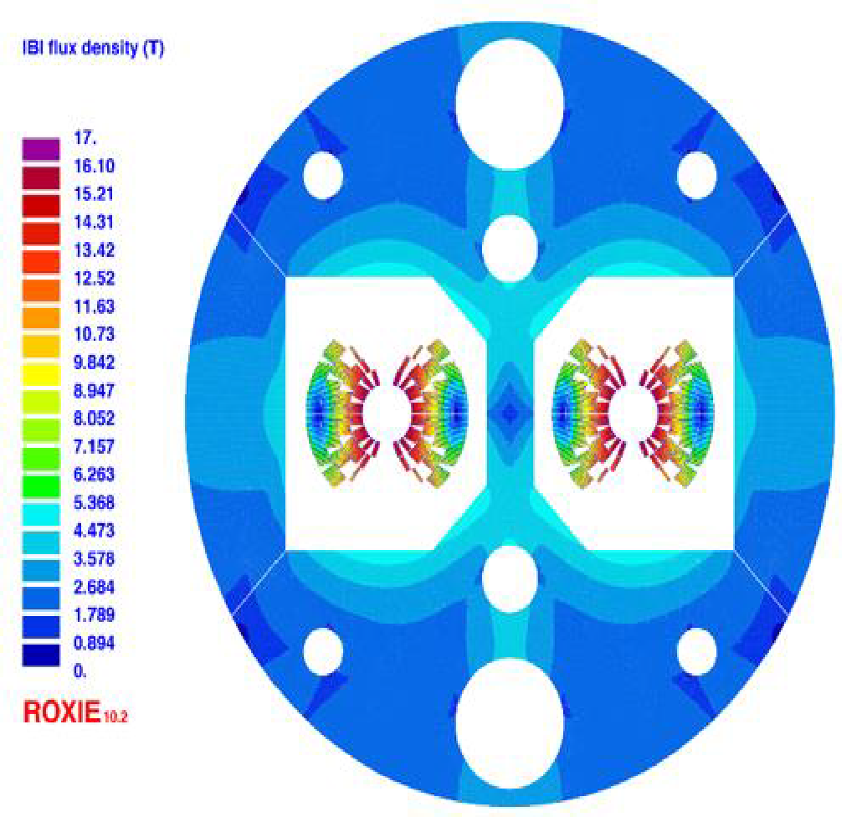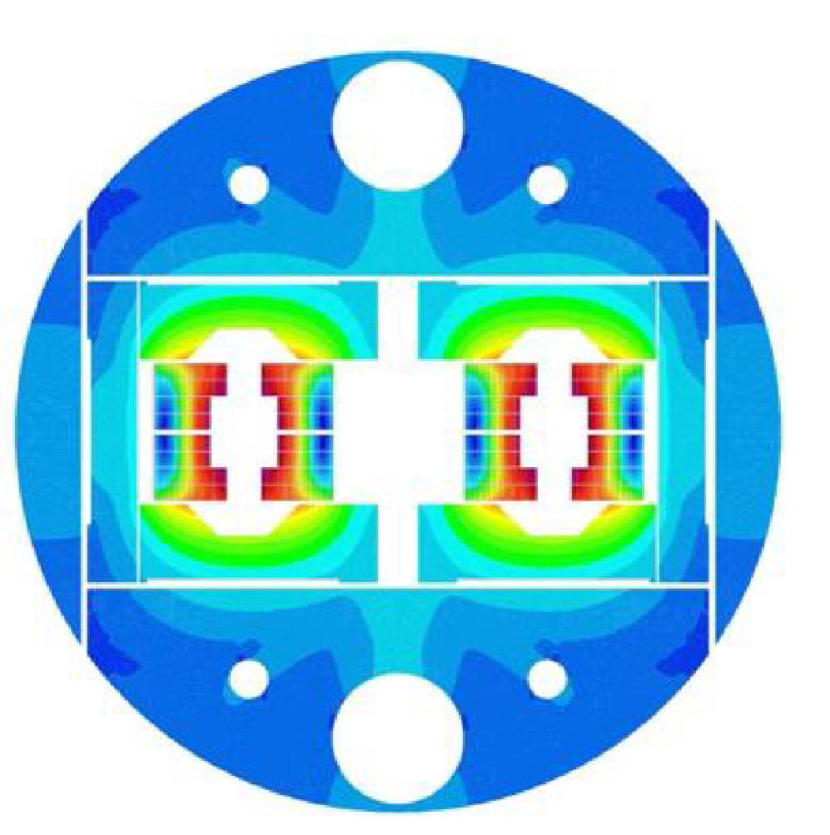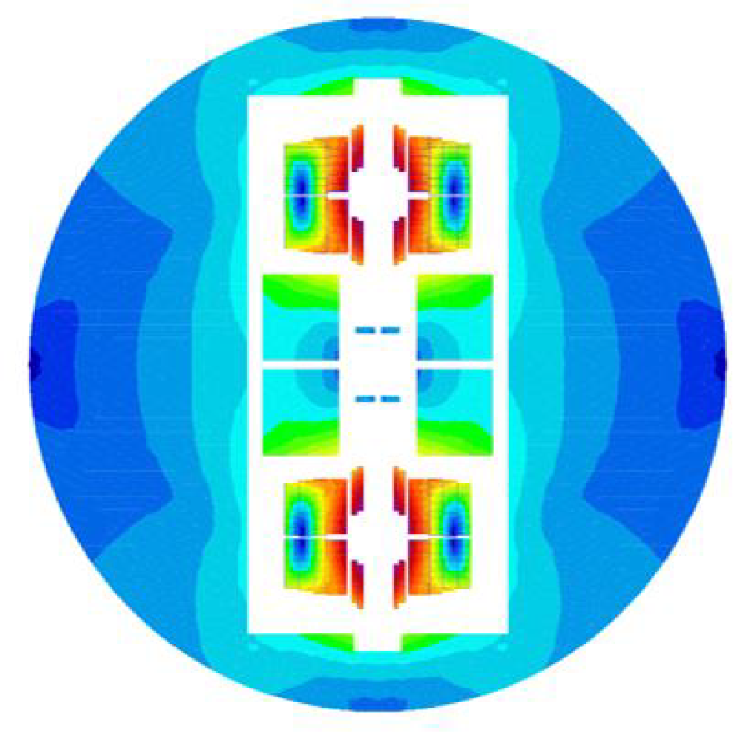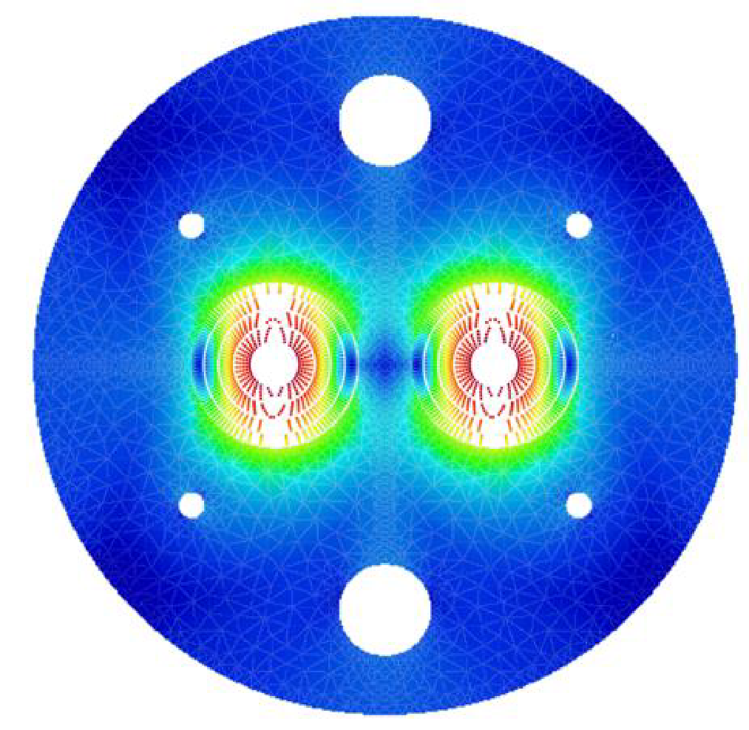
Figure 3.1. Cross section of the four main dipole design options explored within the Eurocircol program. From left to right, cos-theta design (INFN), bock design (CEA), common coil design (CIEMAT) and CCT design (PSI).

Table 3.1. Salient features of design options for 16 T magnets.
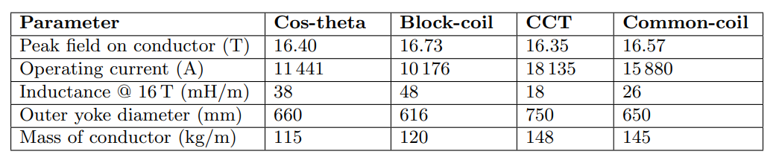
The main FCC quadrupoles (MQ) are twin-aperture magnets based on a cos-theta coil configuration assembled in a 20 mm thick helium II vessel. Their design is detailed in [3.8]. Like the main dipole magnet, the inter-beam distance is 250 mm and the physical aperture is 50 mm in diameter. Each aperture is mechanically independent from the other due to the use of a collar-and-key mechanical assembly. Each double pancake is made of 18 turns of Nb3Sn Rutherford cable with a 0.4◦ keystone angle. The electromagnetic cross section is shown in Figure 3.2.
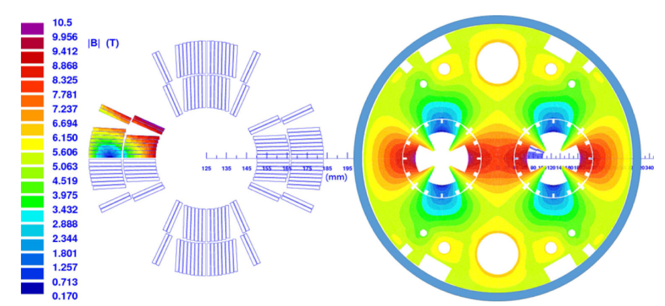
Figure 3.2. Left: conductor distribution and magnetic field [T] in the coil. Right: iron yoke, steel collar layout and HeII vessel.
For the FCC-hh, the FODO cell length in the arc was chosen to be 213 m, roughly double the length of the LHC FODO cell. The FCC-hh has 8 long arcs, each with 36.5 FODO cells, and 4 short arcs, each with 15 FODO cells. Each FODO cell has 12 dipoles and 2 Short Straight Sections (SSS). As in the LHC, each SSS contains one MQ, and sextupole (MS) and dipole corrector magnets (MC). Depending on the SSS location in the arc, there may be in addition octupole corrector magnets (MO), tuning quadrupoles (MQT) or skew quadrupoles (MQS). The magnet types and their main parameters are listed in Table 3.2. All these magnets, except the DIS quadrupole (MQDA), use Nb–Ti technology [3.9]. The MQDA relies on Nb3Sn.
Table 3.2. Other magnets in the arc
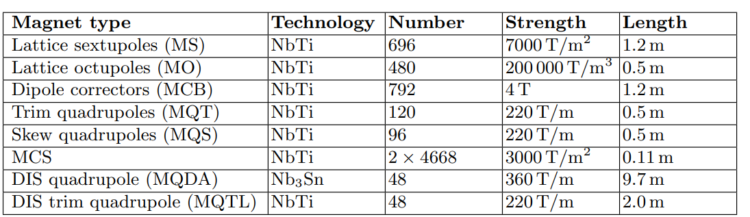
The low-beta triplets are composed of quadrupole magnets and corrector magnets. There are two types of low-beta triplets for installation in the high- and low luminosity interaction regions, respectively. The magnet types and their main parameters are listed in Table 3.3. The magnets around the collision points will be exposed to high radiation levels which may adversely affect their performance. It is assumed that the conductor performance can be maintained until a displacement-per-atom (DPA) value of 2 × 10⁻³ and that the magnet insulation can withstand an accumulated radiation dose of 30 MGy. These values may be exceeded over the machine lifetime, going up to 40–50 MGy assuming the use of the baseline 35 mm thick tungsten shield.
Table 3.3. Low-beta triplets
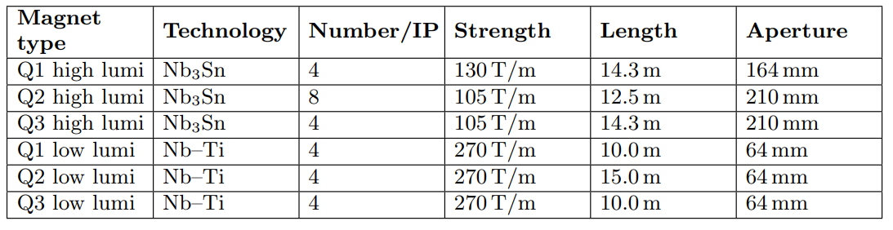

SPPC magnets
To achieve the 75-150 TeV c.o.m. energy, SPPC needs accelerator dipole magnets with nominal magnetic fields within 12-24 T and aperture of 40-50 mm and the field uniformity on the level of 10⁻⁴ in ~65% of their aperture. The magnets have two apertures with opposite field direction inside the common iron yoke to minimize the magnet transverse size and reduce its cost. The aperture separation in the main dipoles is presently estimated on the level of 200-300 mm. This parameter in the final magnet design will be optimized to achieve the acceptable crosstalk between two apertures and minimize the overall magnet cross-section. The outer diameter of the arc dipole and quadrupole cold masses is limited by 900 mm to be installed inside vacuum vessels with an outer diameter of 1.5 m. The total magnetic length of the main dipoles is ~65.4 km at the total collider ring circumference of 100 km. For the dipole length of about 15 m, approximately 4360 dipole magnets will be needed [5.2-1] - [5.2-3].
SPPC magnets with fields up to 15-16 T will need advanced Nb₃Sn superconductors. To increase the nominal operation fields up to 24 T High Temperature Superconducting materials with acceptable cost are needed. Special attention at the present time is being paid to Iron Based Superconductors (IBS) discovered in 2008.
Conceptual design studies of twin-aperture 12 T dipole magnets for the SPPC based on the IBS technology are being performed to achieve the SPPC requirements. In addition to the significant increase of the current caring capability, it is also anticipated that the IBS will have better mechanical properties than the present high field superconductors such as Nb₃Sn, REBCO or Bi2212, and substantially lower cost. Cross-sections of the two design options under consideration for the 12 T SPPC dipole based on the IBS conductor are shown in Figure 3.3. The coil aperture in both cases is 45 mm and the nominal field in the two magnet apertures is 12 T with the geometrical field quality of 10⁻⁴. The coil layout uses the common-coil configuration due to its simple structure compatible with the tape-type conductor and simplicity for fabrication.
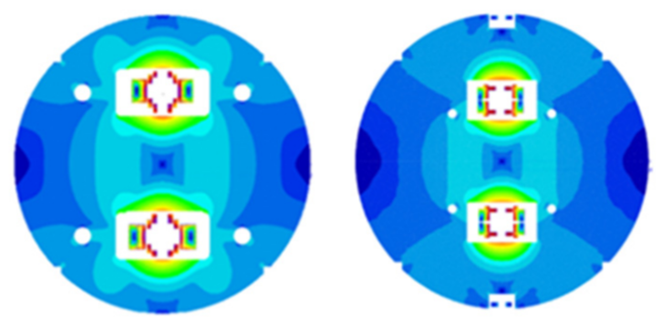
Figure 3.3. Cross-sections of the two design options for the 12 T SPPC dipole based on IBS [5.2-3].

Muon Collider Magnets

Muon collider magnet system
MC magnet needs and challenges are discussed in [BOT]. The pictures of main MC magnets is shown in Figure 3.4. The US MC studies [PAL-14], [PAL-15] provide the most consistent baseline, including an overview of the magnet requirements for a Muon Collider. The MAP results provide a broad envelope of the required magnet performance. The WP gives a summary of the perceived challenges, authors view on technology options, and selected magnet engineering tasks.
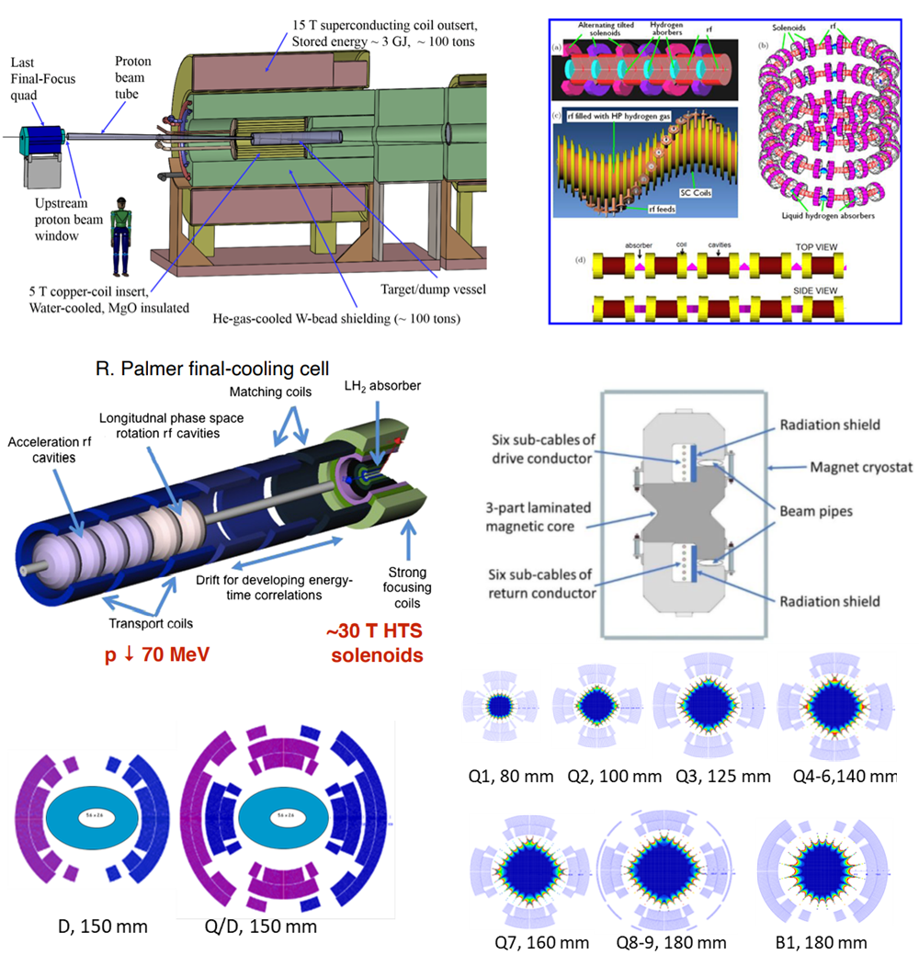
Figure 3.4. MC magnets: a) production solenoid; b) 6D muon cooling solenoids: c) final muon cooling system; d) fust-cycling muon acceleration magnet; e) collider ring magnets; f) IR magnets.

Muon production
Muons are produced by the decay of pions produced by interaction of intense proton bunches with a target placed in a high-field production solenoid which captures the pions and guide them into a decay channel to produce muons. The production solenoid generates a high magnetic field of 20 T in a 150 mm bore. A present baseline option is based on the 12-15 T, 2400 mm aperture superconducting (SC) outsert solenoid and the 5-10 T, 150 mm aperture normal conducting (NC) insert. As an alternative, a large bore LTS and HTS solenoid is also considered, though high resistance to radiation and heat load would need to be demonstrated. The advantages of an HTS-based solution would be the reduction of the outer diameter, profiting from the large temperature margin of HTS, the possibility to operate at higher temperature than liquid helium, and the reduction of the operating costs. The challenges of this magnet include high magnet field, mechanics, stored energy and protection, high-radiation environment. While a SC+NC hybrid magnet as originally planned in MAP can be built based on the extrapolation of known technology, an HTS SC+NC hybrid or LTS+HTS version would require a comprehensive R&D. The requirements and technology challenges of the target solenoid broadly overlap with those of magnets for high-magnetic field science, as well as solenoids for Tokamaks. The technology for an LTS+HTS option has overlap with that of ultra-high-field NMR magnets, and such development would profit from synergy with the development of HTS windings for High Energy Physics (e.g. HEP dipoles) and light sources (e.g. super bends).

Muon cooling
The cooling of muon beams occurs in a channel formed by solenoids and RF cavities. Since the final emittance of the muon beam is inversely proportional to the magnetic field of the final cooling solenoids, the goal for the final cooling solenoid is to produce a magnetic field of 40-60 T in a 50 mm bore. The preferred technology in this case is a SC LTS+HTS magnet. The main challenges of this ultra-high field solenoids are the large forces and stresses, quench protection, and the mechanical, cryo-cooling and powering integration of the LTS and HTS coils. These solenoids go beyond available technology and, thus, will require considerable R&D and demonstration. The challenges for the final cooling solenoids are similar with magnets for high-field magnet user facilities based on all-SC solenoids and ultra-high field NMR. The R&D on the final cooling solenoids is also synergic with the HTS magnet R&D for High Energy Physics (HEP) and light sources.

Acceleration
After cooling, muon beams are rapidly accelerated to relativistic momentum, so to extend their laboratory lifetime. After an initial acceleration stage of a Linear Accelerator (LINAC) and Recirculating Linear Accelerators (RLA) a sequence of Fixed Field Alternating Gradients (FFAG), Rapid-Cycled Synchrotrons (RCS) and Hybrid Cycled Synchrotrons (HCS) is used. RCS and HCS based either on NC fast ramped magnets (RCS) or a combination of NC fast ramping and static SC magnets (HCS) is the preferred option. They both require fast ramped magnets. In the first HCS, the fast ramped magnets for the muon acceleration need a magnetic field sweep of ~4 T (± 2 T) within 0.4 ms, which corresponds to a field ramp rate of 10 kT/s, in a rectangular bore of 80 mm by 40 mm. A resistive solution appears preferred for these specifications. The last HCS would require 4 T over about 10 ms, or a rate of 400 T/s, which makes HTS promising. A higher field swing would be welcome, which may be also the key advantage of HTS. Besides the engineering of such magnets, the main challenge is that the stored energy of an accelerator ring of the required dimension is of the order of several tens of MJ, and powering at high-pulse rate would need to master the management of peak power in the range of tens of GW. Energy storage seems to be the only viable solution, based on capacitor banks, or alternatives such as SMES and flux-pumps, with high Q-factor to improve on energy efficiency. The work required on magnets and powering for the accelerator stage has clear synergies with the design of RCS for nuclear physics machines, as well as accelerator driven transmutation and fission systems.
An opportunity to build fast cycling dipole magnets using HTS is discussed in [PIEK]. Besides being superconducting at relatively high temperatures, rare-earth HTS tapes have shown very small AC losses compared to low-temperature Nb-Ti cables. Recent tests of the HTS-based 0.5 m long two-bore SC dipole have shown record-high field ramp rate of ~300 T/s at 10 Hz repetition rate and 0.5 T field amplitude. No temperature rise in 6 K cooling He was observed within the ~0.003 K error setting the upper limit on the cryogenic power loss in the magnet conductor coil below 0.2 W/m. Based on this result a possible upgrade of this magnet design to 2 T in the 10 mm beam gap with the dB/dt up to 1000 T/s is discussed.

Collision
The last stage of the muon accelerator complex is a storage ring (SR) and an interaction region (IR). The SR needs to have the smallest possible size to maximize the number of muon collisions within their limited lifetime. Radiation shielding, from the collisions, and neutrino flux mitigation, due to muon decay, need to be addressed. As a result, the SR and IR magnets are designed for high-field and large aperture for shielding and in the case of the IR magnets to achieve high luminosity. Ring dipole magnets are required to generate a steady-state magnetic field up to 16 T in a 150 mm aperture for a 10 to 14 TeV muon collider. In order to reduce straight sections, and mitigate dose, the collider magnets are presently assumed to have combined functions (D+Q and D+S). SR magnets need to sustain a heat load of 500 W/m from muon decay and synchrotron radiation. In a 3 TeV c.o.m. MC, IR quadrupoles with steady-state gradient of 250 T/m, and a 150 mm aperture (peak field 12 T), are foreseen for the final beam focus. These requirements seem to be marginally within reach of Nb₃Sn. At higher energies the required gradient will need to increase, up to a peak field in the range of 20 T. The challenges of SR and IR magnets stem principally from the high field and large aperture required, as well as the radiation and heat load. These challenges are broadly shared with the development of high-field magnets for future collider, and in particular the need to manage stress in compact windings with high engineering current density.
The results of 3 TeV c.o.m. MC studies and a design concept of the 6 TeV c.o.m. MC optics, the SC magnets, and a preliminary analysis of the protection system to reduce radiation loads on the magnets and particle backgrounds in the MC detector are discussed in [ALE-1]. The SC magnets and detector protection considerations impose strict limitations on the design of the collider optics, magnets and Machine Detector Interface (MDI). SC magnets based on traditional cos-theta coil geometry and Nb₃Sn superconductor were used to provide realistic field maps for the analysis and optimization of the arc lattice and IR design, as well as for studies of beam dynamics and magnet protection against radiation. An important issue to address is the stress management in the coil to avoid substantial degradation or even damage of the brittle SC coils. An important issue to address is the stress management in large-aperture high-field SC magnet coils to avoid substantial degradation or even damage of the brittle Nb3Sn and/or HTS superconductor. Stress management concepts for shell-type coils are being developed for high-field accelerator magnets based on LTS (Nb3Sn) and HTS (Bi2212 and REBCO) cables by the US-MDP.
A low energy medium luminosity MC has been studied and is discussed in [ALE-2] as a possible Higgs Factory (HF). Electrons from muon decays will deposit more than 300 kW in SC magnets of the HF SR, which imposes significant challenges to SC magnets used in the MC SR and IR. Magnet designs are proposed which provide high operating gradient and magnetic field in a large aperture to accommodate the large size of muon beams, as well as a cooling system to intercept the large heat deposition from the showers induced by decay electrons. The distribution of heat deposition in the MC SR lattice elements requires large-aperture magnets to accommodate thick high-Z absorbers to protect the SC coils. A sophisticated radiation protection system was designed for the collider SR and IR to bring the peak power density in the SC coils below the quench limit and reduce the dynamic heat deposition in the cold mass by a factor of 100. The system consists of tight tungsten masks in the magnet interconnect regions and elliptical tungsten liners in the magnet aperture optimized individually for each magnet.

Electron Collider Magnets

FCC-ee magnets
The requirements for the FCC-ee main magnets are quite similar to those of LEP: the arcs contain many long, low-field bending magnets interleaved with short straight sections, containing quadrupoles and auxiliary magnets [3.3.1]. As such, the resistive magnet system resembles those used at LEP and at other large lepton machines (e.g. HERA electron ring and SLC); many of its features can be retained, for example, modular cores with aluminium busbars threaded through them. However, as a major innovation, for FCC-ee it is possible to exploit a dual-aperture approach. Coupling the two collider rings through twin-aperture arc magnets does not only halve the total number of main magnets, but it also saves 50% in electric power compared with two separate sets of magnets. For operation at high energy, especially at or above the tt threshold, the SR energy sawtooth is important. To compensate for its effect, the arc dipole and quadrupole fields need to be tapered, i.e. adjusted for the local beam energy. This tapering could be achieved, for example, with individual-aperture trim coils added to the main magnets. Such trim coils for the main bending magnets could also serve as horizontal orbit correctors. Figure 3.5 shows the design for the main bending, quadrupole and sextupole magnets. For the dipoles, the design of the magnetic yoke is based on an I configuration, combining two back-to-back C layouts. In this way, the return conductor for one aperture provides the excitation current for the other. The quadrupoles cannot be considered to be low field magnets because although the beam, which is quite small with respect to the physical aperture, sees at most 100 mT (that is, 10 T/m at 10 mm), the pole tip field reaches 0.42 T. This has an impact on the Amp-turns and the power consumption. It will be even more critical for large aperture sextupoles, where the field grows quadratically from the centre. Therefore, a twin aperture layout providing significant power savings is also particularly interesting for the quadrupoles, even if they are relatively short compared to the dipoles
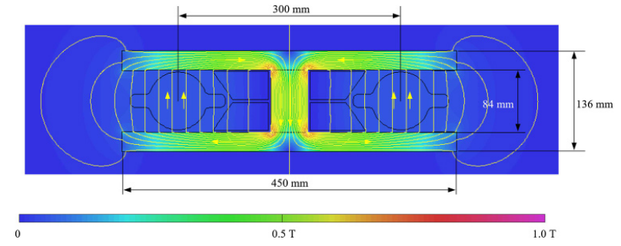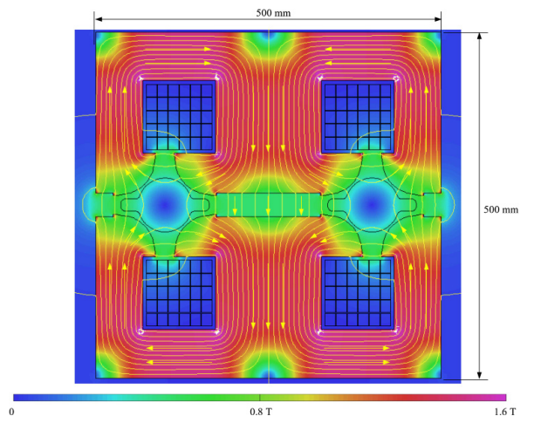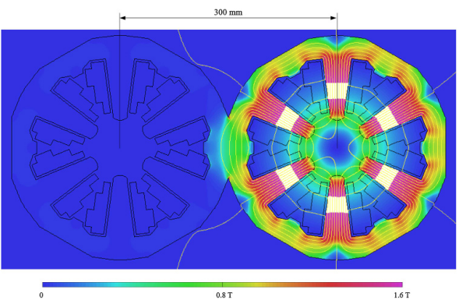
Figure 3.5. Cross section of the FCC-ee main dipole magnets (top), quadrupole (bottom, left) and sextupole (bottom, right) magnets
The Canted Cosine Theta (CCT) technology without an iron yoke has been chosen for the final focusing quadrupoles (Figure 3.). This technology provides the required field quality and has many possibilities for customisation of the field which is necessary for cross talk compensation (the tips of the FF quadrupoles closest to the IP are only 66 mm from the beams).
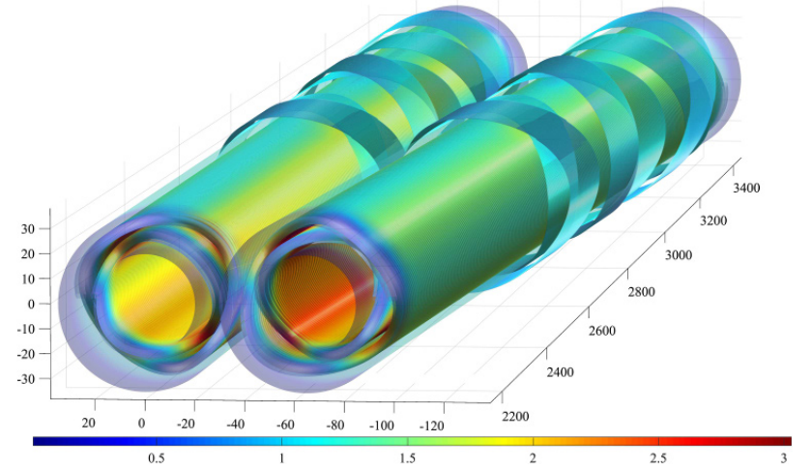
Figure 3.. Focusing qudrupoles based on the CCT technology.

CEPC magnets
The dipole field needed for CEPC main bending dipoles is 0.07 T. Each magnet has four C-shaped steel-concrete cores of about 4.5 m length, installed end to end in groups. The cores are composed of stacks of low carbon steel laminations, 1.5 mm thick, spaced by 6 mm gaps filled with cement mortar. The filling factor of 0.2 gives a small drop of ampere turns at the maximum field. Because of large quantity of 1,984 magnets and their long length of 18 m, the scheme of steel-concrete core not only increases the working field in the yokes of the dipole magnets but also reduces their cost significantly. The design of the quadrupoles is similar to that of quadrupole magnets in LEP. Hollow aluminium conductor is used for the coils. The iron core is made of laminated low carbon silicon steel sheet with a thickness of 1.5 mm. The pole has parallel sides so that simple racetrack shaped coils can be used. The magnet will be assembled from four identical quadrants and can also be split into two halves for the installation of the vacuum chamber. There are two types of sextupole magnets in the Main Ring, with the same aperture and cross section but of different lengths. The cores of the sextupole magnets are made from 1.5 mm thick low carbon steel laminations. To reduce cost, the coils will be wound from hollow aluminium conductors. Figure 3.7 shows a cross section of the quadrupole magnet and the 3D view of the sextupole [3.3.2].
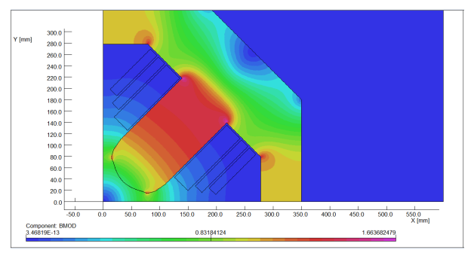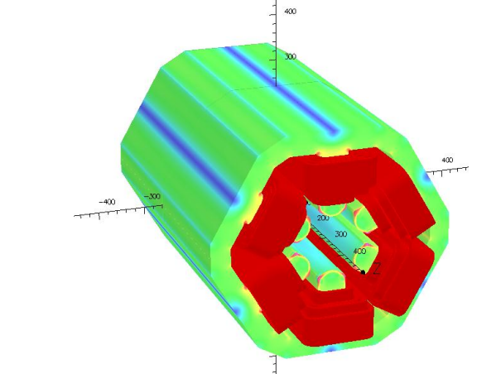
Figure 3.7. CEPC quadrupole (left) and sextupole (right) magnets.

Detector Magnets Progress and Future Requirements
Superconducting detector magnets are a key component to analyze the momentum and polarity of charged particles in particle physics experiments. A large warm bore and a large solid angle are required.
Over the past four decades, the design and fabrication of detector magnets has made significant progress thanks to the introduction and demonstration of specific technologies such as: high current, high strength, aluminum-stabilized superconducting cables; coil winding performed directly in the outer support cylinder to support large hoop stress; improved transparency using indirect cooling to eliminate the liquid helium vessel and no mechanical structure in the winding; pure aluminum strips as temperature equalizer and fast quench propagation. Table 4.1 summarizes the advances in thin detector solenoids.
Table 4.1 Advances in thin/transparent solenoid magnet technology.
Technology | First Detectors of the technology implemented
Al-stabilized superconductor (soldered) and indirect/conduction cooling | ISR[R4-2], CELLO[R4-3]
Secondary winding and quench back | PEP4-TPC[R4-4]
Co-extruded Al-stab. superconductor | CDF[R4-5]
Inner winding | TOPAZ[R4-6]
CFGP outer vacuum vessel/wall | VENUS[R4-7]
Thermo-siphon and indirect cooling | ALEPH[R4-8], DELPHI[R4-9]
2-layer coil and grading | ZEUSR4-10], CLEO[R4-11]
Al-stabilizer w/ Zn, and Isogrid vacuum vessel | SDC-Prototype[R4-12]
Shunted coil w/ conductor soldered to mandrel | CMD-2[R4-13]
High-strength Al-stabilizer w/ Ni micro-alloying and fast quench propagation w/ pure-AL strips and heater | ATLAS[R4-14]
Hybrid conductor configuration using EBW | CMS[R4-15]
Self-supporting coil with no outer support cylinder | BESS-Polar[R4-16]
Detector magnets for future colliders will be based on these technologies but further improvements will be required to cope with larger size, radiation loads and physics performance requirements. At the same time there is a risk that expertise and industrial capabilities are gradually lost due to the long time between projects. The industrial technology of Al-stabilized superconductor production is of particular concern. In other cases, precise control of the magnetic field distribution required high precision simulation, and tight control of fabrication tolerances. If the calorimeter is placed outside the magnet, such as ATLAS, high transparency is also required for charged particles passing through with a minimum energy. Otherwise, particle detectors need to be installed inside the magnet bore (except for muon detectors) resulting in larger bore, higher field and longer coil length.
Despite the impressive breakthroughs in detector magnet technology over past four decades there is a concern that these capabilities may erode over time due to the long time between projects. A sustained R&D effort is needed to preserve and further develop these technologies for application to future detector magnets. The development and industrial production capabilities of Al-stabilized conductor are of particular concern. A collaborative framework between institutes and industries is needed, and pre-industrialization programs will be necessary to adapt the technologies to the specific needs of the new detector magnets, and to validate that the required quality and performances can be reached.
The detector solenoids design study is in progress for future big projects in Japan and Europe, that is, ILC, FCC and CLIC. The proposed design parameters for each solenoid are summarized in Table 4.2.
Table 4.2. The proposed design parameters for the detector solenoids for future projects
Project | Magnet | Bc (T) | Rinner (m) | Length (m) | E/M (kJ/kg) | Stored Energy (GJ)
FCC-ee | IDEA | 2 | 2.24 | 5.8 | 14 | 0.17
FCC-ee | CLD | 2 | 4.02 | 7.2 | 12 | 0.6
FCC-hh |  | 4 | 5 | 20 | 11.9 | 13.8
CLIC |  | 4 | 3.65 | 7.8 | 13 | 2.3
ILC | ILD | 4 | 3.6 | 7.35 | 13 | 2.3
ILC | SID | 5 | 2.5 | 5 | 12 | 1.4

FCC-ee
Three detector designs have been proposed for FCC-ee [R4-29]-[R4-32]: the Innovative Detector for Electron-positron Accelerators (IDEA, [R4-33]), the CLIC-Like Detector (CLD, [R4-34]) and a design comparable to the IDEA detector that remains to be named. Each of these three designs includes a superconducting solenoid that produces a 2 T magnetic field in the center of each detector. The CLD magnet is positioned outside of the calorimeter volume while the two other solenoids are situated inside the calorimeter barrels just after the tracking detectors.
The most important difference between the IDEA and CLD detector designs (Fig. 4.1) is the location of the solenoid with respect to the calorimeters. Since the IDEA magnet is inside the calorimeter volume there are strict requirements on the particle transparency that needs to be lower than 1 X0. The concept of the solenoid of the IDEA is similar to the ATLAS Central Solenoid [R4-35] and whereas the CLD magnet is similar to the CMS solenoid [R4-36]. However, the free-bore diameter of the IDEA solenoid is almost two times bigger than the free bore of the ATLAS CS. This also means that the IDEA magnet has around four times the stored magnetic energy of the ATLAS CS at 170 MJ. The free-bore diameter of CMS is 6 m with a stored energy of 2.6 GJ. The CLD design has a larger free bore of 7.2 m and its stored energy is 600 MJ. The design parameters for the IDEA and the CLD are summarized in Table 4.3 [R4-37].
Table 4.3. Design parameters of the superconducting solenoids for the IDEA and CLD detectors at the FCC-ee.
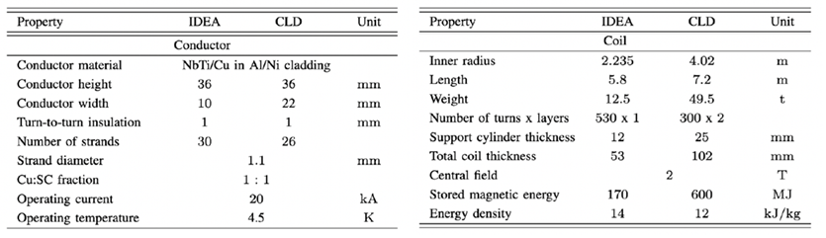
The challenges of the IDEA and CLD designs are well illustrated by their energy density, i.e. the stored magnetic energy divided by the cold mass weight. The ATLAS CS has a maximum energy density of 7.0 kJ/kg during nominal operation (with a demonstrated maximum of 8.1 kJ/kg) while for the IDEA magnet the energy density would be twice as high at 14 kJ/kg. Similarly, the CMS energy density is 11 kJ/kg and the CLD magnet has an energy density of 12 kJ/kg. The large free-bores in combination with the high stored energies translate to strong requirements on quench protection design, mechanical support and strength of the materials used [R4-37].
Both the IDEA and CLD include an aluminum 5083 support cylinder with yield strength of 209 MPa at 4.2 K [R4-39]. The aluminum stabilized conductor proposed for these magnets has a yield strength of 147 MPa at 4.2 K when [R4-35]. The conductor will be glued on the inside of the support cylinder with an epoxy resin type adhesive. These can have a shear strength of up to 76.8 MPa at 77 K depending on the type of resin used [R4-40].
Mechanical analysis shows that the peak hoop stress is 105 MPa for IDEA and 75 MPa for CLD, both within the elastic regime of the conductor and the Al5083 support cylinder. The peak tensile strains for IDEA and CLD are 0.13 % and 0.11 %, respectively. At the interface between the coils and the support cylinder the peak shear stresses are 0.5 MPa for IDEA and 0.24 MPa for CLD, within the maximum shear stress that adhesives can tolerate.
Preliminary protection studies have been carried out using energy extraction in combination with quench heaters and aluminum strips for faster propagation. For both detectors a safe peak temperature of about 60 K can be maintained [R4-37]. The propagation strips have a large benefit as they allow faster propagation already in the initial phase of the quench, before the quench is detected.

FCC-hh
The FCC-hh [R4-41] detector magnet (Fig. 4.1) features three powerful superconducting solenoids each generating 4 T in their bore [R4-42]. The central solenoid has 10 meter free bore diameter and a length of 20 meters, whereas the forward solenoids have a cold mass length of 3.4 meters and a free bore diameter of about 5 meters.
The basic detector layout is similar to CMS, featuring a tracker, electromagnetic calorimeter (E-CAL), and a hadron calorimeter (H-CAL) in the bore of the magnet, and muon chambers on the outside of the magnet. The muon chambers utilize the magnetic return flux generated by the main solenoid for the purpose of muon tagging. However unlike CMS, the FCC-hh detector does not feature iron yokes.
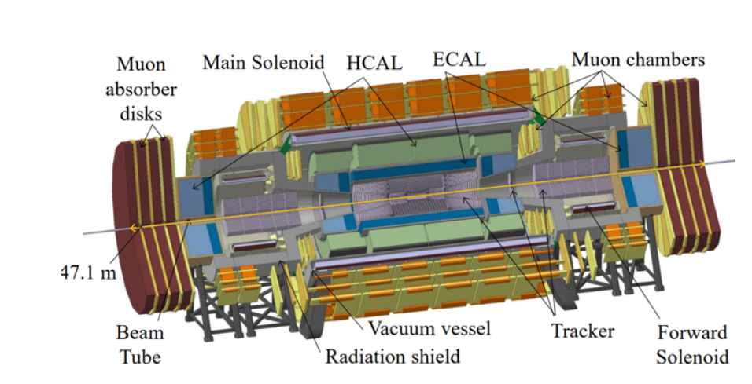
Figure 4.1. Proposed FCC-hh detector base-line layout
The unique combination of a main and forward solenoids is proposed to enhance the momentum resolution for particles travelling nearly parallel to the bore tube, and for this purpose trackers and calorimeters are located both in the main and the forward solenoids (Fig. 4.1). Due to the close proximity of the main and forward solenoids, the forward solenoids are each exposed to a net attractive force of 60 MN towards the main solenoid. This force is transferred to the solenoid vacuum vessels through reinforced tie rods, and subsequently transferred to the main solenoid through the vacuum vessels and additional support structure.
Table 4.4 shows various properties of the proposed superconducting detector magnets for FCC-hh. The bore magnetic field of 4 T and the energy density of 11.85 kJ/kg are a bit higher than CMS, while the total stored magnetic energy of 13.8 GJ is more than five times higher. The peak Von Mises stresses in both the main and the forward solenoid are at 100 MPa under nominal conditions which illustrates that, similar to CMS and the ATLAS Central Solenoid, a reinforced conductor is required to handle the Lorenz forces.
Table 4.4 Overview of various detector magnet properties for the FCC-hh proposed detector magnet concept
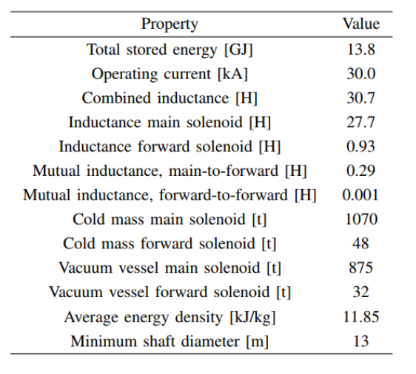
The conductors comprise Nb-Ti/Cu Rutherford cables surrounded by nickel-doped aluminum stabilizer. The Nb-Ti/Cu Rutherford cables feature 40 strands with a diameter of 1.5 mm, a Cu:non-Cu ratio of 1:1, and a current sharing temperature of 6.5 K. The operating current is 30 kA.
The solenoids are powered in series so that a single power supply and slow dump circuit are sufficient to charge and discharge the solenoids. In case of a quench, the different operating current densities in the main and forward solenoids necessitates a current decoupling of these two different magnet types, and therefore the two magnet types each feature their own fast discharge dump system comprising diodes and resistors. In parallel protection heaters are used to initiate quenches in different areas of the coils, thus avoiding strong temperature gradients even under fault conditions where the fast dump units fail to discharge the magnets. The calculated peak hot-spot temperature is well below 100 K under nominal conditions.

CLIC
The CLICdet design is based on a 4 T solenoid and is designed to operate at the three stages of the CLIC accelerator phases with center-of-mass energies of 380 GeV, 1.5 TeV, and 3 TeV. It takes advantage of the technical approaches developed for the CMS solenoid [R4-46] and the Atlas Central Solenoid (CS) [R4-47]. The main parameters are indicated in Table 4.5.
Table 4.5 CLICdet magnet parameters
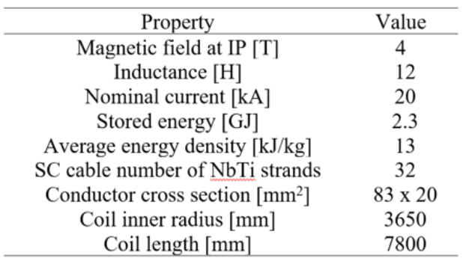
The conductor comprises a Rutherford cable composed of 32 Nb-Ti strands that is stabilized with an aluminum sheath. Both ATLAS CS and CMS approaches for a reinforced conductor are considered at this stage, respectively the structural cold worked Ni-doped aluminum stabilizer [R4-18] and the Electron-Beam welded aluminum alloy reinforcement [R4-39]. For both options the Nb-Ti Rutherford cable will be co-extruded with the high Residual Resistivity Ratio (RRR) aluminum stabilizer.
The CLICdet coil will be built using the inner winding technique inside a 50-mm thick external mandrel serving as structural external wall, as support for the liquid helium cooling circuit, and as fixation for the supporting tie rods. Similar to CMS, the external mandrel is made from the aluminum 5083 alloy. It is also used for the protection of the coil against the quench acting as a so-called quench-back cylinder. Aluminum thermal strips shall be used to ensure a good temperature uniformity in the cold mass, during cool down, operation at 4K, warm-up and for quench protection. Quench heaters are also included. The coil will be built from 3 modules with splices integrated on the low field region on the outer radius of the coil, similar to the CMS coil [R4-51], [R4-52]. The vacuum impregnation technique is considered. Heat radiation shields, together with an indirectly cooling with boiling helium at 1.2 bar and in thermosiphon mode will allow the operation of the magnet at 4 K. An iron yoke is used to confine the magnetic flux and muon detectors are installed in between the iron layers. A set of 4 end coils are attached on each end cap of the detector.
The end coils are used both to limit the magnetic field in the machine detector interface region, in particular on the QD0 final focusing quadrupoles located just in front of the end caps, and to limit the stray field outside the detector to 16mT at a radial distance of 15m in the service cavern that is used for detector maintenance and where detector services, powering systems and cryogenics are located. The use of these ring coils also contributes to limit the amount of iron in the yoke. It was proposed in the CLIC CDR [R4-53] to build these end coils with normal conducting windings operated at room temperature and water cooled, but we see here a good application of more sustainable solutions in order to limit the heat losses due to the dissipated power by using high temperature superconductor coils, connected in series.
Several technology R&D and pre-industrialization programs will be needed before launching the manufacturing of such a magnet. Power leads [R4-54], [R4-55] and superconducting busbars [R4-56], [R4-57] are typical applications that can be developed using high temperature superconductors. Other developments can also be performed for powering DC converters and dumping circuit. Dedicated studies applied to the detector magnet applications will be needed.
The feasibility of having a dual beam delivery system serving two interaction regions for the Compact Linear Collider has recently been studied and looks promising for physics programs [R4-45]. At this present stage, no distinction has been made on the magnets for these two detectors. It is the CLICdet baseline magnet design that has been considered with two crossing angles to check the physics feasibility in the interaction regions with the CLIC dual beam delivery system.

ILC – ILD and ILC-SID
The design parameters of the magnet for the International Large Detector (ILD) feature a central field of up to 4 T, in a volume of about 275 m3 (useful diameter 6.88 m over a length of 7.35 m) and its conceptual design has been undertaken by CEA, DESY and CERN [R4-58][R4-59][R4-60]. The ILD magnet design is very similar to the one of CMS, except for its geometrical dimensions, and the presence of the anti-DID. Consequently, many technical solutions successfully used for CMS are proposed for the design of the ILD magnet. The winding radius (3.615 m) of the ILD has larger figure-of-merit of 58.4 T2m than the value of CMS (47.2 T2m) due to its larger size. Similarly to CMS, a 4-layer coil is retained, with a nominal current in the range of 20 kA, so the conductor for the ILD magnet has larger cross section of 74.3 x 22.8 mm2. It consists of a superconducting Rutherford cable, clad in a stabilizer and mechanically reinforced. Two solutions are considered for the reinforcement. The first option is a micro-alloyed material such as the ATLAS central solenoid [R4-14], which acts both as a stabilizer and a mechanical reinforcement. A R&D program on the Al-0.1wt%Ni stabilizer has been launched at CERN and is underway to demonstrate the feasibility of producing a large conductor cross section with this material. The second option is a CMS-type conductor with two aluminum alloy profiles welded by electron beam to the central conductor stabilized with high purity aluminum.
A conceptual design study for a 5 T superconducting solenoid for the Silicon Detector (SiD) of the International Linear Collider (ILC) has been undertaken in FNAL [R4-61]-[R4-63]. The solenoid has a clear bore with 5.0 m in diameter and 5.0 m in length, where 5 T magnetic field is produced for inner detectors. Although the winding radius (2.65 m) of the SiD coil is smaller than that of the CMS (2.95 m), it has larger figure-of-merit of 62.5 T2m than the value of CMS (47.2 T2m) due to its higher magnetic field. Utilizing the existing CMS magnet conductor as the starting point, a winding design has been proposed for the magnet as shown in Fig. 4.17. Finite element analysis shows the resulting magnetic stresses in the coil parts do not greatly extrapolate beyond those of CMS.
Major R&D subject for SiD magnet is its conductor required to sustain such large EMF in the coil. In “SiD Letter of Intent” described in 2009 [R4-63], a more advanced and most likely cheaper conductor was proposed. It is based on high purity aluminum alloys, such as Al-0.1%Ni, which were used in the ATLAS central solenoid. Other conductor stabilizer possibilities are also under consideration and study. These include TiB2 grain refinement aluminum matrix composites, and cold working via the equal area angle extrusion process

Detectors for secondary particle experiments

COMET
The COMET experiment in J-PARC aims to explore the rare decay phenomenon of muons. Superconducting solenoids are used throughout the muon beamline: Pion Capture Solenoid (PCS), Muon Transport Solenoid (MTS), Bridge Solenoid (BS) and Detector Solenoid (DS). The magnetic field of all the magnets is required to be connected smoothly without large dips and peaks, otherwise the muons might be trapped or reflected. All the solenoids are covered by iron yokes, which are used as both radiation shield and magnetic flux return yoke.
The detector solenoid acts as a spectrometer of the electrons produced by the decay of muons, and all the electron detectors are installed inside the magnet bore. The detector solenoid is conventional solenoid wound by copper-stabilized Nb-Ti conductor cooled by GM cryocoolers. The total length of superconducting coil is 1.9 m, coil inner diameter is 2.14 m. The coil consists of 14 coils of 170 mm in length and 8 mm in thickness. All the coils are connected in series, and the nominal current is 189 A to generate the central field of 1 T.
The inductance of the detector solenoid is very large, 236 H, making the energy extraction by a dump resistor ineffective. Therefore, a passive heater protection scheme is adopted. Heater wire of 1.5 mm in diameter is wound on the outside of superconducting coils, and the heaters are connected in parallel with coils. Thanks to the quick quench propagation by the heaters, the maximum temperature in the coil can be limited to 150 K.
The PCS is not a detector solenoid, but the technology of the detector magnet is adopted, such as, the superconducting cable stabilized with high purity aluminum [R4-64]. The PCS contains the pion production target, and it is exposed to high radiation, meaning that large heat load is expected into the coils, calculated to be 228 W at maximum in the Phase-II experiment. In addition, conduction cooling scheme is applied in order to reduce the exposure of the liquid helium to direct radiation. The Nb-Ti with copper stabilizer based thick aluminum stabilized cable is used in the PCS; 15 mm in width, 4.7 mm in thickness and composition ratio of Al/Cu/Nb-Ti is 7.3/0.9/1.0.
The magnets are cooled down by cooling pipes flowing two-phase liquid helium on the outer surface of the coil shell, and the pure aluminum strips are sandwiched between layers to help the removal of radiation heat.

J-PARC g-2/EDM
In the J-PARC g-2/EDM experiment, the detector solenoid is also used as muon storage magnet. Positive muons are stored in the magnet, and decay positrons of polarized μ+ are measured. The decay positrons are detected by silicon strip detectors placed inside the muon storage orbit. One unique feature of the magnet is to adopt the three-dimensional spiral injection scheme. The muon beam enters the solenoid from the top end, and spirally go down to the storage region around the magnet center. When the beam crosses the storage region, magnetic field to kick the beam is applied to store the beam in the storage region. A very small static weak-focusing field is also applied around the storage region to maintain the beam in the storage region.
The important feature in the superconducting magnet is the magnetic field homogeneity in the storage region, less than 1 ppm locally and 0.1 ppm in circumferential average. In order to satisfy the requirement, new analytical code using truncated singular value decomposition method to optimize coil position and size is being newly developed [R4-66], and the design work is in progress using both the new code and existing commercial FEM code that can calculate with nonlinear effect. The superconducting main, shim and weak focusing coils are wound with a conventional Nb-Ti wire with copper stabilizer. Main characteristics of the magnet are summarized in Table 4.6. A superconducting switch is also connected with the main coils and these are operated in persistent current mode so that the magnetic field fluctuation caused by a voltage ripple of power supply can be ignored. All superconducting coils are cooled by liquid helium in cryostat to keep coil temperature constant.
Table 4.6 Main parameters of the storage magnet
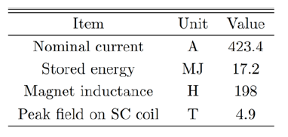
GM cryocoolers are attached to the cryostat to minimize evaporation of liquid helium and decrease the change of temperature distribution in the coils. Iron yoke covers the superconducting magnet to decrease the effect of ferromagnetic material outside the magnet on the field homogeneity, and iron yoke with cylindrical poles to make the homogeneous magnetic field in the storage region with ring shape.
The magnet is operated with persistent current mode as describe above, and it means that the stored energy must be mainly consumed during quench. In order to decrease the current decay time and enhance the quench propagation by utilizing AC loss in superconductor, small loops are made using diodes. The loops are adjusted in such a way that the self and mutual inductance match with each other. The peak temperature and voltage are calculated to be around 180 K and 1.6 kV, indicating that the magnet could be safely protected from the quench.
These 3D magnetic field design and control technologies are being developed in collaboration with Ibaraki University. Accompanying the precise magnetic field control, precise magnetic field monitoring system development is necessary. US-JP collaboration on NMR magnetometer with ultra-high precision [R4-67] is being progressed effectively.

Magnet technology R&D for High Energy Physics

Superconducting composites (Sasha)
There is a large variety of technical superconductors. Important features of practical materials for superconducting magnets include performance (appropriate combination of critical parameters) and its reproducibility in long lengths, commercial production and affordable cost. The superconducting materials described below belong to the class of practical superconducting materials being used in various magnets. The Table 5.1 below summarizes the critical performance parameters and production parameters of the conductors available for procurement in 1 km length that also meet needs for accelerator magnets. Cross-sections of the practical wires and tapes are shown in Figure 5.1. Magnet conductors are discussed in [COO].

Table 5.1. Critical performance parameters and production parameters of the conductors.
SC material | T_{c},  K | B_{c2}(4.2K),  T | Mechanical property | Billet or batch mass,  kg | Annual production scale,  tons | Relative cost | Final cost /material cost
Nb-Ti | 9.2 | 11 | ductile | 200-400 | >100 | 1 | 3
Nb₃Sn | 18 | 26 | brittle | 45 | 1–10/1* | 5/8* | 5-7
Nb₃Al | 18 | 26 | brittle | 45 | 1 | 8 | ?
Bi-2212 | 85 | 100 | brittle | 20 | < 1 | 20–50 | ~10
REBCO | 92 | >120 | brittle | 10 | < 1# | 20–50 | >>10
MgB₂ | 39 | 20 | brittle | 20 | < 1 | 2 | ?
* RRP/PIT
# few tons planned for fusion

Nb-Ti  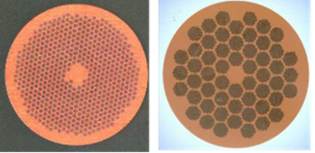 | Nb₃Sn  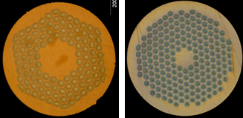 |  | Nb₃Al  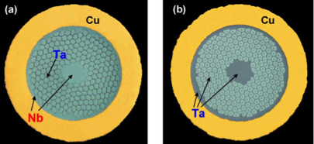
MgB₂ |  | Bi2212  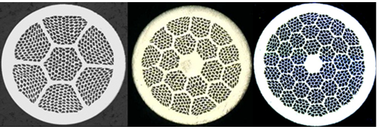
REBCO tape
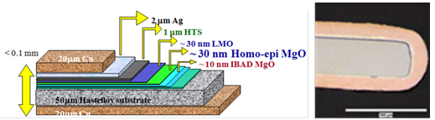
Figure 5.1. Composite SC wire and tapes.

5.1.1 LTS composite wires
Nb-Ti composite wires. Since its discovery in the 1960s, Nb-Ti is the most successful practical superconducting material. A composite wire is manufactured by a co-drawing process with intermediate heat treatments to achieve an optimal pinning structure. The final anneal provides a high Residual Resistivity Ratio (RRR) of the copper stabilizer. Diameters of practical wires are in the range of 0.1 mm to 3 mm and piece lengths are of a few km. The typical RRR value of the copper matrix is in the range of 50–200. A thin Nb barrier separates the Nb-Ti alloy from the copper to avoid the formation of brittle CuTi intermetallic composite during the high-temperature extrusion and the annealing heat treatments. The number of filaments in a wire may reach ~10⁵ and the filament diameter is 5–50 µm (the practical low limit is ~1–2 µm). The number of filaments and thus the filament size are determined mainly by stability criteria and also by hysteresis magnetization or AC loss requirements. Figure 2 shows typical cross-sections of Nb-Ti superconducting composite wires with different architectures. The single stack design is limited to ~10⁴ filaments. Using the double stack design allows achieving larger-number and smaller-size filaments.
Artificial Pinning Centers (APC) based on thin normal metal rods incorporated in the Nb-Ti filaments were proposed in the 1970s to improve and control flux pinning. This method has resulted in enhanced performance at lower fields with respect to conventional Nb-Ti, as needed in some magnet applications. It was found also that ternary Nb-Ti-Ta alloys have the potential to provide a small gain in upper critical field (up to 1.25 T at 1.8 K) while preserving the traditional wire manufacturing process. Low-loss Nb-Ti composite wires with ultrafine filaments (~0.1µm) and extra resistive Cu-Ni matrix are also produced for AC applications.
Nb₃Sn composite wires. Nb₃Sn is an intermetallic composite, the second superconducting material most widely used in SC magnets. Its superconducting properties were discovered in the 1960s. Nb₃Sn composite wires are currently produced using three main methods: bronze, internal tin, and powder-in-tube methods. The last two are most interesting for accelerator magnets due to high Jc.
The Nb₃Sn wires produced by Restacked-Rod-Process (RRP) use an architecture, wherein rods of Nb, Nb-Ta alloy, or Nb-Ti alloy are sheathed in copper and extruded, drawn, stacked in an annulus around a central core, wrapped with a diffusion barrier, and extruded a second time. Part of the core is then replaced with Sn, and this assembly forms what is called a sub-element. After further drawing, the sub-elements are re-stacked and further drawn to the final size. A reaction sequence produces mixed Cu-Sn phases at low to moderate temperatures (below 600°C) before a final high-temperature segment facilitates a diffusion reaction between Cu-Sn and Nb (or Nb-alloy) to form Nb₃Sn (or Nb₃Sn alloyed with Ti, Ta, etc.). Conductor naming typically refers to the number of sub-elements that occupy a theoretical number of sub-element sites while keeping hexagonal symmetry. RRP research strands explored configurations restacks from 61 up to 217 sub-elements, including Cu. Procurements in 2021-2022 focuses on 150/169 and 162/169 designs and 1.0 to 1.1 mm final diameter.
The tube-based Nb₃Sn approaches, such as Powder-in-tube (PIT) and rod-in-tube (RIT), replace the annulus of stacked rods in RRP conductors with a solid tube of Nb or Nb-alloy. The Sn source, often combined with Cu, can be a powder or a rod inserted in the center of the tube, whereby a radial diffusion reaction following a similar path as for RRP conductors is used to form the Nb₃Sn layer. The assembled tube and core material is restacked in a similar fashion as described for RRP conductors, where design flexibility is provided by tube shape (hexagonal or round), separation, and composition of components in the tube core. Since the tube starts off with much less deformation strain than that used to create the RRP annulus, it is plausible that tube-type conductors can achieve larger re-stack counts and smaller diameters before reaching deformation limits. Reports investigated restacks with as many as 744 tube sub-elements (n = 18 with 169 sub-elements being Cu) at tube diameter approaching 15 µm for 0.7 mm wire diameter.
There are two important areas where tube-like Nb₃Sn wire need research to improve them to have properties comparable to RRP wires. First, transverse pressure studies of Rutherford cables show that PIT wire tolerate less transverse strain than RRP wires, with respective onset of degradation at 50–120 MPa vs 170–250 MPa. Second, studies of round and rolled wires noted the tendency for PIT reactions to retain a higher degree of radial symmetry than for RRP, which results in a lower conversion of the available Nb to Nb₃Sn in distorted sub-elements. While high levels of deformation lead to RRR reduction for both designs, the associated loss of J_{c} for PIT wires presents challenges for magnets. In addition to the research topics discussed for RRP wires, further improvement of tube-type Nb₃Sn conductors could result from:
• Improved manufacturing of tubes with reliable mechanical properties
• Improved manufacturing of fine powders of Nb-Sn and Cu-Sn intermetallic compounds
• Continued use in magnets to reveal conductor vulnerabilities
The continued improvement of Nb₃Sn wires will be vital to future colliders. It includes using advanced Nb-alloys and incorporating high Cp materials into the wire architecture.
A number of the potential benefits of using internal oxidation to improve flux pinning and increase J_{c} at high field providing retention or increase of B_{c2} in Nb₃Sn conductors is being explored. Development of both RRP and tube routes is presently underway using advanced alloys. These developments are presently bridging from nascent wires to industry R&D. Provision of adequate conductor development resources could encourage maturation through industry R&D toward practical wires over a 5-year timeframe.
Development of Nb₃Sn wires with high C_{p} additives is underway in parallel with investigation of advanced alloys mentioned above. Challenges exist in identifying and then optimizing powders for both properties and compatibility with manufacturing. Support from conductor development programs could extend nascent wires to industry R&D or farther within 5 years.
In addition to these opportunities, improvement of RRP conductors also needs research attention given to:
• Reducing d_{eff} without concomitant loss of performance, loss of yield, or increase of cost.
• Scaling production to 100 kg billets or larger.
• Modifying the conductor architecture and heat treatment to optimize properties above 15 T.
Nb₃Al composite wires. The NIMS group in Japan invented a rapid-heating quench treatment (RHQT) process that circumvented thermodynamic limitations of the Nb-Al system. They attained excellent properties of the Nb₃Al phase in wires of kilometer length. However, the treatment temperature is above the melting point of Cu, which required manufacturing to develop special processes, such as ion plating, to add Cu stabilizer. Conductor development at Ohio State and some cabling and magnet studies at Fermilab provide additional background.
MgB₂ composite wires. MgB₂, a binary intermetallic superconductor, is a new promising material for application in superconducting magnets. It is brittle, but relatively easy to fabricate in long lengths. The traditional PIT method and a variety of sheath materials with appropriate barriers or reinforcing components are used to fabricate MgB₂ composite wires. The MgB₂ superconducting phase is formed during a reaction heat treatment at 700ºC for 20 minutes. Since both components Mg and B, and the sheath materials are inexpensive, the cost/performance ratio for MgB₂ is much lower than that for other superconductors. Thanks to the relatively high Tc, MgB₂ is suitable for use in superconducting magnets cooled at temperatures of ~10–30 K, above those currently used for low temperature superconductors. The density of MgB₂ is lower than the density of other superconductors making it attractive for specific applications in lightweight magnets or in supporting accelerator magnets as it has been done for the CERN Superconducting Link.

5.1.2 HTS conductors
Conductors made from high-temperature superconductor (HTS) also are capable of extremely high fields. The 1990s advanced three main HTS conductors in long length under the auspices of the DOE Office of Electricity: Bi2223, nominally Bi₂Sr₂Ca₂Cu₃O₁₄ and often called “1G-HTS” representing a first generation; Bi2212, nominally Bi₂Sr₂CaCu₂O₁₀; and REBCO, nominally RE₁Ba₂Cu₃O₇ where RE stands for Y or a rare earth element and often called “2G-HTS” representing a second generation of electricity conductor. For purposes of high-field magnets, Bi2223, still offers some interest in its present form but its current density is comparatively low for most applications in the accelerator sector. Bi2212 and REBCO attain stronger flux pinning by virtue of its lower anisotropy compared to Bi2223, which is an intrinsic advantage held over other materials in the cuprate family too.
Bi2212 round wires. Bi2212 offers the potential to displace Nb₃Sn above about 15 T field. Since Oxygen is evolved during the phase transition, and other gases are present between the powder grains, an external pressure must be applied to prevent coalescence of gas bubbles and blockage of the filaments by gaps. This necessitates a wind-and-react magnet approach. Present reactions are carried out at 50 bar pressure in specially designed furnace at Florida State University. A round wire HTS architecture is important for the accelerator magnets in several ways. First, wire-drawing techniques presently applied to copper-clad superconductors can be applied to Bi2212 in large degree. This could permit scale-up and quality control like that which has been essential to large-scale production of Nb-Ti and Nb₃Sn conductors for accelerator magnets. Second, cabling techniques are generally unchanged between Nb-based conductors and Bi2212. Third, twisted conductors are needed to reduce magnetization and losses upon ramping of accelerator magnets. Fourth, existing insulation winding and braiding schemes can be adapted to accommodate the temperature and chemical interactions for Bi2212.
Many of the basic requirements for using Bi2212 in magnets were worked out by the Very High Field Superconducting Magnet Collaboration between 2009 and 2013, which combined investigators from the former DOE Office of Electricity program with HEP national laboratory teams and university groups. Further advances were achieved by advancing the production of Bi2212 powder between 2013 and 2018, where the present standard composition, the so-called “521” formulation, traces back to that effort. Multiple, but small-scale, manufacturers now produce uniform fine powders that facilitate conductor fabrication with low breakage. Continued support from both DOE-HEP and the National Science Foundation (NSF) via the National High Magnetic Field Laboratory (NHMFL) has led to demonstrations of good reproducibility for coil reactions based on conductor witness samples.
New over-pressure reaction systems should allow dipole model coils up to 1 m length and 250 mm diameter to be completed by end of 2024, if provided adequate resources. This infrastructure should also facilitate exploration of laboratory solenoids and NMR systems at well above 30 T field. Infrastructure for longer magnets has received initial informal consideration.
REBCO tapes. REBCO became a viable high-field magnet conductor when high-strength Hastelloy substrates entered development with great assistance by the many methods to incorporate pinning centers. As conductor technology progressed, REBCO has become the basis for the 32 T user magnet at NHMFL, Bruker Biospin’s 28.2 T, 1.2 GHz NMR system, and numerous other magnet demonstrations above 25 T. Several projects are underway aiming toward 40 T magnets [Bai].
Further advances to reduce the Hastelloy thickness to 30 µm provide a significant enhancement of the winding current density, especially in the so-called “no insulation” condition. This enhancement led to achievement of winding current densities of over 1400 A/mm² and reaching beyond 45 T field.
Conductor being procured for privately funded fusion magnets is a significant production run that will provide huge amounts of data for the evaluation of manufacturing readiness. Smaller production runs associated with the fabrication of large magnets such as the 32 T user magnet at NHMFL have yielded insight about the readiness of this conductor for accelerator magnets. A central challenge is that the applications in the accelerator sector require verification of properties at 4 K and high field.
Roebel cables were developed from REBCO conductors during this period, and they have been implemented in short model coils. Extensive characterization of Roebel cables uncovered susceptibility to degradation under transverse stress, which could be partly managed by epoxy impregnation. A difficulty with the Roebel design is that wide REBCO tapes are required as starting material, and over half of the starting material is cut and discarded by the patterning process, significantly driving up the cable cost. These challenges remain at the present time.
The importance of thin Hastelloy for HEP magnets is the ability to make compact round “wires” from cables of REBCO as an alternative to Roebel cables. Conductor on round core (CORC®) and symmetric tape round (STAR) are two variants envisioned for future accelerator magnets. Each consists of a REBCO production tape conductor wound in a helical fashion around a conductive core. Thin substrates reduce the strain applied to the REBCO layer, or alternatively permit winding to smaller wire diameter and higher current density. Wires with typical diameter of ~ 3 mm are facilitated by the 30 µm Hastelloy product. Flexibility to bend either CORC® or STAR conductors is related to the tape width and winding pitch, where conductors that are narrower (now pushing below 2 mm width) and wound with a shorter helix pitch have the best flexibility. Unfortunately, these trends drive up cost by requiring more conductor per unit length of cored wire and increasing the losses due damaged material at the slit edges.
The vulnerability of cables to stress is receiving new attention in accelerator magnets and some fusion cable tests.

5.1.3 Other high-field conductors
Chevrel phase. HEP resources were provided to develop materials with so-called Chevrel structure PbMo₆S₈, based on critical temperature approaching 15 K and upper critical field of ~60 T at low temperature. Powder-in-tube wire technologies could not emerge from R&D status due to lack of densification of the powder core and persistent contamination by oxygen. These challenges are similar to those discussed for iron-based superconductors above. Manufacturing with stainless steel sheaths, hot isostatic pressing, and hot-rolling or hot-drawing has been used to make laboratory scale wires with high density, but the process complexity is too high to compete with HTS conductors.
Iron-based superconductors. Iron based superconductors present the interesting opportunity of an extremely rapid increase of critical field with reduction in temperature. Nascent wires and tapes are emerging, more often following the path of REBCO coated conductors than that of multifilamentary round wires. Powder-in-tube wires are beginning to show promising critical current density, but requisites for magnet technology still need to be demonstrated. Some processes are compatible with copper based on temperature and chemical reactivity. However, densification is an underlying requisite for further development, where addition of substantial high-strength sheathes appear to be necessary to constrain powders and achieve high utilization of the powder core. The same underlying challenge has prevented multifilamentary wires and tapes made from Bi-2223, PbMo₆S₈, and MgB₂ from realizing the full potential of properties shown on small scale. While continued support of basic research to advance iron-based superconducting wires is needed, it is unclear where the transition point lies for more focused development for accelerator magnets. High density powder cores must be achieved without requirements of excessive iron or steel sheaths. Coated conductors need to demonstrate advantages over the much more mature REBCO, and cost obstacles connected with reel-to-reel manufacturing capital must be overcome.
A practical plan to make the Fe-based superconductor (IBS) AEFe₂As₂ (122) (AE = alkaline earth, here Ba or Sr) into a much cheaper, higher stability margin, round, twisted and effectively isotropic multifilament conductor suitable for 16-20 T dipole magnet construction is discussed in [KAM]. Compared to Nb₃Sn, 122 is still at the early stage of development. This paper urges to accelerate progress by providing a fundamental understanding of what controls the transport critical current density, Jc, of 122 polycrystals and then fabricating it into wire form. High grain-to-grain Jc is the one key property not yet fully demonstrated in this new superconductor and this is the key breakthrough that would make 122 a practical superconductor. Whereas the intragrain Jc is already high enough to compete with Nb₃Sn, the unpredictable superconducting connectivity at grain boundaries (GBs) is the critical problem that limits the long-range Jc. The most important questions to increase the long-range Jc are:
- What degrades the GB connectivity in 122?
- How can we overcome this GB degradation yielding high Jc?
- Can we incorporate the processes that increase Jc into powder-in-tube fabrication process yielding inexpensive, high-performance composite wires?
These questions are crucial for 122 to become the affordable 16+ T magnet technology that the Particle Physics Project Prioritization Panel (P5) and the US Magnet Development Program (MDP) strongly demand. In the next 10 years, we propose to address the following key issues so that IBS’s potential can be fully evaluated and transformed into a magnet-ready conductor with Jc >1500 A/mm² at 4.2 K and 16-20 T:
- Define the most effective synthesis for high quality 122 powder to eliminate extrinsic current blockers at GBs;
- Comprehensively evaluate the true nature of GB superconductivity;
- Define the most effective wire design and fabrication route to transfer the effective synthesis into long-length multi-filamentary wire form.
These thrusts are inter-related and must be addressed in series in a strategic manner with long term commitment. We strongly emphasize the need to evaluate the true intrinsic nature of GBs in the polycrystalline forms before focusing on wire fabrication.

High-Current Cables
Large superconducting accelerator and detector magnets require high-current multistrand cables. To achieve in a cable the required current level, several strands are connected in parallel and twisted or transposed in the axial direction. Using multistrand cables allows limiting the piece length requirement for wire manufacturing, the number of turns in coil winding, the coil inductance, and also allows current redistribution between strands in the case of a localized defect or quench. Four main designs of superconducting cable are shown in Figure 5.2. They include the rope-type and Rutherford-type designs used with round strands, and the Roebel-type and Conductor-on-round core (CORC®) cable suitable for ribbon or tape conductors.
To provide cable mechanical reinforcement in the transverse and axial directions, and improve cable stability and quench protection, additional amounts of a normal metal or stabilizer are used. Depending on the cooling scheme, gaps or channels for coolant flow could be also added. Two examples of such cables are shown in Figure 5.3. The Cable-In-Conduit-Conductor (CICC) is a version of rope-type cable with strong jacket (conduit) and free space between strands for liquid helium. This arrangement combines good support of the strands against Lorentz forces with a low shielding loss and high current. The copper or Al-clad cables are fabricated using soft-soldering, rolling or co-extrusion processes. High purity Al is used to reduce weight, provide high electric and thermal conductivity, and achieve small radiation length.
The maximum current Ic of a cable is the sum of strand currents or slightly less. It depends on strand degradation during cabling and current distribution in the cable cross-section. Due to strand coupling inside the cable, its magnetization and AC losses have additional eddy current components controlled by the inter-strand resistance and strand twist pitch. To reduce coupling, strands can be coated with resistive metal, such as Sn-5%Ag, Cr, Ni, or a thin resistive core can be used in the cable.
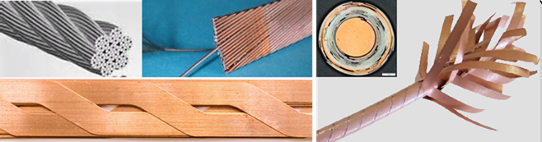
Figure 5.2. Rope-type (top left), Rutherford-type (top right) and Roebel-type (bottom) multistrand superconducting cables. Add CORC, etc.
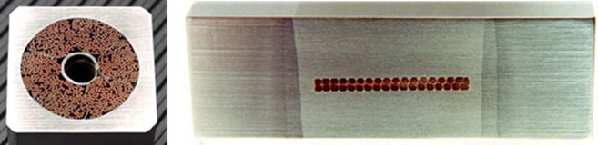
Figure 5.3. Heavily stabilized and mechanically reinforced large current cables: cable-in-conduit-conductor (left) and Al-clad Rutherford cable (right).

Magnet Development and Test Technologies
Magnetic field of ~10 T is considered as the practical limit for Nb-Ti accelerator magnets. The field range up to 10 T using Nb-Ti magnet technology has been scientifically explored and practically realized in all the present HEP colliders such as Tevatron, HERA, RHIC and LHC as well as some smaller machines. Magnets with a higher field are the most efficient way to achieve higher collision energies in future colliders. To produce higher fields, new superconducting accelerator magnets and technologies based on advanced superconductors and structural materials are being studied.

Approaches and Status of high-field Nb₃Sn accelerator magnet R&D
The present “work horse” that is readily available on an industrial scale is Nb₃Sn. Over the last three decades, several programs have probed a variety of accelerator magnet concepts, with record dipole fields in multiple configurations. As examples:
- The “Cosine-Theta” approach, used in all high-energy collider magnets to-date. The “D20” cosine-theta magnet [9] was a flagship 4-layer magnet built in the late 1990’s that achieved a peak field of 13.5 T at 1.9 K. Most recently, the MDPCT1 magnet, built at FNAL within the MDP program (see section 5), achieved the record field of 14.5 T at 1.9 K in a 50 mm bore, with excellent field quality [10].
- The “Common Coil” dipole configuration, wherein racetrack coils are energized in “reverse polarity” so as to create a strong magnetic field between the coils, yielding effectively twin apertures. Examples include the “RD3c” magnet built by LBNL [11], the HFDC01 magnet developed by FNAL [12], and the DCC017 magnet built and tested by BNL [13]. The latter continues to be in use, serving as a magnet facility for a variety of high field (∼ 10 T) tests for experiments for collaborators [14].
- The “Block Dipole” magnets; similar to the common-coil layout, but energized in “same polarity”, resulting in a single, high field bore. To maximize field while allowing access for the particle beam, the ends are “flared”. The concept was most thoroughly explored by LBNL in the mid 2000’s, culminating in the “HD3” magnet that achieved 13.8 T at 4.2 K [15]. The technology was ultimately utilized in the CERN “FRESCA-II” magnet, which achieved 14.6 T with a large, ∼ 100 mm bore [16]. The magnet is not designed as an accelerator magnet, but rather serves as a test facility for superconducting cables.
- The “Canted Cosine Theta” (CCT) concept, wherein the cable is directly placed in individual grooves machined into a cylindrical support structure. The tilted winding results in a solenoidal field component, which is compensated by the next layer in the structure, and uniform transverse component. The cross-section (right) shows the intrinsic “cos-theta” nature of the resulting current distribution, resulting in excellent field quality.

The 12 T operation field range for large scale deployment
Develop Nb3Sn magnet technology for collider-scale production, through robust design, industrial manufacturing processes and cost reduction. The present benchmark for Nb3Sn accelerator magnets is HL-LHC, with an ultimate field in the range of 12 T and a production of the order of a few tens of magnets. Nb3Sn magnets of this class should be made more robust, considering the full spectrum of electro-thermo-mechanical effects and the processes adapted to an industrial production on the scale of a thousand magnets. The success of this development should be measured through the construction and performance of long demonstrator and prototype magnets, targeting the 12 T range. The Nb₃Sn magnet development will improve areas of HL-LHC technology that have been found to be sub-optimal, notably the degradation associated with the fragile conductor, targeting the highest practical operating field that can be achieved. The plan is to work jointly with wire and cable development to mitigate degradation associated either with length or electro-thermo-mechanical effects. The R&D will explore design and technology variants to identify robust design options for the field level targeted. In Europe, the program includes the construction and test of short and long model magnets 2203.08054.

Accelerator magnets in the 14-16 T operation field range
The projected upper field limit for a Nb₃Sn dipole is presently 16 T (the reference for FCC-hh). The performance of Nb3Sn magnets relies upon mastery of the magnet mechanics. Finding the right balance between cost-efficiency, maximum field, and robustness is at the core of the R&D activity to provide satisfactory input to the High Energy Physics community. Nb₃Sn is strain- and stress-sensitive and brittle. Besides the known reversible critical current dependency on applied strain, the main concern is that stress or strain exceeding allowable limits lead to a permanent reduction of critical current and eventual damage through fracture of the superconducting phase. Thus, it is paramount to minimise stress concentrations on the conductor. In the last years, and within the FCC-Conceptual Design Studies, the WP5 of EuroCirCol gathered CEA, CERN, CIEMAT, INFN, KEK, the University of Geneva, the University of Tampere and the University of Twente to explore different design options for 16 T dipole magnets to give a baseline for future development. The focus was on the design of electromagnetically efficient coil cross sections. In the US, the MDP program focused in the stress management approaches to reduce the stress in the strain-sensitive Nb₃Sn conductor.
Advanced magnet technology is the driving technology for any energy-frontier circular collider envisioned by the community, fundamentally impacting both science reach and facility cost. There are many elements of technology development that lie at the heart of advanced magnet R&D. It includes new diagnostics and testing techniques, materials and composites development, new solutions for detection and protection and the development of modelling tools together with the required specialized testing infrastructure. Finally, dedicated manufacturing and test infrastructure required, including instrumentation upgrades, needs to be developed, built and operated through close coordination between the participating laboratories.

Coil stress management
To reduce conductor stress, the US MDP program [ref MDP white paper] is focused on stress-management approaches introduce internal structures and additional interfaces when compared to more traditional magnet designs. The concept of stress-management, i.e. intercepting magnetic forces to structural members before they can accumulate to damaging levels, promises a path towards very high field accelerator magnets. Two stress management design approaches are shown in Figure 5.4.
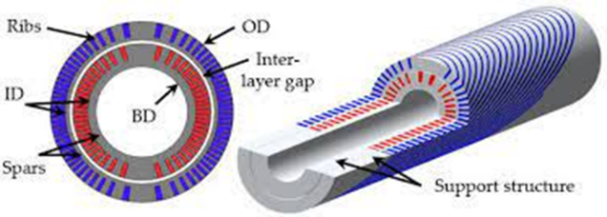
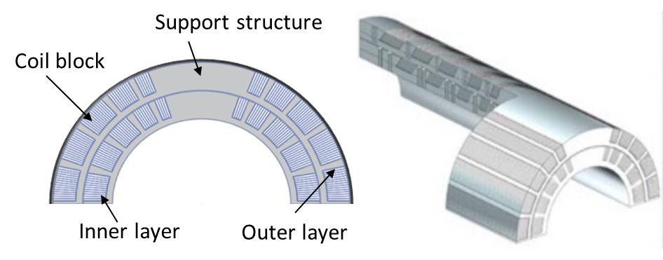
Figure 5.4. Top - the Canted Cosine Theta (CCT) concept, wherein the individual cables are directly placed and supported in grooves machined into a support structure. Bottom - the Stress Managed Cosine Theta (SMCT) concept, wherein groups of Rutherford cable are placed and directly supported in grooves machined into a support structure.
To take full advantage of these technologies, further understanding and development in several areas is necessary. Below are some key issues that are being investigated to develop these stress-management approaches:
- Development stress management coil structures and their fabrication methods including exploration of conventional machining methods as well as additive manufacturing approaches;
- Investigate and optimize external structures for use in stress-managed magnets with increases internal structure rigidity.
- Understand the influence of interfaces on stress-limits and training under different interface conditions;
- Explore the limits of stress-management approaches on high field / large bore demonstrators.
- Develop efficient and cost-effective fabrication methods using minimal tooling to reduce overall magnet fabrication cost and complexity;
- Investigate approaches for scale up to larger magnets;

Considerations for accelerator magnets beyond 20 T
      - Hybrid magnet design studies
Bore fields at 15 to 16 T level are considered as the practical limit for Nb₃Sn superconductor [Nb₃Sn Accelerator Magnets. Springer Open, 2019]. To further push the magnetic field of dipole magnets, HTS need to be considered. Taking into account the higher HTS cost and the present level of HTS magnet technologies with respect to the Nb₃Sn conductors and magnets, hybrid approach to the magnet design looks the most practical.
Judicious magnet design, incorporating concepts such as stress management and optimized pre-stressing, indicates 20 T dipole fields may be achievable with existing superconducting materials in a variety of magnet configurations. Magnetic analysis of a 20 T hybrid magnet in a 50 mm aperture with at least 15 % of load-line margin are on-going within MDP (see 2203.13985 and 2203.0875), considering different layouts: traditional Cos-theta (CT) design, Stress Management Cos-theta (SMCT) design, Canted Cos-theta (CCT) design, Block (BL) design, and Common-Coil (CC) design (see Figure 5.5). Two HTS conductors are considered at the present time: Bi2212, in the form of a Rutherford cable with Je of 740 A/mm² at 20 T, and REBCO tape in a CORC®/STAR® wire with J_{e} of 590 A/mm² at 20 T.
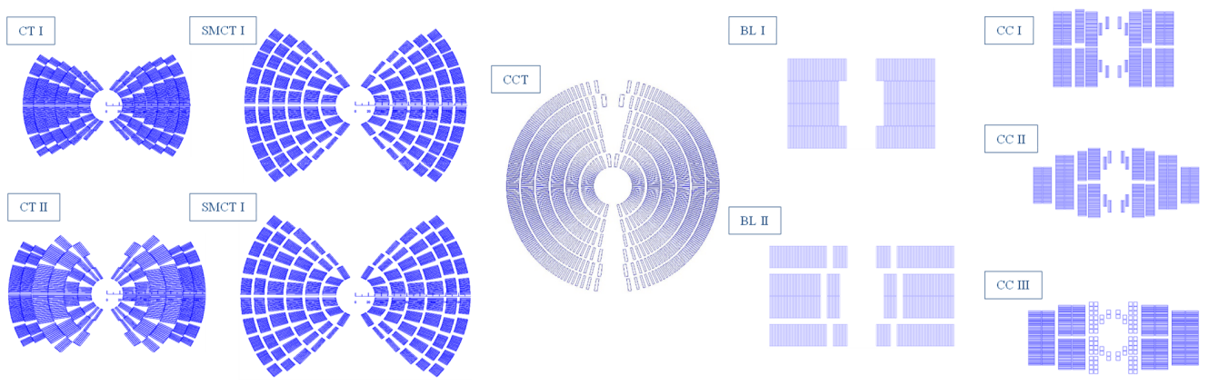
Figure 5.5. Cross-sections of 20 T hybrid dipole coils. The designs use consistent conductor properties but are at different stages of the analysis in terms of field quality, mechanics, and quench protection. From left two right: Cos-theta (CT) design, with 4 (top) and 2 (bottom) layer Bi2212 coils; Stress management Cos-theta (SMCT) design, with 4 (top) and 2 (bottom) layers Bi2212 coils; Canted Cos-theta (CCT) design, with 4-layer Bi2212 coil; Block (BL) design, with and without stress management; Common Coil (CC) design, with Bi2212 (top, with 3 external Nb₃Sn layers, and center, with 5 external Nb₃Sn layers) and REBCO CORC® coils (bottom, with 4 external Nb₃Sn layers). For all the CC designs, only one aperture is shown.
      - Hybrid LTS/HTS model magnets
Hybrid high field dipole models based on different design approaches are being developed at LBNL [x-y] and Fermilab [x1-y1] as part of US MDP [MDP updated plan]. A strategy by which a tape-stack REBCO cable may be configured in a conformal winding in such a way that the favourable 𝑩∥ orientation is sustained everywhere in the winding is presented and discussed in [MCINT]. A dipole geometry is presented in which such a conformal REBCO insert winding is configured within a cable-in-conduit Nb³Sn outsert winding so that the sub-windings can be separately fabricated, and then assembled in a common structure and preloaded for effective stress management. The total cost of superconductor in this dipole is a minimum among the design options for 18 T. Plans for development of the coil technologies and a model dipole are presented. Figure 5.6 shows an example field design for such a dipole. The insert winding consists of a tape-stack cable in which 25 REBCO tapes are stacked face-to-face, and each turn of the cable is oriented closely parallel to the field at that location.
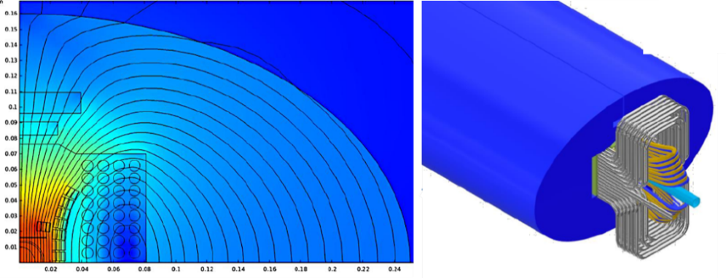
Figure 5.6. TAMU Hybrid dipole models.

      - HTS insert technology R&D plan
The HTS inserts are the key most complicated part of the hybrid magnet design. The plans to develop HTS dipole inserts for high field hybrid magnets are discussed below based on submitted WPs. Technologies of nb3Sn outserts will be produced as a part of Nb₃Sn HFM R&D.
Bi2212 inserts. Bi2212 model magnet R&D program is discussed in {SHEN].: As the only high-temperature superconducting (HTS) material available as an isotropic, twisted, multifilamentary round wire, Bi2212 is very promising for expanding the high-field superconducting accelerator magnet technologies beyond the round-wire, isotropic Nb-Ti and Nb3Sn conductors. The document describes the technology status and define appropriate steps to develop Bi2212 into a practical very high field (>15 T for accelerator magnets, and >25 T for solenoids) magnet technology, from superconductor development, to design and development leading to the construction of model coils and magnets fulfilling accelerator-quality needs for muon or hadron colliders. The first and most relevant target is to develop high-field accelerator dipole magnets capable of generating 16-20 T in a bore of 40-50 mm suitable for colliders. The second target is to develop large-bore, high-field >15 T quadrupole magnets for interaction regions. A third target is to develop 25 T or greater commercial solenoid magnets in collaboration with the US magnet industry and to develop the essential elements of the technology needed to build >30 T solenoids for muon colliders. Given the potential helium shortage, a fourth relevant target is to develop Bi-2212 magnets, both solenoids and accelerator magnets, for other special uses at higher working temperatures (10-25 K). The paper first explains the general challenges to building superconducting accelerator magnets, then moves to describe specific challenges of building Bi-2212 magnets, then describes ongoing research, and finally outlines a ten-year plan with opportunities for collaboration and industry partnerships.
Preliminary data show that Bi-2212 Rutherford cables can show 5% critical current degradation under ~120 MPa transverse pressure [22]. To increase the safety margin, two stress management accelerator magnet concepts have been proposed, the Canted Cosine Theta (CCT) at the LBNL [22-25]and the Stress Management Cosine Theta (SMCT) at the Fermilab [28].
Similar to Nb₃Sn, Bi-2212 magnets are fabricated using a wind and react process. A key advance for Bi2212 since the 2014 P5 is the introduction of the overpressure processing heat treatment, which uses a high-pressure mixed Argon and O₂ (50 bar typically with 98% Ar and 2% O₂) to densify the superconducting filaments and obtain a high wire J_{E}. For single wires a TiO2 coat on the wire and a braided mullite insulation works well but this is not yet working as well for Rutherford cables because an application of a robust TiO₂ has not yet been achieved. The result is some Bi2212 leakage through the encasing metal (Ag or Ag alloy) at high temperatures which can react with surrounding SiO₂-containing insulation [26, 27]. Leakage degrades wire JE because it depletes a portion of filaments and interrupts current flow. Methods to evade these restrictions are under active development.
Nb-Ti and Nb₃Sn magnets are prone to quench due to a low Tc and enthalpy margin. However, it is much easier to spread out the stored energy for Nb-Ti and Nb₃Sn magnets due to fast normal zone propagation velocity [26]. Slow growth of normal zones in HTS magnets makes reliable quench detection critical to reliable quench protection.
To fabricate accelerator magnets of >15 T and solenoids of >25 T, HTS coils are combined with Nb-Ti and Nb3Sn to minimize overall costs. Typical designs use HTS inserts nested concentrically inside Nb-Ti and/or Nb₃Sn outsert magnets, setting up issues of magnet assembly and integration for both accelerator and solenoid magnets given their very different stabilities and quench velocities. This magnet integration will require careful modeling, design, and experimental validation.
The main ring dipole magnets for circular colliders range from 5-15 m long. Scaling the magnet fabrication from ~1 m long demonstration magnets to 5-15 m presents another challenge. The coil reaction will require building heat treatment facilities that are sufficient to handle such long magnets. The magnet stored energy goes up linearly with the magnet length and thus quench protection may become an issue.
Proposed paths to developing Bi2212 for accelerator applications:
- All Bi2212 magnets depend on a stable supply of good conductors with reliable properties. As for Nb-Ti and Nb₃Sn, an essential component of the background R&D is to understand the conductor, especially present limitations on properties so that ongoing collaborations in the university-industry-lab nexus can drive further improvements.
- Use CCT and SMCT Bi2212 designs as R&D vehicles to drive conductor development and accelerator magnet design, technology, and test towards maturity. The goal is to build multiple short (up to 1 m long) dipole model magnets with a bore of 40-50 mm in standalone configuration with incremental dipole field from 5 T to 10 T. Several critical technology elements are to be optimized and developed: a) Master technology knowhow of the reaction of ~1 m long coils and demonstrate reliability. b) Optimize Bi2212 Rutherford cable fabrication including its packing factor and insulation, especially to minimize the contribution of insulation materials to the thermodynamic ceramic leakage.
- In hybrid magnet configuration, fully explore the hybrid magnet technology and its reproducibility. Gain experience with magnet operation and quench protection for the new kind hybrid magnets.
- With technology maturing, build multiple, 1 m long >16 T, series-connected (one power circuit) Nb₃Sn/Bi2212 hybrid accelerator dipole magnets with a projected bore diameter of 40-50 mm. Gain fabrication and operation experience.
- Perform a critical assessment in the feasibility of scaling up accelerator magnets (technologies and infrastructure, etc.) to 5-15 m long.
- For both accelerator and solenoid magnets, explore special uses at higher working temperatures (10-25 K).
- Engage the US superconductor and magnet industry to develop production capabilities for large scale raw materials, wire and cable fabrication, and to reduce cost and supply chain risk.
REBCO inserts. REBCO model magnet R&D plan is discussed in [WANG]. The paper concerns two issues: the ultimate high field to meet the physics needs, and the ultimate low cost. REBCO material has a high irreversibility field with an upper limit of 110 T at 4.2 K and 100 T at 20 K. Such a high irreversibility can allow REBCO magnets to generate a dipole field of at least 20 T over a temperature range of 1.9-20 K. REBCO coated conductors have significant room for cost reduction due to the raw material cost. Operating at elevated temperatures without liquid Helium can be another opportunity that REBCO can offer to further reduce the magnet and collider operation cost.
Although REBCO shows great potential for addressing the high-field and low-cost needs, the challenges to realize the potential are significant for two reasons. First, we know little about REBCO magnet and conductor. Second, we do not have enough conductors to make magnets and to learn in a sufficiently fast pace. We recommend the following:
- Engage REBCO conductor vendors and couple the development of conductor and magnet technology. Use the magnet results as critical feedback to the conductor development that, in turn, can help improve the magnet performance.
- When sufficient funding is available, fast-track the development with the goal to quickly progress on the maximum dipole field a REBCO magnet can generate. Aim for 10 T dipole field within three years and 15 T within five years.
- Collaborate with the fusion magnet community and support the development of REBCO fusion magnet systems.
Two material properties of REBCO exacerbate the situation. First, the ceramic REBCO material is brittle. The REBCO layer can crack, when subject to a tensile strain of around 0.6% and higher, and permanently degrade its current-carrying capability. Bending or twisting the tapes that are necessary to wind coils or making multi-tape cable must not exceed this strain limit. REBCO coated conductors are also weak to withstand a tensile force applied transverse to its broad surface; a stress of several MPa can delaminate the tape and degrade the REBCO layer. Epoxy impregnation can degrade REBCO conductor if the thermal contraction of the epoxy mismatches that of the conductor. Similar mechanical issues appear again during magnet operation when the Lorentz forces become excessive on the conductor. The maximum dipole field a REBCO magnet can generate will likely be determined by the mechanical limit of the conductor. One particular concern from the brittleness of REBCO is the potential performance degradation in conductor and magnet. Such a degradation has been observed in high-current REBCO fusion cable samples.
Second, REBCO coated conductors are only available as a tape with an aspect ratio of at least 10. The tape conductor can be bent, but only as a developable surface with limited exibility. This geometric constraint limits the potential magnet designs that one can work with REBCO conductors. One solution is a round-wire conductor form assembled from multiple tapes, such as CORC® and STAR® wires, both are actively pursued in the U.S. with a strong support from SBIR programs.
High-field dipole magnets require large-current conductors, operating at 10-20 kA, to reduce the magnet inductance and to accelerate current ramping. Various concepts exist for multi-tape REBCO cable for high-field magnets, such as twisted-tape stack, Roebel cable, CORC® and STAR® wires.
CERN developed dipole magnets using a stack of tapes and Roebel cables.
The U.S. MDP is developing dipole magnets using CORC® wires with different magnet concepts. The current maximum dipole field achieved by a REBCO magnet is 5.4 T at 4.2 K in a racetrack magnet from the European EuCARD program and 4.5 T at 4.2 K in a Roebel-cable based magnet from the European EuCARD2 program.
There is a significant technology gap between where we are today and a REBCO high-field dipole magnet. Here are some important questions that need to be addressed for REBCO dipole magnet and conductor technology:
- How to make high-field accelerator magnets using multi-tape REBCO conductor?
- What is the maximum field a REBCO dipole magnet can achieve? What factors limit the maximum dipole field a REBCO magnet and how can we address them? How to develop magnet structures to limit stress on conductors? What is the long-term performance of REBCO magnets under Lorentz loads? Will the performance under strong Lorentz forces degrade the conductor and magnet performance?
- How do REBCO magnets transition from superconducting to normal state and how can we detect the transition?
- What is the field quality of REBCO accelerator magnets?
- What is the required performance for REBCO conductors to achieve the desired magnet performance?
- How to determine the performance of a long multi-tape REBCO conductor for predictable magnet performance?

Diagnostics and testing techniques, technology, advanced modeling.
New diagnostics and testing techniques are providing important insight into magnet behaviour and provide critical feedback to conductor and magnet designers. The main diagnostics and testing technique development plans are discussed in [Marchevsky, 2203.08871], [Baldini, 2203.08309] and [Marchevsky, 2203.08869]. They include:
- Develop a next-generation acoustic emission diagnostic hardware capable of self-calibration to improve disturbance triangulation accuracy and “fingerprinting”;
- Establish fiber-optic based diagnostic capabilities through the use of Fiber Bragg Grating (FBG) and Rayleigh scattering-based sensors;
- Develop new methods for reliable and robust quench detection and localization for HTS magnets and hybrid LTS/HTS magnets using Rayleigh sensors;
- Develop flexible multi-element quench antennas, large-scale Hall sensor arrays and non-rotating field quality probes, aiming at understanding electromagnetic instabilities in LTS magnets and imaging current-sharing patterns in superconducting cables and HTS magnet coils;
- Develop new algorithms for current flow reconstruction and disturbance localizations;
- Apply machine learning and deep learning approaches to process diagnostic data and identify real-time predictors of magnet quenching;
- Develop non-invasive surface and insulation failure detection and localization using electrical reflectometry, to protect magnets due to unexpected defects on the surface or insulation;
- Develop cryogenic digital and analog electronics to facilitate, simplify and improve reliability of diagnostic instrumentation by enabling pre-processing of magnet diagnostic data in the cryogenic environment.
A number of potential techniques and technologies aiming to affect magnet parameters and performance need to be further investigated including a) the development of high-Cp conductor and insulation that can lead to conductors and coils with optimized characteristics enabling stable operation against perturbations; b) artificially increasing the coil current during a quench by discharging a large capacitor at quench detection; c) using diffuse field ultrasonic techniques to enable targeted delivery of vibrational excitation to the conductor, for a non-invasive structural local probing of SC coils; d) development of composite and structural magnet components, with a specific focus on the characterisation of insulation systems (polymers and reinforcement) for both Nb₃Sn and HTS magnets; e) thermal management of high field magnets including internal heat transfer, heat transfer to coolant, and external heat transfer to cryoplant.
Advances in modeling are providing more detailed insight into stress and strain states in magnets, including full 3D effects and complex nonlinear material and interface behaviour. An analysis of the data acquired by the diverse diagnostic tools and advance modeling is the key to guide the potential techniques to affect magnet performance. A diverse and challenging set of new modeling tools are required to continue this effort and ultimately improve design time, cost, and performance of future superconducting accelerator magnets. The new developments include simulation and advanced modeling of a) conductors and cables, b) interfaces and other potential sources of training in stress-managed designs, c) LTS/HTS hybrid magnets, and d) radiation-induced thermal effects on magnets in synergies with the broader Accelerator Modeling community [Biedron 2203.08335 ].

Test infrastructure
The development of novel SC magnet technology at the high-field frontier requires specialised infrastructure, often of large size. The necessary investment is considerable, so the effort should extend across national and international labs. New test facility will be available at Fermilab within next 3-5 years.

Technologies for Detector Magnets
The main development item for the future detector solenoid is Al stabilized superconducting cable with both higher strength and high RRR. The most likely solution is a combination of technologies used in ATLAS-CS (reinforcement of the aluminum stabilizer, with Ni doping and simultaneous cold-work hardening) and CMS (reinforcement by pure-aluminum stabilized conductor and high strength aluminum alloy, which are mechanically bonded by electron beam welding). By combining these approaches, a (0.2%) yield strength of more than 300 MPa might be expected [R4-26]. Examples of designs under consideration for future detectors are described in the next section.
Future detectors will also take advantage of technologies such as: coil winding inside the outer shell; indirect cooling to reduce materials used in magnet structure; pure aluminum strips as temperature equalizer in the steady operation and fast quench propagation; light-weight and high transparency vacuum vessels. [R4-25].
High temperature superconductors are also of great interest to reduce cryogenics power consumption of detector magnets.
While solenoids have been prevalent in past detectors, other types of magnets, such as split coil and saddle shape coil, could be candidates depending on the requirements from a physics viewpoint [R4-27].
Solenoids for mid-scale experiments often do not need the development of unique conductor, but instead, precise control of magnetic field distribution might be required using high precision simulation and coil fabrication technology to meet tight tolerances [R4-28].

Aluminum stabilized superconductor and superconducting coil
Aluminum-stabilized superconducting conductors have benefitted from a number of improvements over the last four decades, in particular to improve their mechanical strength. The evolution of conductors is summarized in Figure 5.7. One approach has been to provide homogeneous reinforcement of the stabilizer itself; the other was to work with a hybrid configuration of soft high conductivity material with a strong alloy.
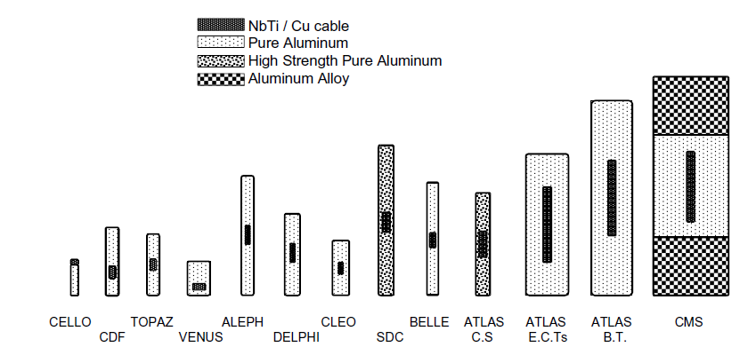
Figure 5.7. Evolution of conductors for detector magnets. From left to right: CELLO, CDF, ALEPH, ATLAS-CS, -BT and CMS.
It was found that nickel additive effectively contributes to mechanical strength while keeping a reasonably low electrical resistivity in the aluminum. The strength of the aluminum stabilizer has become comparable with that of copper, while maintaining its high RRR and the all-important advantage of lightness. The conductor clad with reinforced 0.5 % Ni aluminum stabilizer provides a 30% reduction in the thickness of the ATLAS central solenoid compared to a conductor using a pure aluminum stabilizer [R4-18], [R4-19].
For the CMS solenoid a hybrid configuration was developed, consisting of a combination of pure aluminum stabilized superconductor with high strength aluminum alloy blocks attached to both sides by electron-beam welding. It allows a hoop strain of 0.15 % induced by a hoop stress of 105 MPa, and it is an essential feature in order to achieve a 4 T solenoid field. However, in this approach the Lorentz force acting on the superconductor needs to be reacted by the soft pure Aluminum. At fields greater than 4 T that are being considered for future detectors, it is envisaged to combine the two approaches to reinforcement, co-extruding the conductor with the micro-alloyed material followed by electron beam welding (EBW) of the tough alloy flanges [R4-19].

Winding technique to support cylinder and indirect/conduction cooling
Solenoid coils were traditionally wound to the outside of a thick mandrel/bobbin with sufficient tension to ensure compressive prestress and avoid separation of the coil from the inner-bobbin due to hoop stress during coil excitation. More recent designs have used the opposite approach, where the conductor is wound inside a support cylinder. In this case, the inner support is eliminated and hoop forces cause the winding to go in compression, ensuring good thermal conductivity and opening the possibility of indirect cooling from pipes placed on the outer surface of the support cylinder [R4-1], [R4-9], [R4-10], [R4-13], [R4-14].

E/M ratio and transparency
A high ratio of stored energy to effective coil cold mass (E/M ratio) is required to maximize transparency and acceptance [R4-1][R4-19]. The development of high strength aluminum stabilizer allowed doubling the E/M ratio from ~5kJ/kg to 10-13 kJ/kg while retaining a low engineering current density as required to limit the maximum temperature in case of a quench (SDC prototype, CMS and BESS prototype)

Thermal stabilization and fast quench propagation by using pure-Al strips
The use of pure-Al strips placed along the inner bore of the magnet has been demonstrated to bypass the turn-to-turn electrical insulation and increase the axial quench propagation velocity by up to an order of magnitude. lowering the peak temperature after the quench [R4-14], [R4-16], [R4-17], [R4-21]. Absorbing a larger fraction of the stored energy inside the coil also allows to be less dependent on energy extraction providing a more robust and redundant protection system. A benefit of the quench protection strips is that they are fully passive, and they work even in case of a detection delay or extraction failure.

Transparent vacuum vessel
The outer vacuum vessel needs to withstand large buckling forces due to the external pressure. In order to minimize the material in the vacuum vessel as well as in the cold mass, a brazed honeycomb vacuum vessel has been investigated for the SDC solenoid at SSC [R4-21], [R4-22]. The honeycomb plate has high stiffness coupled to light weight, allows welding, and provides high reliability since no epoxy resin is used. An alternative approach to transparent vacuum vessel is the aluminum isogrid shell. Aluminum isogrid shells are typically fabricated in steps: the grid pattern is first CNC machined in flat plates, then the flat plates are formed on a press brake into cylindrical sections which are welded to make up the shell, as shown in Fig. 2.7 [R4-7], [R4-21].
Table 5.2 summarizes the transparency comparison with solid, Al-honeycomb, and isogrid outer-vacuum vessel/wall, evaluated in the SSC-SDC detector solenoid R&D work [R4-12].
Table 5.2 Comparisons of outer vacuum vessel/wall options considered for the SSC-SDC detector solenoid.
Type | Unit | Solid | Isogrid | Honeycomb
Al alloy |  | 5083 | 5083-H32 | 6951/4045-T6
# shells to be assembled |  | 12 | 12 | 21
Physical wall-thickness | mm | 27 | 46 | 46
Skin wall-thickness | mm | (27) | 4.0 | 3.0+3.0
Effective thickness (averaged) | mm | 27 | 11 | 7
Weigh reduction ratio |  | 1 | 0.4 | 0.26
Radiation thickness X0 |  | 0.303 | 0.123 | 0.079
Isogrid and honeycomb technologies may also be used in combination to best exploit their respective advantages and compose a light weight and transparent vacuum vessel Further effort for an ultimately transparent vacuum vessel/wall has been made by using plastic material such as Carbon/Glass-Fiber-Reinforced-Plastic (CFRP/GFRP). An effort was the CFRP outer vacuum vessel for the TRISTAN-VENUS detector solenoid [R4-7]. The effort has been progressed according to the reinforced plastic technology advances, and the technology is considered for future detector solenoids [R4-24], [R4-25].

Conclusions
The “Snowmass” community exercise started in April 2020 to help define the US HEP priorities in the coming decades. Following a series of meetings to introduce the program goals and process, the submission of Letters of Interest (LoI) from the community were solicited. By October 2020, the Magnet topical group had received a total of 50 LoI which were subdivided in 6 groups: Regional Plans (8 LoI), Conductor (16 LoI), High Field Magnet Development (9 LoI), Magnet Technologies (8 LoI), Detector Magnets (4 LoI) and Special Magnets (5 LoI). Because of the coronavirus pandemic, a pause was decided in January 2021. The process resumed in fall 2021 with a call for White Papers describing technical progress and opportunities in specific areas, as well as recommended plans and priorities for the next decade. In March 2022, the Magnet topical group received 20 White Papers which were used as a basis for this summary report.
This report summarizes the status of accelerator and detector magnet technologies and discuss ideas and plans to push this key area of the US and international HEP to the new horizons. …

References

Section 1 and 2 References

[MWP1] S. Prestemon et al., “A Strategic Approach to Advance Magnet Technology for Next Generation Colliders”, arXiv:2203.13985 [physics.acc-ph] (pdf)
[MWP G. Apollinari et al. ”A Strategic Approach to Advance Magnet Technology for Next Generation Colliders”, arXiv:2203.13985 [physics.acc-ph] (pdf).
[MWP2] G. Ambrosio, G. Apollinari, M. Baldini, R. Carcagno, C. Boffo, et al. ”Leading-Edge technology And Feasibility-directed (LEAF) Program aimed at readiness demonstration for Energy Frontier Circular Colliders by the next decade”, arXiv:2203.07654 [physics.acc-ph] (pdf).
[MWP3] Giorgio Ambrosio, Giorgio Apollinari, Vito Lombardo, Stoyan Stoynev, Mauricio Suarez, George Velev, Paolo Ferracin, Soren Prestemon, GianLuca Sabbi . “Development and demonstration of next generation technology for Nb_3Sn accelerator magnets with lower cost, improved performance uniformity, and higher operating point in the 12-14 T range”, arXiv:2203.07352 [physics.acc-ph] (pdf).
[MWP4] Pierre Védrine, et al. ”High Field Magnet Development for HEP in Europe : A Proposal from LDG HFM Expert Panel”, arXiv:2203.08054 [physics.acc-ph] (pdf).
[MWP5] L. Bottura, et al. ”A Work Proposal for a Collaborative Study of Magnet Technology for a Future Muon Collider”, arXiv:2203.13998 [physics.acc-ph] (pdf).
[MWP6] Toru Ogitsu, Tatsushi Nakamoto, Ken-ichi Sasaki, Michinaka Sugano, Masami Iio, Kento Suzuki, Makoto Yoshida, Satoshi Awaji, Naoyuki Amemiya. ”R&D works for Superconducting Magnet for Future Accelerator Applications in Japan”, arXiv:2203.12118 [physics.acc-ph] (pdf).
[MWP7] F. Kametani, C. Tarantini, E. Hellstrom. ”Fe-based high field superconductors for cost-effective future accelerator magnets”, arXiv:2203.07551 [cond-mat.supr-con] (pdf).
[MWP8] Cooley, Superconductor white paper, TBD
[MWP9] Yu. I. Alexahin, E. Barzi, E. Gianfelice-Wendt, V. Kapin, V. V. Kashikhin, N. V. Mokhov, I. Novitski, V. Shiltsev, S. Striganov, I. Tropin, A. V. Zlobin. ”Critical problems of energy frontier Muon Colliders: Optics, Magnets and Radiation”, arXiv:2203.10431 [physics.acc-ph] (pdf).
[MWP10] Yu. Alexahin, E. Gianfelice-Wendt, V. Kapin, V. V. Kashikhin, N. V. Mokhov, S. I. Striganov, I. S. Tropin, A. V. Zlobin. ”Solving Critical Problems of the Muon Collider Higgs Factory: Optics, Magnets and their Protection, Detector Backgrounds“, arXiv:2203.09010 [physics.acc-ph] (pdf).
[MWP11] Xiaorong Wang , Anis Ben Yahia , Ernesto Bosque , Paolo Ferracin , Stephen Gourlay, et al. ”REBCO – a silver bullet for our next high-field magnet and collider budget?”, arXiv:2203.08736 [physics.acc-ph] (pdf).
[MWP12] Ramesh Gupta, Kathleen Amm, Julien Avronsart, Michael Anerella, Anis Ben Yahia, et al. ”Common Coil Dipole for High Field Magnet Design and R&D”, arXiv:2203.08750 [physics.acc-ph] (pdf).
[MWP13] T. Shen, A.V. Zlobin, D. Larbalestier. ”High Temperature Superconducting Bi-2212 Magnets for Energy Frontier Circular Colliders“, arXiv:2203.10564 [physics.acc-ph] (pdf).
[MWP14] Peter M McIntyre, “Hybrid conformal REBCO dipole for a next hadron collider,” https://arxiv.org/ftp/arxiv/papers/2203/2203.08132.pdf
[MWP15] Maria Baldini, Giorgio Ambrosio, Paolo Ferracin, Piyush Joshi, S. Krave, Linqing Luo, Maxim Marchevsky, G. Vallone, Xiaorong Wang. ”Fiber-optic diagnostic system for future accelerator magnets”, arXiv:2203.08309 [physics.acc-ph] (pdf).
[MWP16] Stoyan Stoynev. ”Test samples and infrastructure for accelerator magnet developments”, arXiv:2203.07274 [physics.acc-ph] (pdf).
[MWP17] M. Marchevsky, R. Teyber, G. S. Lee, M. Turqueti, M. Baldini, et al. ”Advancing Superconducting Magnet Diagnostics for Future Colliders“, arXiv:2203.08869 [physics.acc-ph] (pdf).
[MWP18] Maxim Marchevsky. ”Understanding training in superconducting accelerator magnets using acoustic emission diagnostics”, arXiv:2203.08871 [physics.acc-ph] (pdf).
[MWP19] Matthias Mentink, Ken-ichi Sasaki, Benoit Cure, Nikkie Deelen, Alexey Dudarev, et al. ”Superconducting detector magnets for high energy physics“, arXiv:2203.07799 [physics.ins-det] (pdf).
[MWP20] Henryk Piekarz, Bradley Claypool, Steven Hays, Matthew Kufer, Vladimir Shiltsev, Alexander Zlobin, Lucio Rossi. ”Fast cycling HTS based superconducting accelerator magnets: Feasibility study and readiness demonstration program driven by neutrino physics and muon collider needs”, arXiv:2203.06253 [physics.acc-ph] (pdf).
[R1-1] A. Yamamoto and Y. Makida, “Advances in superconducting magnets for high energy and astroparticle physics,” Nucl. Instrum. Meth. A, vol. 494, pp. 255–265, 2002.

[R1-2] M. Morpurgo, “Design and construction of a superconducting aluminum stabilized solenoid,” Cryogenics, Vol. 17, 1977.

[R1-3] H. Desportes et al., “Construction and Test of the Cello Thin-Wall Solenoid,” Adv. Cryog. Eng., Vol. 25, p175, 1980.

[R1-4] M. A. Green, “The role of quench back in quench protection of a superconducting solenoid,” Cryogenics, Vol. 24, pp. 659, 1984.

[R1-5] H. Minemura et al., “Construction and testing of a 3 m diameter x 5 m superconducting solenoid for the Fermilab collider detector facility (CDF),” Nucl. Instru. And Meth. A, Vol. 238, pp 18-34, 1985.

[R1-6] Xu et al., Conceptual design study of iron-based superconducting dipole magnets for SPPC, International Journal of Modern Physics A, 34(13), April 2019.

[SNM2013] N. Graf, M. Peskin, J. Rosner (ed.), “Proceedings, 2013 Community Summer Study on the Future of US Particle Physics: Snowmass on the Mississippi, 2013.

[Strait2003] S. J. Strait et al., Proc. 20th Particle Accelerator Conf. (PAC 2003), Portland, OR, USA, May 2003, Paper MOPA006, pp. 42-44

[S2R1] G. Apollinari, R. Carcagno, G. Ambrosio, S. Feher, L. Ristori, “US contribution to the High Luminosity LHC Upgrade”, J. Phys. Conf. Ser. 1350 (2019) 1, 012005
[Caspi2014] S Caspi et al. “A Concept for High Field Accelerator Magnets", IEEE Transactions on Applied Superconductivity 24.3 (2014). doi: 10.1109/tasc.2013.2284722.
[Zlobin2018] A.V. Zlobin, V. V. Kashikhin, and I. Novitski, Large aperture high field Nb3Sn dipole magnets”, 9th International Particle Accelerator Conference. doi: 10.18429/jacow-ipac2018-wepml026.

Section 3 References

[BOT] L. Bottura et al., A Work Proposal for a Collaborative Study of Magnet Technology for a Future Muon Collider,“ https://arxiv.org/ftp/arxiv/papers/2203/2203.13998.pdf
[PAL-14] R.B. Palmer, “Muon Colliders”, RAST, Vol. 7, p. 137 (2014).
[PAL-15] M.A. Palmer, “The US Muon Accelerator Program,” https://arxiv.org/ftp/arxiv/papers/1502/1502.03454.pdf
[PIEK] H. Piekarz et al., “Fast cycling HTS based superconducting accelerator magnets: Feasibility study and readiness demonstration program driven by neutrino physics and muon collider needs,” https://arxiv.org/ftp/arxiv/papers/2203/2203.06253.pdf
[ALE-1] HE MC SR and IR: Yu. I. Alexahin et al., “Critical problems of energy frontier Muon Colliders: optics, magnets and radiation,” https://arxiv.org/ftp/arxiv/papers/2203/2203.10431.pdf
[ALE-2] HF SR and IR: Yu. Alexahin et al., “Solving Critical Problems of the Muon Collider Higgs Factory: Optics, Magnets and their Protection, Detector Backgrounds,” https://arxiv.org/ftp/arxiv/papers/2203/2203.09010.pdf
[3.1.1] Future Circular Collider Study. Volume 3: The Hadron Collider (FCC-hh) Conceptual Design Report, preprint edited by M. Benedikt et al. CERN accelerator reports, CERN-ACC-2018-0058, Geneva, December 2018. Published in Eur. Phys. J. ST.
[3.1.2] Future Circular Collider Study. Volume 4: The High Energy LHC (HE-LHC) Conceptual Design Report, preprint edited by F. Zimmermann et al. CERN accelerator reports, CERN-ACC-2018-0059, Geneva, December 2018. Published in Eur. Phys. J. ST.
[3.1.3] D. Tommasini et al., "Status of the 16 T Dipole Development Program for a Future Hadron Collider," in IEEE TAS, vol. 28, no. 3, pp. 1-5, April 2018, Art no. 4001305, doi: 10.1109/TASC.2017.2780045.
[3.1.4] V. Marinozzi et al., "Conceptual Design of a 16 T cos θ Bending Dipole for the Future Circular Collider," in IEEE Transactions on Applied Superconductivity, vol. 28, no. 3, pp. 1-5, April 2018, Art no. 4004205, doi: 10.1109/TASC.2018.2795533.
[3.1.5] C. Pes et al., Magnetic and Mechanical Design of the Block-coil Dipole Option for the Future Circular Collider, Presented at the ASC, Seattle, USA (2018) 167.
[3.1.6] F. Toral, Magnetic and mechanical design of a 16 T common coil dipole for FCC, FCC Week (2018) https://indico.cern.ch/event/656491/contributions/2920132/attachments/1629665/2597178/FCCweek2018_common_coil_ftoral.pdf 168.
[3.1.7] B. Auchmann, L. Brouwer, S. Caspi, J. Gao, G. Montenero, M. Negrazus, G. Rolando, S. Sanfilippo, IEEE Trans. Appl. SC 28, 1 (April, 2018)
[3.1.8] C. Genot et al., "FCC-hh Conceptual Designs and Windability of the Main Quadrupoles," in IEEE Transactions on Applied Superconductivity, vol. 31, no. 2, pp. 1-7, March 2021, Art no. 4000107, doi: 10.1109/TASC.2020.3045876.
[3.1.9] A. Louzguiti et al., "Optimization of the Electromagnetic Design of the FCC Sextupoles and Octupoles," in IEEE Transactions on Applied Superconductivity, vol. 29, no. 5, pp. 1-5, Aug. 2019, Art no. 4000805, doi: 10.1109/TASC.2019.2892839.
[3.3.1] Future Circular Collider Study. Volume 2: The Lepton Collider (FCC-ee) Conceptual Design Report, preprint edited by M. Benedikt et al. CERN accelerator reports, CERN-ACC-2018-0057, Geneva, December 2018. Published in Eur. Phys. J. ST.https://link.springer.com/content/pdf/10.1140/epjst/e2019-900045-4.pdf
[3.3.2] CEPC-SPPC Preliminary Conceptual Design Report. 2. Accelerator; IHEP-CEPC-DR-2015-01 https://inspirehep.net/files/f7ee2a25def72c5431deb795ff049e8a

Section 4 References

[R4-1] A. Yamamoto and Y. Makida, “Advances in superconducting magnets for high energy and astroparticle physics,” Nucl. Instrum. Meth. A, vol. 494, pp. 255–265, 2002.
[R4-2] M. Morpurgo, “Design and construction of a superconducting aluminum stabilized solenoid,” Cryogenics, Vol. 17, 1977.
[R4-3] H. Desportes et al., “Construction and Test of the Cello Thin-Wall Solenoid,” Adv. Cryog. Eng., Vol. 25, p175, 1980.
[R4-4] M. A. Green, “The role of quench back in quench protection of a superconducting solenoid,” Cryogenics, Vol. 24, pp. 659, 1984.
[R4-5] H. Minemura et al., “Construction and testing of a 3 m diameter x 5 m superconducting solenoid for the Fermilab collider detector facility (CDF),” Nucl. Instru. And Meth. A, Vol. 238, pp 18-34, 1985.
[R4-6] A. Yamamoto et al., “Performance of the TOPAZ Thin Superconducting Solenoid Wound with Internal Winding Method,” Jpn. J. Appl. Phys., Vol. 25, pp. 440-442 (1986).
[R4-7] A. Arai, M. Wake et al., “Test operations of the VENUS superconducting magnet at KEK”, Nucl. Instr. & Meth. A, Vol. 254, pp.317, 1987.
[R4-8] J. M. Baze et al., “Design, construction and test of the large superconducting solenoid ALEPH,” IEEE Trans. Magn. Vol. 24, pp. 126, 1988.
[R4-9] E. Baynham et al., “Towards the Realization of Two 1.2 Tesla Superconducting Solenoids for Particle Physics Experiments,” Proceedings of 11th International Conference on Magnet Technology, pp. 206-211, 1989.
[R4-10] A. Bonito et al., “Zeus Thin Solenoid: Test Results Analysis,” IEEE Trans. Magn. Vol. 27, pp. 1954, 1991.
[R4-11] C. Monroe et al., “The CLEO II Magnet – Design, Manufacture and Tests,“ Proceedings of the 12th International conference on Cryog. Eng. Conference, Southampton, pp. 773, 1988.
[R4-12] A. Yamamoto et al., " Development of a prototype thin superconducting solenoid magnet for the SDC detector," IEEE Trans. Appl. Supercond., Vol. 5, pp.849-852, 1995.
[R4-13] L. M. Barkov et al., “Superconducting rectifier fluxpump for magnet system of the CMD-2 detector,” IEEE Trans. Appl. Supercond., Vol. 9, pp. 4585-4590, 1999.
[R4-14] A. Yamamoto et al., “Progress in ATLAS Central Solenoid Magnet,” IEEE Trans. Appl. Supercond., Vol. 10, pp. 353-356, 2000.
[R4-15] H. Herve et al., “Status of the construction of the CMS magnet,”, IEEE Trans. Appl. Supercond. Vol. 14, pp. 542-547, 2004.
[R4-16] Y. Makida et al., “The BESS-Polar Ultra-Thin Superconducting Solenoid Magnet and Its Operational Characteristics During Long-Duration Scientific Ballooning Over Antarctica,” IEEE Trans. Appl. Supercond. Vol. 19, pp. 1315-1318, 2009.
[R4-17] A. Yamamoto et al., " Development towards ultra-thin superconducting solenoid magnets for high energy particle detectors," Nuclear Physics B (Proc. Supplements), Vol. 78, pp.565-570, 1999.
[R4-18] K. Wada et al., “Development of high-strength and high-RRR aluminum-stabilized superconductor for the ATLAS thin solenoid,” IEEE Trans. Appl. Supercond., vol. 10, no. 1, pp. 373-376, March 2000, doi: 10.1109/77.828251.
[R4-19] A. Yamamoto and T. Taylor, “Superconducting magnet for particle detectors and fusion devices”, Rev. of Acc. Science and Technology (RAST), Vol. 5 pp91-118, 2012.
[R4-20] M. Wilson, “Superconducting Magnet” Oxford Science Publishing, IBBN 0-19-85-4810-K, P.200~. 19883.
[R4-21] A. Yamamoto et al., " Development of a prototype thin superconducting solenoid magnet for the SDC detector," IEEE Trans. Appl. Supercond., Vol. 5, pp.849-852, 1995.
[R4-22] H. Yamaoka, A. Yamamoto, Y. Makida, K. Tanaka, T. Kondo,” Development of a brazed aluminum honeycomb vacuum vessel for a thin superconducting solenoid magnet”, Advances Cryogenic Engineering, Vol. 39 (1994) 1983-1990.
[R4-23] R. W. Fast, C. P. Grozis, A. Lee, and R. H. Wands, “Isogrid Vacuum Shell for Large Superconducting Solenoid”, Advances in Cryogenic Engineering, Vol. 39., pp. 1991-1998.
[R4-24] N. Cure et al., private communication.
[R4-25] M. Gonzalez et al., “Low mass cryostat for HEP experiments,” CERN EP R&D report 2021, https://cds.cern.ch/record/2764386#
[R4-26] S. Sgobba et al., “Toward an Improved High Strength, High RRR CMS Conductor,” IEEE Trans. Appl. Supercond., vol. 16, pp. 521–524, 2006.
[R4-27] “Strategic R&D Programme on Technoogies for Future Experiments,” CERN Experimental Physics Department, Annual Report 2020, CERN-EP-RDET-2021-001.
[R4-28] T. Ogitsu et al., “R&D works for Superconducting Magnet for Future Accelerator Applications in Japan,” Proceedings of SNOWMASS 2021.
[R4-29] M. Benedikt et al. , “Future Circular Colliders,” Ann. Rev. Nucl. Part. Sci. , vol. 69, pp. 389– 415, 2019. [R4-30] O. S. Bruning, P. Collier, P. Lebrun, S. Myers, R. Ostojic, J. Poole, and P. Proudlock, “LHC Design Report Vol.1: The LHC Main Ring,” CERN Yellow Reports, 6 2004.
[R4-31] G. F. Giudice, Ed., Fifty years of research at CERN: From past to future. Proceedings, Academic Training, Geneva, Switzerland, September 13-16, 2004 , ser. CERN Yellow Reports: Monographs, 2006.
[R4-32] A. Abada et al., “FCC-ee: The Lepton Collider: Future Circular Collider Conceptual Design Report Volume 2,” Eur. Phys. J. ST, vol. 228, no. 2, pp. 261–623, 2019.
[R4-33] M. Antonello, “IDEA: A detector concept for future leptonic colliders,” Nuovo Cim. C , vol. 43, no. 2-3, p. 27, 2020.
[R4-34] N. Alipour Tehrani et al., “CLICdet: The post-CDR CLIC detector model,” CLICdp-Note- 2017-001. Revised 2019.
[R4-35] A. Yamamoto et al., “The ATLAS central solenoid,” Nucl. Instrum. Meth. A, vol. 584, pp. 53–74, 2008.
[R4-36] A. Herve, “Construction a 4-Tesla large thin solenoid at the limit of what can be safely operated,” Mod. Phys. Lett. A, vol. 25, pp. 1647–1666, 2010.
[R4-37] N. Deelen et al., “Design and Quench analysis of superconducting solenoids for the lepton Future Circular Collider,” IEEE Trans. Appl. Supercond., vol. 32, no. 6, pp. 1-4, Sept. 2022, Art no. 4100204, doi: 10.1109/TASC.2022.3149682.
[R4-38] A. Yamamoto et al., “A thin superconducting solenoid magnet for particle astrophysics,” IEEE Trans. Appl. Supercond., vol. 12, no. 1, pp. 438–442, 2002.
[R4-39] S. Sgobba, C. D’Urzo, P. Fabbricatore, and S. Sequeira Tavares, “Mechanical performance at cryogenic temperature of the modules of the external cylinder of CMS and quality controls applied during their fabrication,” IEEE Trans. Appl. Supercond., vol. 14, no. 2, pp. 556–559, 2004.
[R4-40] A. Perin, R. Macias Jareno, and L. Metral, “Study of materials and adhesives for superconducting cable feedthroughs,” AIP Conf. Proc., vol. 613, pp. 551–558, 2002.
[R4-41] “FCC-hh: The Hadron Collider”, EUR. Phys. J. Special Topics 228, p. 755-1107 (2019)
[R4-42] M. Mentink, H. Silva, A. Dudarev, E. Bielert, V. Klyukhin, B. Cure, H. Gerwig, A. Gaddi, C. Berriaud, U. Wagner, and H. ten Kate, “Evolution of the Conceptual FCC-hh Baseline Detector Magnet Design”, IEEE Trans. On Appl. Supercond. 28, p. 4002710 (2018)
[R4-43] The Compact Linear Collider (CLIC) – 2018 Summary Report, edited by P.N. Burrows, N. Catalan Lasheras, L. Linssen, M. Petriˇc, A. Robson, D. Schulte, E. Sicking, S. Stapnes, CERN Yellow Reports: Monographs, Vol. 2/2018, CERN-2018-005-M (CERN, Geneva, 2018). https//doi.org/10.23731/CYRM-2018-002
[R4-44] A. Robson, P.N. Burrows, N. Catalan Lasheras, L. Linssen, M. Petric, D. Schulte, E. Sicking, S. Stapnes, W. Wuensch. The Compact Linear e+e− Collider (CLIC): Accelerator and Detector. 2018. arXiv:1812.07987v1 [R4-physics.acc-ph]
[R4-45] Vera Cilento, Rogelio Tomás, Benoit Cure, Angeles Faus-Golfe, Barbara Dalena, and Yngve Levinsen. Dual beam delivery system serving two interaction regions for the Compact Linear Collider. Phys. Rev. Accel. Beams 24, 071001 (2021).
[R4-46] CMS Collaboration. CMS, the magnet project: Technical design report. CERN-LHCC-97-10. May 1997.
[R4-47] ATLAS Collaboration. ATLAS central solenoid : Technical Design Report. CERN-LHCC- 97-021; ATLAS-TDR-9. April 1997.
[R4-48] B. Cure, B. Blau, A. Herve, P. Riboni, S. S. Tavares and S. Sgobba, “Mechanical properties of the CMS conductor,” IEEE Trans. Appl. Supercond., vol. 14, no. 2, pp. 530-533, June 2004, doi: 10.1109/TASC.2004.829712.
[R4-49] S.A.E. Langeslag , B. Cure, S. Sgobba, A. Dudarev, H.H.J. ten Kate, J. Neuenschwander and I. Jerjen. “Effect of thermo-mechanical processing on the material properties at low temperature of a large size Al-Ni stabilized Nb-Ti/Cu superconducting cable,” Advances in Cryogenic Engineering, AIP Conf. Proc. 1574, 211-218 (2014); doi: 10.1063/1.4860626
[R4-50] K. Wada, S. Meguro, H. Sakamoto, A. Yamamoto and Y. Makida, “High-strength and high- RRR Al-Ni alloy for aluminum-stabilized superconductor,” IEEE Trans. Appl. Supercond., vol. 10, no. 1, pp. 1012-1015, March 2000, doi: 10.1109/77.828403.
[R4-51] B. Cure and I. Horvath, “Developments of electrical joints for aluminum-stabilized superconducting cables,” IEEE Trans. Appl. Supercond., vol. 9, no. 2, pp. 197-200, June 1999, doi: 10.1109/77.783270.
[R4-52] S. Farinon, P. Chesny, B. Cure, P. Fabbricatore, M. Greco and R. Musenich,"Electrical joints in the CMS superconducting magnet,” IEEE Trans. Appl. Supercond., vol. 12, no. 1, pp. 462-464, March 2002, doi: 10.1109/TASC.2002.1018443.
[R4-53] Physics and Detectors at CLIC: CLIC Conceptual Design Report edited by L. Linssen, A. Miyamoto, M. Stanitzki, H. Weerts, CERN–2012–003. ISBN 978–92–9083–372-7.
[R4-54] Ballarino, Amalia. (2007). HTS Current Leads: Performance Overview in Different Operating Modes. Applied Superconductivity, IEEE Transactions on. 17. 2282 - 2285.10.1109/TASC.2007.898448.
[R4-55] Chen, Xiao-Yuan & Jin, Jianxun & Liu, Jie & Ren, Hongtao & Xiang, Tianfa. (2009). Development and Techniques of High Current Leads for HTS Device Applications. 2009 International Conference on Applied Superconductivity and Electromagnetic Devices, ASEMD 2009. 34-41. 10.1109/ASEMD.2009.5306700.
[R4-56] Amalia Ballarino 2014 Supercond. Sci. Technol. 27 044024
[R4-57] K. Konstantopoulou, J. Hurte, J. Fleiter and A. Ballarino, "Electro-Magnetic Performance of MgB2 Cables for the High Current Transmission Lines at CERN," IEEE Trans. Appl. Supercond., vol. 29, no. 5, pp. 1-5, Aug. 2019, Art no. 4802205, doi: 10.1109/TASC.2019.2901885.
[R4-58] ILC, ILD Detector, https://arxiv.org/abs/1912.04601
[R4-59] ILC ILD Detector: SnowMass 2020, report.
[R4-60] F. Kircher et. al, “Conceptual design of the ILD detector magnet system”, LC-DET-2018-081
[R4-61] Updating the SiD detector concept. https://arxiv.org/abs/2110.09965.
[R4-62] R. P. Smith and R. H. Wands, “A five tesla solenoid with detector integrated dipole for the silicon detector at the international linear collider,” IEEE Trans. Appl. Supercond., Vol 16, No. 2, 2006.
[R4-63] “SiD Letter of Intent” edited by H. Aihara, P. Burrows, M. Oreglia, 2009. https://insprehep.net/literature/835665
[R4-64] M. Yoshida et al., “Status of Superconducting Solenoid System for COMET Phase-I Experiment at J-PARC,” IEEE Trans. Appl. Supercond., Vol. 25, 4500904, 2015.
[R4-65] Y. Yang et al., “Study of Irradiation Effects on Thermal Characteristics for COMET Pion Capture Solenoid”, IEEE Trans. On Appl. Supercond., Vol 28, 4001405, 2018
[R4-66] M. Abe et al., “Coil Block Designs with Good Homogeneity for MRI Magnets Based on SVD Eigenmode Strength," IEEE trans. Magn. Vol. 51, 7002713 (2015)
[R4-67] H. Yamaguchi et al., “Development of a CW-NMR Probe for Precise Measurement of Absolute Magnetic Field," IEEE Trans. App. Supercond., Vol. 29, 9000904 (2019).

Section 5 References
[COO] Lance Cooley et al., “Challenges and opportunities to assure future manufacturing of magnet conductors for the accelerator sector,” to be submitted
[KAM]: F. Kametani et al., “Fe-based high field superconductors for cost-effective future accelerator magnets,” https://arxiv.org/ftp/arxiv/papers/2203/2203.07551.pdf
[SHEN] T. Shen et al., “White Paper on High Temperature Superconducting Bi-2212 Magnets for Energy Frontier Circular Colliders,” https://arxiv.org/ftp/arxiv/papers/2203/2203.10564.pdf
[WANG] X. Wang et al., “REBCO - a silver bullet for our next high-field magnet and collider budget?”, https://arxiv.org/pdf/2203.08736.pdf
[MCINT] Peter M McIntyre, “Hybrid conformal REBCO dipole for a next hadron collider,” https://arxiv.org/ftp/arxiv/papers/2203/2203.08132.pdf
[1] A. Yamamoto and Y. Makida, “Advances in superconducting magnets for high energy and astroparticle physics,” Nucl. Instrum. Meth. A, vol. 494, pp. 255–265, 2002.
[2] M. Morpurgo, “Design and construction of a superconducting aluminum stabilized solenoid,” Cryogenics, Vol. 17, 1977.
[3] H. Desportes et al., “Construction and Test of the Cello Thin-Wall Solenoid,” Adv. Cryog. Eng., Vol. 25, p175, 1980.
[4] M. A. Green, “The role of quench back in quench protection of a superconducting solenoid,” Cryogenics, Vol. 24, pp. 659, 1984.
[5] H. Minemura et al., “Construction and testing of a 3 m diameter x 5 m superconducting solenoid for the Fermilab collider detector facility (CDF),” Nucl. Instru. And Meth. A, Vol. 238, pp 18-34, 1985.
[6] A. Yamamoto et al., “Performance of the TOPAZ Thin Superconducting Solenoid Wound with Internal Winding Method,” Jpn. J. Appl. Phys., Vol. 25, pp. 440-442 (1986).
[7] A. Arai, M. Wake et al., “Test operations of the VENUS superconducting magnet at KEK”, Nucl. Instr. & Meth. A, Vol. 254, pp.317, 1987.
[8] J. M. Baze et al., “Design, construction and test of the large superconducting solenoid ALEPH,” IEEE Trans. Magn. Vol. 24, pp. 126, 1988.
[9] E. Baynham et al., “Towards the Realization of Two 1.2 Tesla Superconducting Solenoids for Particle Physics Experiments,” Proceedings of 11th International Conference on Magnet Technology, pp. 206-211, 1989.
[10] A. Bonito et al., “Zeus Thin Solenoid: Test Results Analysis,” IEEE Trans. Magn. Vol. 27, pp. 1954, 1991.
[11] C. Monroe et al., “The CLEO II Magnet – Design, Manufacture and Tests,“ Proceedings of the 12th International conference on Cryog. Eng. Conference, Southampton, pp. 773, 1988.
[12] A. Yamamoto et al., " Development of a prototype thin superconducting solenoid magnet for the SDC detector," IEEE Trans. Appl. Supercond., Vol. 5, pp.849-852, 1995.
[13] L. M. Barkov et al., “Superconducting rectifier fluxpump for magnet system of the CMD-2 detector,” IEEE Trans. Appl. Supercond., Vol. 9, pp. 4585-4590, 1999.
[14] A. Yamamoto et al., “Progress in ATLAS Central Solenoid Magnet,” IEEE Trans. Appl. Supercond., Vol. 10, pp. 353-356, 2000.
[15] H. Herve et al., “Status of the construction of the CMS magnet,”, IEEE Trans. Appl. Supercond. Vol. 14, pp. 542-547, 2004.
[16] Y. Makida et al., “The BESS-Polar Ultra-Thin Superconducting Solenoid Magnet and Its Operational Characteristics During Long-Duration Scientific Ballooning Over Antarctica,” IEEE Trans. Appl. Supercond. Vol. 19, pp. 1315-1318, 2009.
[17] A. Yamamoto et al., " Development towards ultra-thin superconducting solenoid magnets for high energy particle detectors," Nuclear Physics B (Proc. Supplements), Vol. 78, pp.565-570, 1999.
[18] K. Wada et al., “Development of high-strength and high-RRR aluminum-stabilized superconductor for the ATLAS thin solenoid,” IEEE Trans. Appl. Supercond., vol. 10, no. 1, pp. 373-376, March 2000, doi: 10.1109/77.828251.
[19] A. Yamamoto and T. Taylor, “Superconducting magnet for particle detectors and fusion devices”, Rev. of Acc. Science and Technology (RAST), Vol. 5 pp91-118, 2012.
[20] M. Wilson, “Superconducting Magnet” Oxford Science Publishing, IBBN 0-19-85-4810-K, P.200~. 19883.
[21] A. Yamamoto et al., " Development of a prototype thin superconducting solenoid magnet for the SDC detector," IEEE Trans. Appl. Supercond., Vol. 5, pp.849-852, 1995.
[22] H. Yamaoka, A. Yamamoto, Y. Makida, K. Tanaka, T. Kondo,” Development of a brazed aluminum honeycomb vacuum vessel for a thin superconducting solenoid magnet”, Advances Cryogenic Engineering, Vol. 39 (1994) 1983-1990.
[23] R. W. Fast, C. P. Grozis, A. Lee, and R. H. Wands, “Isogrid Vacuum Shell for Large Superconducting Solenoid”, Advances in Cryogenic Engineering, Vol. 39., pp. 1991-1998.
[24] N. Cure et al., private communication.
[25] M. Gonzalez et al., “Low mass cryostat for HEP experiments,” CERN EP R&D report 2021, https://cds.cern.ch/record/2764386#
[26] S. Sgobba et al., “Toward an Improved High Strength, High RRR CMS Conductor,” IEEE Trans. Appl. Supercond., vol. 16, pp. 521–524, 2006.
[27] “Strategic R&D Programme on Technoogies for Future Experiments,” CERN Experimental Physics Department, Annual Report 2020, CERN-EP-RDET-2021-001.
[28] T. Ogitsu et al., “R&D works for Superconducting Magnet for Future Accelerator Applications in Japan,” Proceedings of SNOWMASS 2021.
[29] M. Benedikt et al. , “Future Circular Colliders,” Ann. Rev. Nucl. Part. Sci. , vol. 69, pp. 389– 415, 2019. [30] O. S. Bruning, P. Collier, P. Lebrun, S. Myers, R. Ostojic, J. Poole, and P. Proudlock, “LHC Design Report Vol.1: The LHC Main Ring,” CERN Yellow Reports, 6 2004.
[31] G. F. Giudice, Ed., Fifty years of research at CERN: From past to future. Proceedings, Academic Training, Geneva, Switzerland, September 13-16, 2004 , ser. CERN Yellow Reports: Monographs, 2006.
[32] A. Abada et al., “FCC-ee: The Lepton Collider: Future Circular Collider Conceptual Design Report Volume 2,” Eur. Phys. J. ST, vol. 228, no. 2, pp. 261–623, 2019.
[33] M. Antonello, “IDEA: A detector concept for future leptonic colliders,” Nuovo Cim. C , vol. 43, no. 2-3, p. 27, 2020.
[34] N. Alipour Tehrani et al., “CLICdet: The post-CDR CLIC detector model,” CLICdp-Note- 2017-001. Revised 2019.
[35] A. Yamamoto et al., “The ATLAS central solenoid,” Nucl. Instrum. Meth. A, vol. 584, pp. 53–74, 2008.
[36] A. Herve, “Construction a 4-Tesla large thin solenoid at the limit of what can be safely operated,” Mod. Phys. Lett. A, vol. 25, pp. 1647–1666, 2010.
[37] N. Deelen et al., “Design and Quench analysis of superconducting solenoids for the lepton Future Circular Collider,” IEEE Trans. Appl. Supercond., vol. 32, no. 6, pp. 1-4, Sept. 2022, Art no. 4100204, doi: 10.1109/TASC.2022.3149682.
[38] A. Yamamoto et al., “A thin superconducting solenoid magnet for particle astrophysics,” IEEE Trans. Appl. Supercond., vol. 12, no. 1, pp. 438–442, 2002.
[39] S. Sgobba, C. D’Urzo, P. Fabbricatore, and S. Sequeira Tavares, “Mechanical performance at cryogenic temperature of the modules of the external cylinder of CMS and quality controls applied during their fabrication,” IEEE Trans. Appl. Supercond., vol. 14, no. 2, pp. 556–559, 2004.
[40] A. Perin, R. Macias Jareno, and L. Metral, “Study of materials and adhesives for superconducting cable feedthroughs,” AIP Conf. Proc., vol. 613, pp. 551–558, 2002.
[41] “FCC-hh: The Hadron Collider”, EUR. Phys. J. Special Topics 228, p. 755-1107 (2019)
[42] M. Mentink, H. Silva, A. Dudarev, E. Bielert, V. Klyukhin, B. Cure, H. Gerwig, A. Gaddi, C. Berriaud, U. Wagner, and H. ten Kate, “Evolution of the Conceptual FCC-hh Baseline Detector Magnet Design”, IEEE Trans. On Appl. Supercond. 28, p. 4002710 (2018)
[43] The Compact Linear Collider (CLIC) – 2018 Summary Report, edited by P.N. Burrows, N. Catalan Lasheras, L. Linssen, M. Petriˇc, A. Robson, D. Schulte, E. Sicking, S. Stapnes, CERN Yellow Reports: Monographs, Vol. 2/2018, CERN-2018-005-M (CERN, Geneva, 2018). https//doi.org/10.23731/CYRM-2018-002
[44] A. Robson, P.N. Burrows, N. Catalan Lasheras, L. Linssen, M. Petric, D. Schulte, E. Sicking, S. Stapnes, W. Wuensch. The Compact Linear e+e− Collider (CLIC): Accelerator and Detector. 2018. arXiv:1812.07987v1 [physics.acc-ph]
[45] Vera Cilento, Rogelio Tomás, Benoit Cure, Angeles Faus-Golfe, Barbara Dalena, and Yngve Levinsen. Dual beam delivery system serving two interaction regions for the Compact Linear Collider. Phys. Rev. Accel. Beams 24, 071001 (2021).
[46] CMS Collaboration. CMS, the magnet project: Technical design report. CERN-LHCC-97-10. May 1997.
[47] ATLAS Collaboration. ATLAS central solenoid : Technical Design Report. CERN-LHCC- 97-021; ATLAS-TDR-9. April 1997.
[48] B. Cure, B. Blau, A. Herve, P. Riboni, S. S. Tavares and S. Sgobba, “Mechanical properties of the CMS conductor,” IEEE Trans. Appl. Supercond., vol. 14, no. 2, pp. 530-533, June 2004, doi: 10.1109/TASC.2004.829712.
[49] S.A.E. Langeslag , B. Cure, S. Sgobba, A. Dudarev, H.H.J. ten Kate, J. Neuenschwander and I. Jerjen. “Effect of thermo-mechanical processing on the material properties at low temperature of a large size Al-Ni stabilized Nb-Ti/Cu superconducting cable,” Advances in Cryogenic Engineering, AIP Conf. Proc. 1574, 211-218 (2014); doi: 10.1063/1.4860626
[50] K. Wada, S. Meguro, H. Sakamoto, A. Yamamoto and Y. Makida, “High-strength and high- RRR Al-Ni alloy for aluminum-stabilized superconductor,” IEEE Trans. Appl. Supercond., vol. 10, no. 1, pp. 1012-1015, March 2000, doi: 10.1109/77.828403.
[51] B. Cure and I. Horvath, “Developments of electrical joints for aluminum-stabilized superconducting cables,” IEEE Trans. Appl. Supercond., vol. 9, no. 2, pp. 197-200, June 1999, doi: 10.1109/77.783270.
[52] S. Farinon, P. Chesny, B. Cure, P. Fabbricatore, M. Greco and R. Musenich,"Electrical joints in the CMS superconducting magnet,” IEEE Trans. Appl. Supercond., vol. 12, no. 1, pp. 462-464, March 2002, doi: 10.1109/TASC.2002.1018443.
[53] Physics and Detectors at CLIC: CLIC Conceptual Design Report edited by L. Linssen, A. Miyamoto, M. Stanitzki, H. Weerts, CERN–2012–003. ISBN 978–92–9083–372-7.
[54] Ballarino, Amalia. (2007). HTS Current Leads: Performance Overview in Different Operating Modes. Applied Superconductivity, IEEE Transactions on. 17. 2282 - 2285.10.1109/TASC.2007.898448.
[55] Chen, Xiao-Yuan & Jin, Jianxun & Liu, Jie & Ren, Hongtao & Xiang, Tianfa. (2009). Development and Techniques of High Current Leads for HTS Device Applications. 2009 International Conference on Applied Superconductivity and Electromagnetic Devices, ASEMD 2009. 34-41. 10.1109/ASEMD.2009.5306700.
[56] Amalia Ballarino 2014 Supercond. Sci. Technol. 27 044024
[57] K. Konstantopoulou, J. Hurte, J. Fleiter and A. Ballarino, "Electro-Magnetic Performance of MgB2 Cables for the High Current Transmission Lines at CERN," IEEE Trans. Appl. Supercond., vol. 29, no. 5, pp. 1-5, Aug. 2019, Art no. 4802205, doi: 10.1109/TASC.2019.2901885.
[58] ILC, ILD Detector, https://arxiv.org/abs/1912.04601
[59] ILC ILD Detector: SnowMass 2020, report.
[60] F. Kircher et. al, “Conceptual design of the ILD detector magnet system”, LC-DET-2018-081
[61] Updating the SiD detector concept. https://arxiv.org/abs/2110.09965.
[62] R. P. Smith and R. H. Wands, “A five tesla solenoid with detector integrated dipole for the silicon detector at the international linear collider,” IEEE Trans. Appl. Supercond., Vol 16, No. 2, 2006.
[63] “SiD Letter of Intent” edited by H. Aihara, P. Burrows, M. Oreglia, 2009. https://insprehep.net/literature/835665
[64] M. Yoshida et al., “Status of Superconducting Solenoid System for COMET Phase-I Experiment at J-PARC,” IEEE Trans. Appl. Supercond., Vol. 25, 4500904, 2015.
[65] Y. Yang et al., “Study of Irradiation Effects on Thermal Characteristics for COMET Pion Capture Solenoid”, IEEE Trans. On Appl. Supercond., Vol 28, 4001405, 2018
[66] M. Abe et al., “Coil Block Designs with Good Homogeneity for MRI Magnets Based on SVD Eigenmode Strength," IEEE trans. Magn. Vol. 51, 7002713 (2015)
[67] H. Yamaguchi et al., “Development of a CW-NMR Probe for Precise Measurement of Absolute Magnetic Field," IEEE Trans. App. Supercond., Vol. 29, 9000904 (2019).

