**MDP 2024 Roadmap Preparations – Discussion Points**

**Soren – May 28, 2024**

**General principles:**

* We remain a GARD program, i.e. our focus is on “generic magnet R&D”
* The key guiding directions from the new P5 are:
  + clear emphasis on 10TeV parton center of momentum colliders
  + clear interest in a muon collider as one of those options
    - and possibly located in the US!
  + the importance in maintaining and further developing the workforce to enable such machines
  + cost and sustainability are critically important to enable next-generation machines

***Question: To what degree can MDP impact cost and sustainability, vs a Directed R&D?***

**10pTeV collider options:**

* Muon Collider
  + Large bore high-field dipoles
  + Large Bore and/or high field Solenoids for muon cooling
  + Magnet technology relevant to interaction regions (?)
    - what field, 20T? Where is the R&D “threshold” for NB3Sn and/or HTS?
  + Magnet technology relevant to boosters (?)
    - HTS rapid cycling magnets
    - FFAG designs
  + Combined function magnets in IR (?)
* Hadron collider
  + FCC-hh is effectively the only current scenario for hadron collider
  + Robust 12-14T magnet technology
    - E.g. 2 layers; what aperture? 120-150 mm is relevant also for muon collider
  + High field hybrid dipoles – 14-20T - for higher energy
* All collider options:
  + Sustainability considerations
    - operating temperature / cryogenic cost
    - cryogen – supply, cost

***Question: How can we interact with the Hadron and Muon collider communities to guide MDP priorities and to enable effective baseline collider designs?***

***Question: What new "Areas" do you think should be considered in the new Roadmaps and program structure, taking into consideration the new P5 report?***

**Feedback from the TAC:**

* Increase integration of efforts, e.g. 3-D modeling
* Increase effort related to post-mortems
  + in particular concerning degradation (magnet de-training)
* Increase our engagement with Muon collider and HFM
* Further expand our connections with Universities
* Maintain a “High Field” component of the program
* Fully qualify and model HTS tapes and cables
* Recommend a “post-mortem diagnostic workshop” be run by MDP
* Concern about REBCO behavior in magnets to-date, e.g. degradation due to fabrication
  + Invest more in conductor/cable characterization
* Strong diagnostics progress, but suggest we develop metric to rate value of investments/returns
* Suggest we capture P5 themes (Performance, Cost Reduction, Sustainability) in new Roadmaps - note that may need to refocus somewhat to do so
* Strengthen the integration of modeling and analysis efforts to help understand and address magnet performance issues

**Review of existing Areas:**

* Can we evaluate (quantitatively or qualitatively) the “value” of each area?
  + How did they perform against milestones? What challenges did they face?
  + Did the progress impact our results? Impact our understanding?
  + How integrated are they to other Areas?
  + …

*[Note: this evaluation is not of “individuals”; the intent is to understand what program elements have been supported via people and funds, where progress has been promising, and where issues have been encountered.]*

* What important results do we see in the coming 2-3 years?
* How well does each Area align with the P5 strategy?
* What elements of the P5 strategy are missing from the current Areas?

***Question: Are there existing "Areas" that should be re-evaluated? Are there "Areas" that should be merged?***

***Question: What aspects of the current structure impede technical progress? How might they be modified/improved to help you make technical advances?***

**Feedback requested (by June 21, 2024):**

* Look at figures 1 and 2 below, and the schedule for our process in figure 3. In the first phase of re-planning, we appreciate feedback on the questions above either via email or via a [google form](https://docs.google.com/forms/d/e/1FAIpQLScSIPzOl9a53UXjHUxOHMSbzQWShA_4IXzprmxs_4feAOcyNQ/viewform?usp=sf_link), summarized again here:
  1. What new "Areas" do you think should be considered in the new Roadmaps and program structure, taking into consideration the new P5 report?
  2. Are there existing "Areas" that should be re-evaluated? Are there "Areas" that should be merged?
  3. What aspects of the current structure impede technical progress? How might they be modified/improved to help you make technical advances?
  4. To what degree can MDP impact cost and sustainability, vs a Directed R&D?
  5. How can we interact with the Hadron and Muon collider communities to guide MDP priorities and to enable effective baseline collider designs?

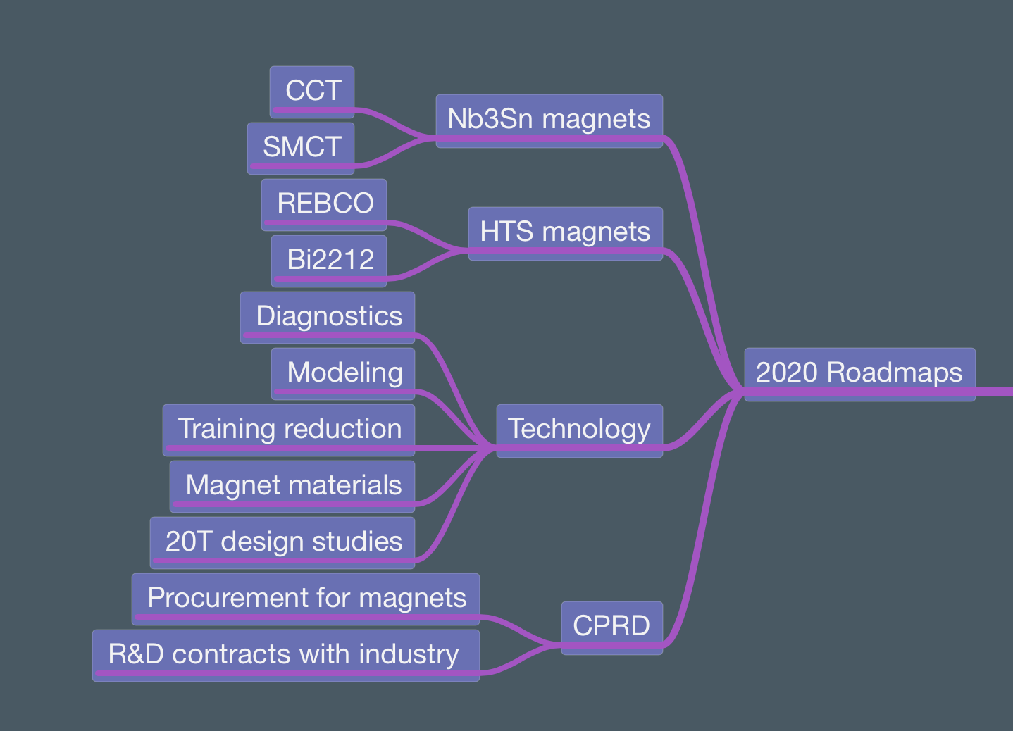

Figure 1. The current structure of MDP, with focus on Nb3Sn magnets, HTS magnets, Technology, and Conductors.

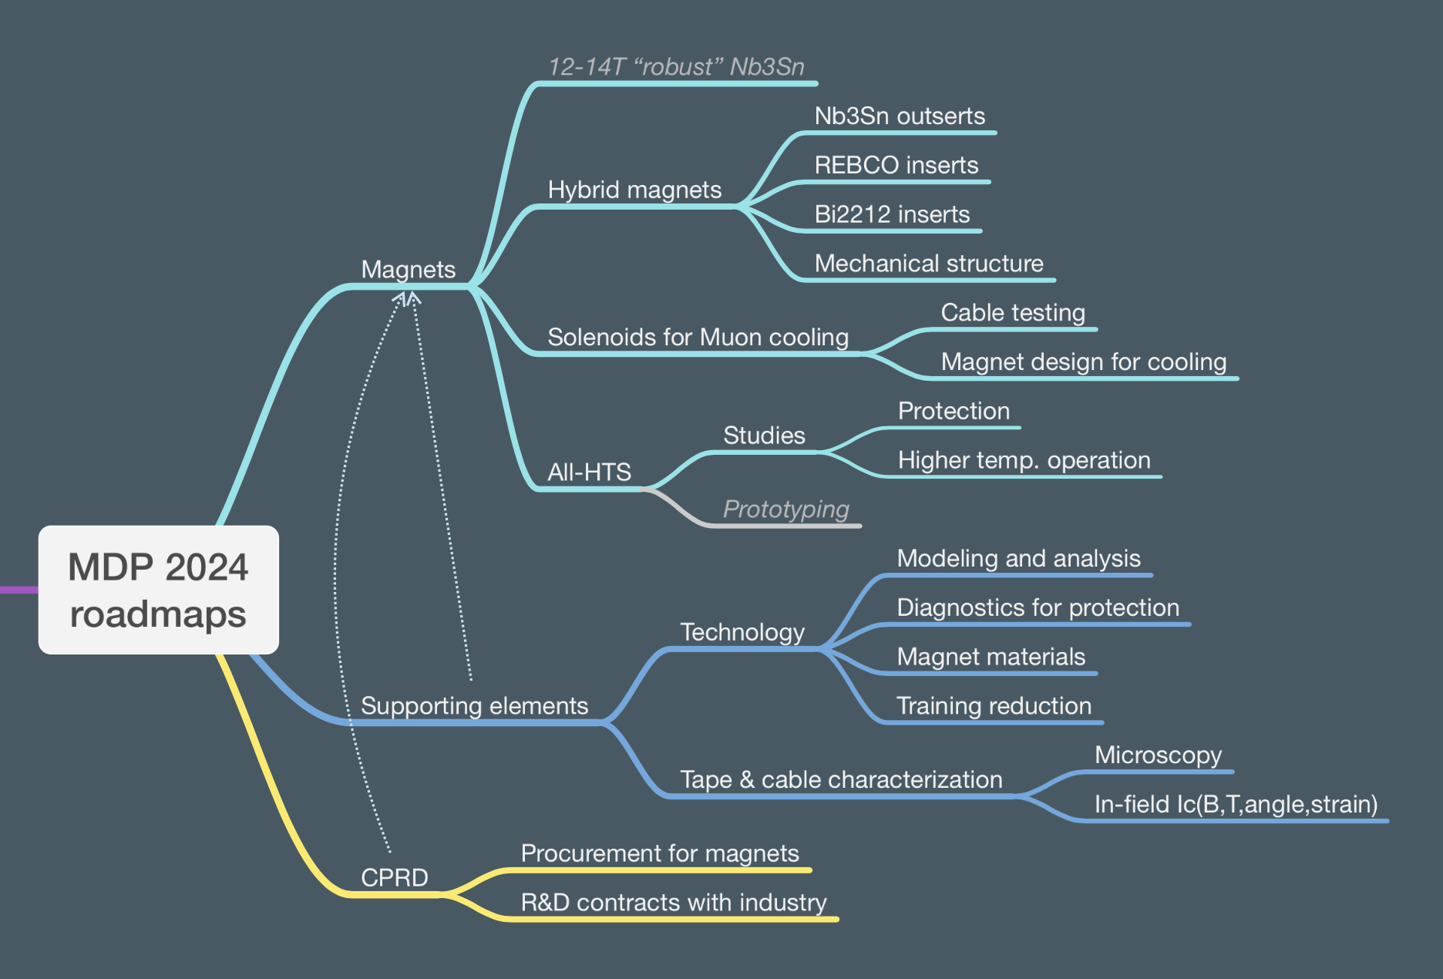

Figure 2. An example of brainstorming on an evolution of MDP in light of the new P5 report.



Figure 3. Schedule for the 2024 Update of MDP Roadmaps in light of the 2023 P5 report.