# Homework day 1

## Problem 1

### M. Marchevsky (Unit 2 and Unit 3)

#### 4 points

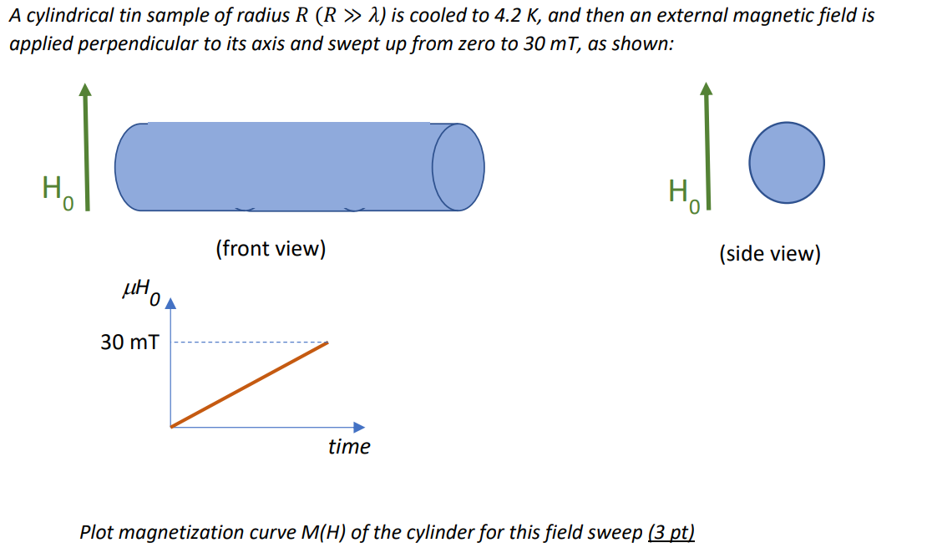

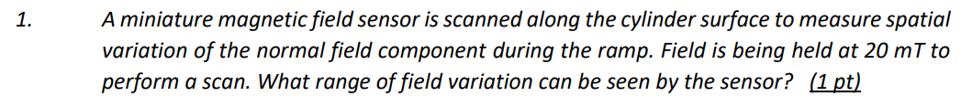

## Problem 2

### M. Marchevsky (Unit 2 and Unit 3)

#### 4 points



## Problem 3

### E. Todesco, (Unit 5 and Unit 6)

#### 6 points

The LHC has a quadrupole spacing of *L*=50 m, and a 90 degrees phase advance. Quadrupole integrated strength is 660 T, and is realized via 3.15-m-long quadrupoles having a nominal gradient of 210 T/m.

1. Compute the required integrated gradient in the case of a 60 degrees phase advance. *(1 point)*
2. Assuming that the cell quadrupole has the same nominal gradient of 210 T/m, estimate the required length of the magnet. *(1 point)*
3. Assuming that the space made available by the quadrupole length can be used by the dipoles, estimate the increase of the energy of the accelerator. *(1 point)*
4. Repeat the same computation (integrated gradient, quadrupole length and energy increase) keeping a 90 degrees phase advance, but increasing the cell length by a factor 3. *(1 point)*
5. In this case, give also a guess for the increase of the aperture of the magnets due to the larger beta functions, assuming that the offset (see equation in slide 2.18) is *0*=20 mm. The LHC main magnet aperture is 56 mm (diameter). *(2 points)*

## Problem 4

### E. Todesco, (Unit 5 and Unit 6)

#### 2 points

The LEP accelerates electrons at 110 GeV, and these particles are faster than the 7 TeV protons in the LHC. Compute the energy of a proton collider having particles as fast as in the LEP. Is the particle speed closer to the speed of light by one part per billion ? *(2 points)*