# Homework day 1

## Problem 1

### M. Marchevsky (Unit 2 and Unit 3)

#### 4 points

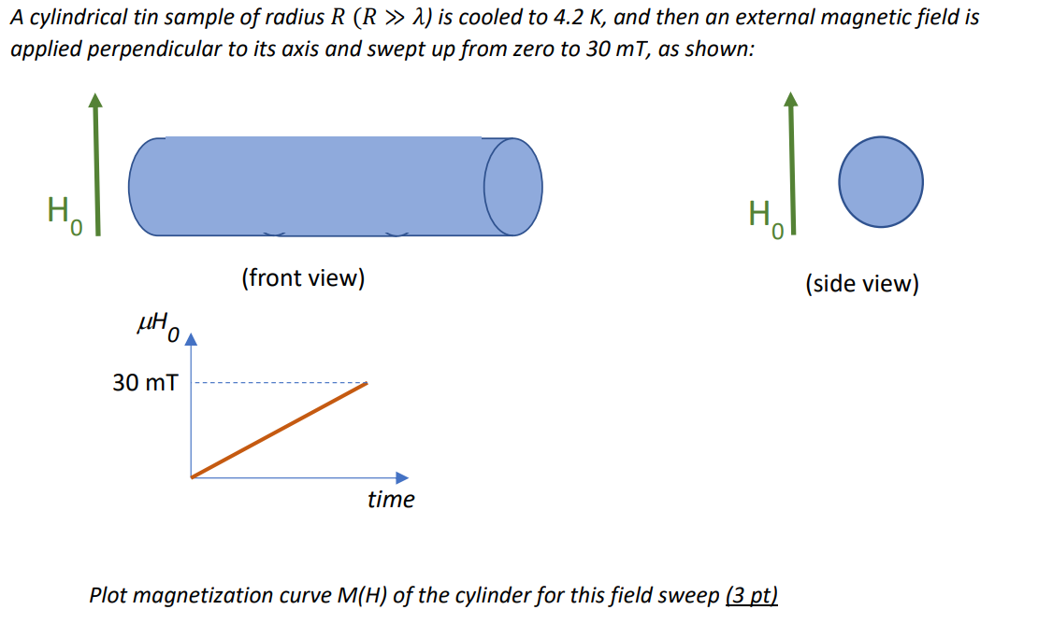

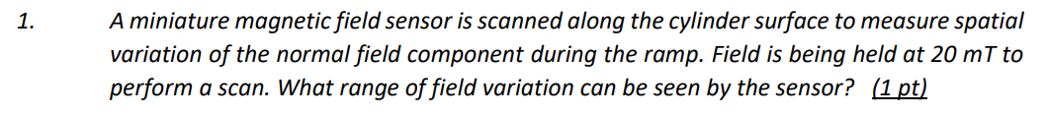

## Solution Problem 1

### M. Marchevsky (Unit 2 and Unit 3)

#### 4 points

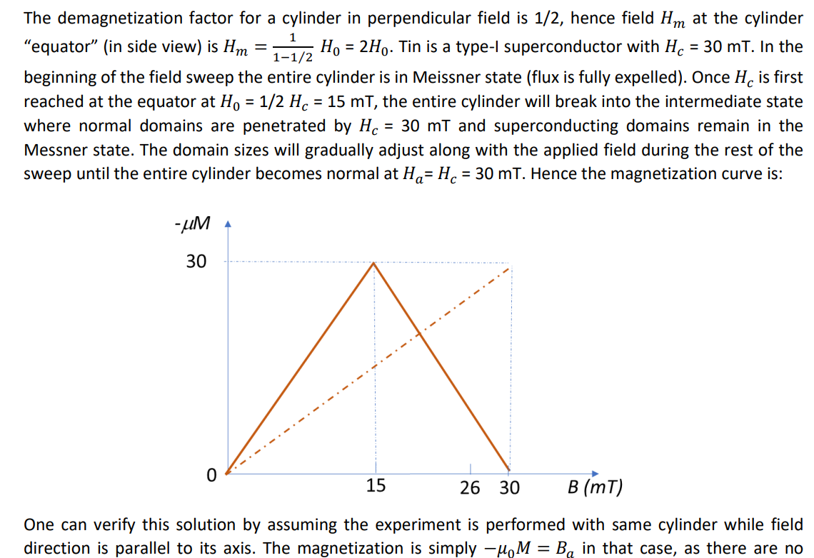

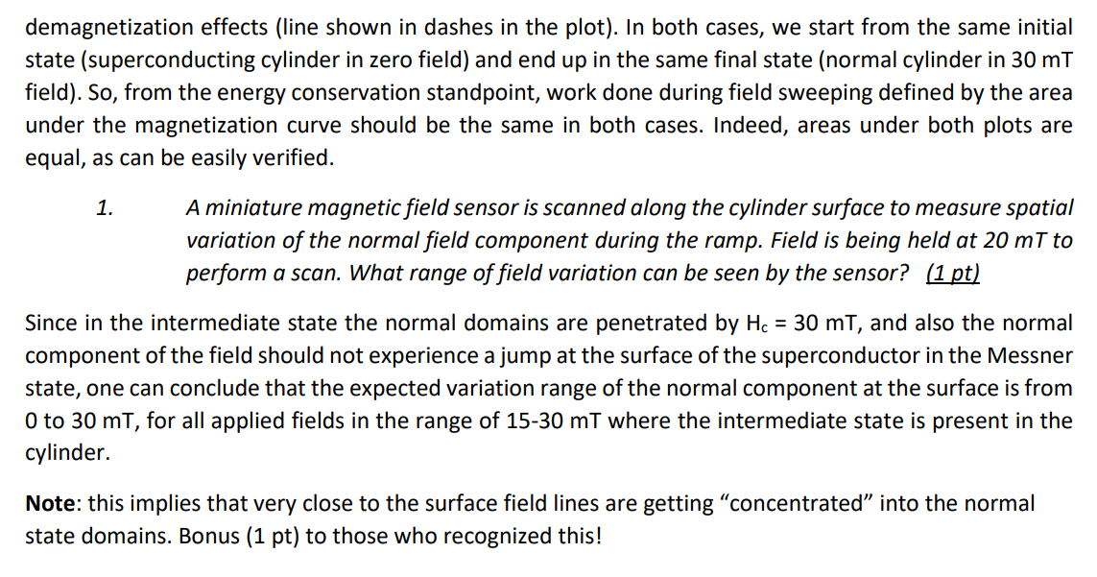



## Problem 2

### M. Marchevsky (Unit 2 and Unit 3)

#### 4 points



## Solution Problem 2

### M. Marchevsky, (Unit 2 and Unit 3)

#### 4 points

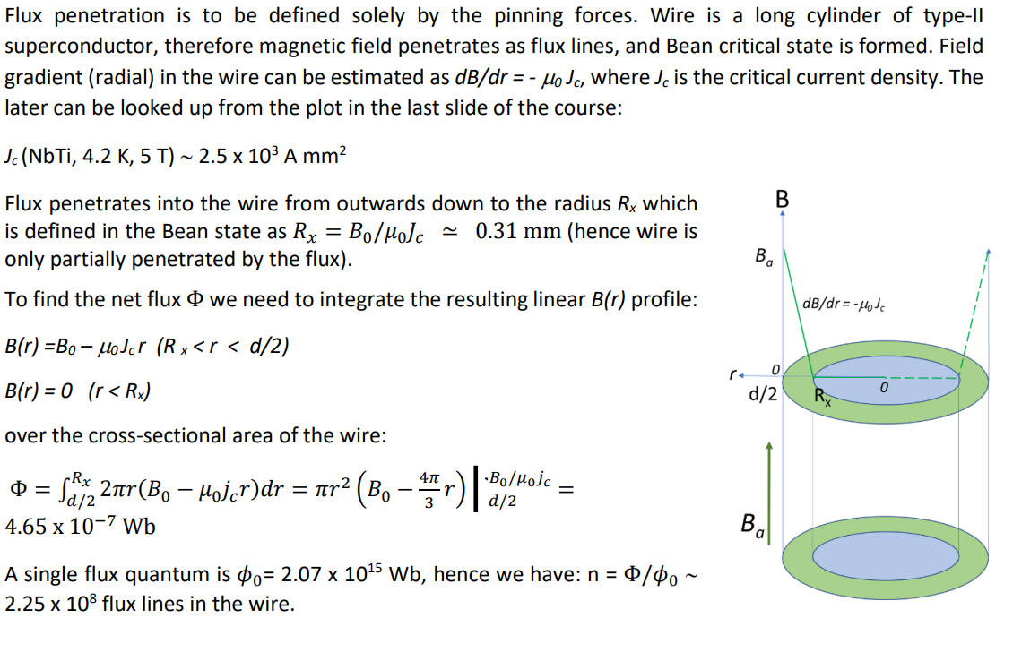

## Problem 3

### E. Todesco, (Unit 5 and Unit 6)

#### 6 points

The LHC has a quadrupole spacing of *L*=50 m, and a 90 degrees phase advance. Quadrupole integrated strength is 660 T, and is realized via 3.15-m-long quadrupoles having a nominal gradient of 210 T/m.

1. Compute the required integrated gradient in the case of a 60 degrees phase advance. *(1 point)*
2. Assuming that the cell quadrupole has the same nominal gradient of 210 T/m, estimate the required length of the magnet. *(1 point)*
3. Assuming that the space made available by the quadrupole length can be used by the dipoles, estimate the increase of the energy of the accelerator. *(1 point)*
4. Repeat the same computation (integrated gradient, quadrupole length and energy increase) keeping a 90 degrees phase advance, but increasing the cell length by a factor 3. *(1 point)*
5. In this case, give also a guess for the increase of the aperture of the magnets due to the larger beta functions, assuming that the offset (see equation in slide 2.18) is *0*=20 mm. The LHC main magnet aperture is 56 mm (diameter). *(2 points)*

## Solution Problem 3

### E. Todesco, (Unit 5 and Unit 6)

#### 6 points

Q1 : since one has (see Eq. 1.58)

 

for a 60 degrees phase advance one has cos*L*=1/2 and



Q2: The quadrupole length can be reduced from 3.15 m to 468/220=2.23 m.

Q3: Since one gains 0.92 m per half cell (i.e. every 50 m), the energy of the collider can be increased by 0.92/50=1.8%, i.e. from 7 to 7.13 TeV.

Q4: In the case of a 90 degrees phase advance,



and for a *L*=150 m, the quadrupole integrated gradient shall be 220 T, and the quadrupole length can be reduced by 2.1 m. If in the LHC quadrupoles require 3.15 m every 50 m (6.3% of space along the cell lattice), in the lattice with *L*=150 they require 1.05 m every 150 m (less than 1% of space along the cell lattice). Therefore if the space is taken by slightly longer dipoles, with the same field, the energy of the LHC could increase by ~5%, i.e. from 7 TeV to 7.35 TeV.

Q5: The beta functions are proportional to *L*,



and therefore will be three times larger. The aperture requirement will increase not more than √3, i.e. 70%.



Assuming that the aperture requirement for LHC has an offset due to tolerances and cold bore/beam screen of 0=20 mm, one has



and therefore the aperture requirement for *L*=150 is



## Problem 4

### E. Todesco, (Unit 5 and Unit 6)

#### 2 points

The LEP accelerates electrons at 110 GeV, and these particles are faster than the 7 TeV protons in the LHC. Compute the energy of a proton collider having particles as fast as in the LEP. Is the particle speed closer to the speed of light by one part per billion ? *(2 points)*

## Solution Problem 4

### E. Todesco, (Unit 5 and Unit 6)

#### 2 points

Solution : since the relativistic factor



is a measure of the particle velocity, it is enough to compute it for LEP:

 

This can also be estimated considering that the electron mass in MeV/c2 is 0.511



For a proton collider, since the proton mass is 938 MeV/c2,



and therefore a proton collider with protons having the same speed as LEP electrons shall have a proton energy of



The ratio between *v* and *c* is

  

and therefore the speed is closer to to speed of light by 1 part per billion: actually, 11 parts per trillion.