# Homework day 2

## Problem 1

### S. Prestemon (Unit 4 and Unit 7)

#### 3 points

The parametrization curves for Nb-Ti and Nb3Sn, described in Unit 4 and 7 and inserted in the excel file “Homework_day2_parameterization”, provide the critical curves Jsc vs B at different temperatures (numerical values in the first 2 worksheets and plot in the third one). At 1.9 K we have:

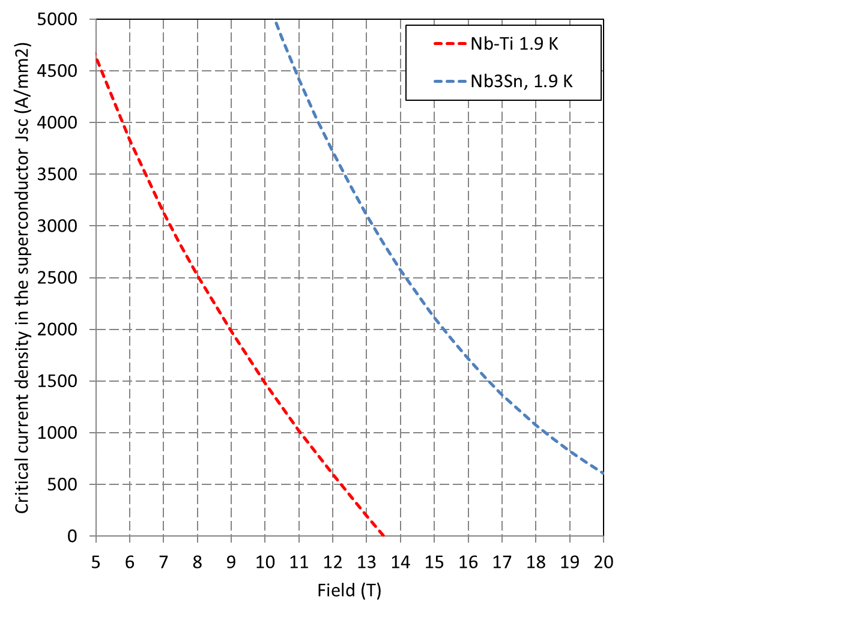

* A Nb3Sn magnet is operating at 1.9 K and with a Jsc=2000 A/mm2 and 13 T. Which is the temperature margin of the superconductor?
* A Nb-Ti magnet is operating at 1.9 K and with a Jsc=1000 A/mm2 and 9 T. Which is the temperature margin of the superconductor?

## Problem 2

### S. Prestemon (Unit 4 and Unit 7)

#### 2 points

Let’s consider the stability criteria (adiabatic, using the Critical State Model) for magneto-thermal instabilities (flux jumps). Let’s assume an infinite slab of superconductor, of thickness *2d* in an external field B. How small should *d* be in the following conditions

* Current density of 1000 A/mm2, i.e. 109 A/m2
* 2 K distance from critical surface (temperature margin)
* Volumetric specific heat ** Cp of Nb-Ti at 2 K is 2000 J/K/m3

## Problem 3

### S. Prestemon (Unit 4 and Unit 7)

#### 2 points

The Nb3Sn magnet for the 11T uses a strand with a 0.7 mm diameter and a Cu/non-Cu ratio of 1.2. Which is the % of Cu and % of non-Cu in the cross-sectional area?

## Problem 4

### M. Marchevsky (Unit 8)

#### 4 points

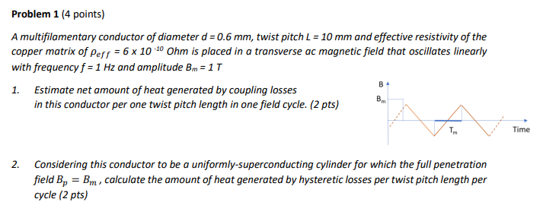

## Problem 5

### E. Todesco (Unit 10-11)

#### 6 points

A dipole for FCC-ee requires 60 mT nominal field.

* Considering a magnet purely based on currents (no iron), and a 60 degrees sector coil, compute the required coil width for a current density of 1 A/mm2. *(1 point)*
* Assuming a 50 mm aperture diameter, estimate the b5 at a reference radius of 16.7 mm. *(2 points)*
* Keeping the same reference radius of 16.7 mm, estimate how much one should increase the aperture to have a b5 satisfying the beam dynamics requirements (smaller than one unit). *(2 points)*
* What is the increase in the coil mass due to the aperture increase to satisfy field quality requirements ? *(1 points)*